*Project Online School Management (OSM)*

**2018**

***Table of Contents***

Introduction 3

OBJECTIVES 5

Tools/Environment Used 5

Analysis Document 6

SRS (Synopsis ) 6

ER Diagram 20

Data Flow Diagram 21

Data dictionary 23

Design Document 30

Modularization details 30

Data Integrity & Constraints Keys 31

Procedural design 32

User interface design 33

Program code (Comments & Description) 33

Testing 183

Unit Testing 183

Integration testing 203

Input and Output Screens 204

Implementation of Security and validation checks 233

Limitations of the Project Future 234

Application of the Project 234

BIBLIOGRAPHY 234

# Introduction

The online school management provides a set of tools - a roadmap if you will, that enables school administrators to

smoothly run the institution and do so in a way that demonstrates

efficiency, cost-savings and ingenuity.

It enables schools with excellent ways to systematically manage schools in multiple locations. It is a simple and powerful solution that connects all departments and campuses in a single

integrated platform. The online school Management solution helps in organizing various aspects of the school system,

including student, staff, admission, timetable, examination, fees, reporting and so on. The system helps administrators to access, manage, and analyse data and processes for quick and well-informed decision-making.

The online school management solution is a web application which features a centralized data storage structure which helps administrators, students, teachers and parents to access data from anywhere and anytime on Android

devices. The school management solution makes the work and functioning of school processeextremely easy to save time and cut down the administrative costs and focus on improving student success. By using online school management software, you will focus on improving the quality of education, reach desired academic goals within specific time and cost parameters. The final outcome is that all the constituents-students, teachers, staff, administrators and parents comes out a winner - which just may be a school

management's best benefit of all.

The “Online School Management” has been developed to override the problems prevailing in practicing manual system. This software is supported to eliminate and, in some cases, reduce the hardships faced by this existing system. Moreover, this system is designed for the particular need of the school/organization to carry out operations in a smooth and effective manner

The application is reduced as much as possible to avoid errors while entering the data. It is also providers error message while entering invalid data. No formal knowledge is needed for the users to use this system, as described above, can lead to error free, secure reliable and fast management system. It can assist the user to concentrate on their other activities rather to concentrate on the record keeping. Thus, it will help organization in better utilization of resources

Our project is based on the above concept i.e. automation of Administration and Management of School. The project has been developed keeping in-view the following

aspects: –

Working environment of the School.

and working environment.

|  |  |
| --- | --- |
| **Function for admin** | |
| Manage Student | Adding New Student  Edit the Exiting Student  View Profile of the Student  Listing of all Student |
| Manage Fees | Add Fees of Student  View Details of the Fees  Listing of all Fees  Filters Fees according to Student |
| Manage Attendance | Add Attendance of Student  Edit Attendance of Student  Listing of the Attendance  Filter attendance according to Student |
| Manage Staff | Update Staff Salary  Edit Staff Salary  Listing all Staff List  Edit Staff |
| Manage Transportation | Add transportations to Student  Edit Transportations to Student  Listing of all Transportation Student  Filter Fees according to Student. |
| Access Page | Show Attendance  Show Class Arrangement |

|  |  |
| --- | --- |
| **Function for Teacher** | |
| Manage Student | View Profile of the Student  Listing of all Student |
| Show Fes | View Details of the Fees  Listing of all Fees |
| Manage Attendance | Add Attendance of Student  Edit Attendance of Student  Listing of the Attendance  Filter attendance according to Student |
| ShowTransportation | Listing of all Transportation Student  Filter Fees according to Student. |

# OBJECTIVES

# 

The main objective of the project on Online School Management is to manage the details of Schools, Students Classes, Teachers , Courses. It manages all the information about Schools, Registration, Courses. The project is totally built at administrative end and thus only administrator is guaranteed the access. The purpose of the project is to build an application program to reduce the manual work for managing the Schools, Students, Registrations, Classes. It tracks all the details about the classes , teachers , courses. Every organization, whether big or small has challenge to overcome and managing the information of Students, Schools, Teachers, Registration, Courses. Every School Management System has different School’s needs; therefore we design exclusive employee management systems that are adapted to your managerial requirements. This is designed to assist in strategic planning, and will help you ensure that your organization is equipped with right level of information and details for your future goals.

Also, for those busy executive who are always on the go, our systems come with remote access features, which will allow you to manage your workforce anytime , at all times. These Systems will ultimately allow you to better manage resource The main objective is to bring all the school work on one platform now a day’s web is growing day by day. People are aware of web .it is easily accessible by many user so that i decided to design a site where user can school can manage daily tasks as said above.

# Tools/Environment Used

*Tools is being used Net beans and My SQL.*

*Environment*

*Browser Google Chrome, Internet Explorer, Firefox , Safari etc.*

# Analysis Document

## Software Requirement Specification (Synopsis)

1 Introduction

1.1 Purpose

1.2 Scope

1.3 Definition and Acronyms

1.4 Overview

2 Overall Description

2.1 Product Perspective

2.2 Product Function

2.3 User Characteristics

2.4 General Constraints

2.5 Assumption and Dependencies

3 Specific Requirement

3.1 External Interface Requirement

3.2 User Interfaces :

3.3 Hardware Requirement

3.4 Software Requirement

3.5 Communication Interface

3.6 Functional Requirement

3.7 Performance Requirement

3.8 Design constraints

3.9 Logical Database Requirement

3.10 Software System Attribute Requirement

3.10.1 Reliability :

3.10.2 Availability :

3.10.3 Security :

3.10.4 Maintainability

**Introduction**

The “Online School Management” has been developed to override the problems prevailing in practicing manual system. Purpose

The purpose of Online school Management is to automate the existing manual system to the help of computerized equipment and full-fledged computer software, fulfilling their requirements, so that their valuable data/information can be stored for a longer period with easy accessing and manipulation of the same that is not relevant while being able to reach the information.

**Scope**

The aim is to automate its existing manual system by the help of computerized equipment and full-fledged computer software, fulfilling their requirement, so that their valuable data/information can be stored for a longer period with easy accessing and manipulation of the same. Basically, the project describes how to manage for good performance and better services for clients

**Definition and Acronyms**

|  |  |
| --- | --- |
| **Designing Languages Used** | **HTML (Hyper Text Markup Language)**  **CSS(Cascading Style Sheet)** |
| **Programming Languages** | **JavaScript**  **Jsp**  **Java** |

**Overview**

**Overall Description**

**Product Perspective**

TEACHER LOGIN

ADMIN

LOGIN

STUDENT LOGIN

**ONLINE SCHOOL MANAGEMENT**

School Photos

*Footer*

**WELCOME TEACHER**

Fees Details

Attendance Management

Show Transportation

Edit Class arrangement

**WELCOME STUDENT**

Fees Details

Attendance Details

Show

Transportation

Show Class Arrangement

**Product Function**

Functionality performed by Admin Account

|  |  |
| --- | --- |
| Function for admin | |
| Manage Student | Adding New Student  Edit the Exiting Student  View Profile of the Student  Listing of all Student |
| Manage Fees | Add Fees of Student  View Details of the Fees  Listing of all Fees  Filters Fees according to Student |
| Show Attendance | Listing of the Attendance  Filter attendance according to Student |
| Manage Staff Salary | Update Staff Salary  Edit Staff Salary  Listing all Staff List  Edit Staff |
| Manage Transportation | Add transportations to Student  Edit Transportations to Student  Listing of all Transportation Student  Filter Fees according to Student. |

Functionality performed by Teacher Account

|  |  |
| --- | --- |
| Function for Teacher | |
| Manage Student | View Profile of the Student  Listing of all Student |
| Manage Fees | View Details of the Fees  Listing of all Fees |
| Manage Attendance | Add Attendance of Student  Edit Attendance of Student  Listing of the Attendance  Filter attendance according to Student |
| Manage Transportation | Listing of all Transportation Student  Filter Fees according to Student. |

**Functionality performed by** Student **Account**

Login For Student

View his Registration Details

Edit Profile For Student

View his Fess Payment History

View his Attendance History

S**tatic Pages and other sections:**

These static pages will be available in project

Home Page with good UI Home

Page will contain an animated slider for images banner

About us page will be available which will describe about the project

Contact us page will be available in the project

**Functionalities provided by Online School Management**

Provides the searching facilities based on factors. Such as Schools, Classes, Teacher, Courses.

Online School Management also manage the Registration Details of Student,

Teacher Details, Attendance, Fee Management , transportation of School and Time Table etc.

It tracks all the information of Student, Registration, Teachers etc.

Manage the information of Students and Teachers.

Shows the Time Table, Attendance of Class, Fee Details , Transport details, Student information, Staff Details.

Editing, adding and updating of Records of improved which result in proper resource management of Schools Data

**User Characteristics**

**Users of Online School Management**

There are three types of users available in the project .

Admin : with full access ,

Teacher: with limited access

Student : with limited access

**General Constraints**

Initial there must be one admin to manage all functions of System

Initial Release is only supported on Google Chrome , Internet Explorer and Firefox.

Online School Management web application does not work without JavaScript and jsp.

Assumption and Dependencies

The Online School Management has all available hardware Requirement to support intended user load.

All the upstream systems including the database, updating and should be correct and unambiguous.

**Specific Requirement**

**External Interface Requirement**

Class Diagram

**Admin**

**Teacher**

**Student**

**Online School Management**

**User Interfaces :**

Online School Management Page :It is welcome page to login the user and it have image of schools.

Welcome Admin Page: it is design for admin user only to manage all the functions on the systems

Welcome Teacher Page: it is design for Teacher user only to manage the functions on the systems.

Welcome Student Page :it is design for admin user only to manage the functions on the systems.

Admission & Registration Page: Only Admin have authenticated to this account. Admin can Update List and Registered new Students

Fees Management Page: Only Admin have authenticated to use this account. Admin can payment and insert the fee of the students.

Attendance Management Page: Only Teacher have authenticated to use this account.

Staff Management Page: Admin can add newly Staff and update them.

Transportation Management Page: Route have been edited, insert and updated by Admin.

Fee Details Page : Teacher and Student access this for Fee Details.

Class Arrangement Page: Teacher make the arrangement of the class period wise.

Showing Class Arrangement Page: Admin and Student have access to this to show class arrangement

Attendance Details Page : Admin and Student have access to this to show Attendance of student.

Transportation Details Page :This page will display all routes of the School

**Hardware Requirement**

Processor : Pentium -II or higher

Hard Disk Space : 200MB

Ram Memory : 32 MB (64 MB Recommend )

**Software Requirement**

Operating System : Windows XP or higher

Database Server : SQL and Oracle

Front end : Internet Explorer, Google Chrome and Firefox

**Communication Interface**

There no need of encrypting but the system in which the software install will save with antivirus protection so that no one able to steal the critical information of organization

**Functional Requirement**

Login Operation

|  |  |
| --- | --- |
| Functional Requirement Id | FR 1 |
| Requirement Title | Login Operation |
| Requirement Description | Registered user enter id and password.  User clicks on “Login” button.  System should authenticate and create a valid user session upon successful authentication and redirect user Welcome Page. |
| Business Rationale | Allow Registered user to get their welcome page according to their type of user (Admin , Teacher and Student ) |
| Exception Scenarios | If authentication fails, user should be redirected to error page showing “User id or password incorrect” message. Maximum Password retries allow are 3 after which account should be temporally locked and request user to contact to. |
| Dependencies | User must be registered on Database . |
| Functional Requirement Id | FR 2 |
| Requirement Title | Registration and Admission |
| Requirement Description | Admin user should fill a form  Admin user enters the New Admission Student Information Admission No, Student Name, Class, Gender, Data of Birth, Address, Mobile No., Father’s Name, Mother’s Name, Transportation (if taken).  User clicks on “Submit” or “Edit” button.  Post Successfully Admitted |
| Business Rationale | Allow Admin User to save the newly admitted student’s information into database. |
| Exception Scenarios | If two student’s admission no. must not same. |
| Dependencies | User must be a Admin.  FR1 User should be logged in. |

|  |  |
| --- | --- |
| Functional Requirement Id | FR 3 |
| Requirement Title | Fee Management |
| Requirement Description | Admin & Teacher is being allow to display any Student’s fee.  user enters Admission No., Student Name and DOB and click on Fee Detail or Edit to edit the Student Details.  Search function should retrieve the matching students’ fee details from Fee Database.  User can Edit and Submit fee, the Student’s fee. |
| Business Rationale | Allow User to get Students’ fee details. |
| Exception Scenarios | Display” No Student Found” if no information match the criteria. |
| Dependencies | User should be a Admin & Teacher.  FR1 User should be logged in. |

|  |  |
| --- | --- |
| Functional Requirement Id | FR 4 |
| Requirement Title | Transportation |
| Requirement Description | Admin & Teacher is being allow to display any Student’s Transportation.  user enters Admission No., Student Name and DOB and click on Fee Detail or Edit to edit the Student Details.  Search function should retrieve the matching students’ Transportation details from Transportation Database. |
| Business Rationale | Allow User to get Students’ Transportation Details and Submit new detail of Student |
| Exception Scenarios | Display” No Student Found” if no information match the criteria. |
| Dependencies | User should be a Admin & Teacher.  FR1 User should be logged in. |
| Functional Requirement Id | FR 5 |
| Requirement Title | Attendance |
| Requirement Description | The Attendance Function should display all Classes Students Attendance by Day, Month and Year.  Teacher can take class wise attendance daily.  Teacher have a daily form in which all student name class present and have two option first present and second is absent they must select one and the data will save in database. |
| Business Rationale | Allow Teacher User to easily update, edit and display daily attendance of students |
| Exception Scenarios | Internal Error of database |
| Dependencies | User should be a Teacher.  FR1 User should be logged in. |

|  |  |
| --- | --- |
| Functional Requirement Id | FR 6 |
| Requirement Title | Staff Management |
| Requirement Description | Admin user should fill a form  Admin user enters the Staff Name , position , Date of joining User clicks on “Add” or “Edit” button.  Post Successfully Admitted  . |
| Business Rationale | Allow Admin User to save the newly admitted staff information into database. |
| Exception Scenarios | Internal Database Error |
| Dependencies | User must be a Admin.  FR1 User should be logged in. |

**Performance Requirement**

The following are the key performance requirement

All pages should load within 2 seconds.

Details of Student and Staff should be displayed within 2 seconds

Payment and adding information of student should be done in 5 seconds

**Design constraints**

The all webpages design with CSS and HTML

W3C Web Accessibility Standards should be followed including keyboard navigation, alternative titles for images, etc,

**Logical Database Requirement**

Admin

Add, Creates

**Registration of Student**

**Fee of Student**

Add, Creates

**Transportation of Student**

Add, Creates

ER Diagram

FORMS

**Software System Attribute Requirement**

**Reliability:**

Online School Management should provide reliable and relevant get result with 100 % of times.

**Availability:**

Online School Management should be available 99.999% of times throughout India region. All software upgrades, patches and fixes be done without shouting down the application. There be disaster recovery environment to handle unwanted damage of hardware and software.

**Security:**

following Security standards is being followed

Login Operation performed transport layer security (HTTPS)

Registration process should use CAPTA to prevent machine/robot to brute force attack

All input fields should be validated in JavaScript and HTML reserved words scenarios. Input should be sanitized before sending them to the upstream systems.

There be well defined password policy covering password pass word change frequency invalid attempts allowed, etc.

Maintainability

Online School Management adopt standards-based integration for extensibility and scalability.

All code artifact have proper documentation

All code components be thoroughly tested and the test coverage should be more than 80%

## **ER Diagram**

Admission no

Studentname

Fathername

Mobileno

Classs

Dateofbirth

Gender

Transport

Route

Totalfee

Balance

**Student info**

'LKG'

'UKG'

'FIRST'

'SECOND'

'THIRD'

'FOURTH'

'FIFTH'

**Class**

'male'

'female'

'other'

**gender**

routeid

routename

too

vehicleno

mobileno

drivername

fees

routetable

staffid

staffname

gender

Mobile_No

Date_of_Birth

staffinfo

fourthfee

**feetype**

**qtr1**

**qtr2**

**qtr3**

**qtr4**

**total**

**Fee Tables**

ukgfee

lkgfee

thirdfee

secondfee

firstfee

classs

cdate

subject/teacher

firsts

seconds

thirds

fourths

fifths

sixs

classarrangement

student_name

classs

status

cdate

attendancemanage

## Data Flow Diagram

**First level DFD**

**Registration & Admission**

**(Student Management)**

**Fee Management**

**Transportation Management**

**ManageClass**

**Arrangement**

**Attendance**

**Management**

**Login**

**Management**

**Generate Student List/Report**

**Generate Fee Details/Report**

**Generate Transport Details/Report**

**Generate Class**

**Arrangement**

**Generate Attendance**

**Details/Report**

**Validate User Login**

**Second level DFD**

**Admin**

**Student**

**Teacher**

**Manage Student**

**Manage Fee**

**Manage Transport**

**Manage Class**

**Arrangement**

**Manage Attendance**

**Manage Login User**

**Manage Staff**

**Manage User Permission**

**Manage Teacher**

## **Data dictionary**

**Tables & Descriptions of their Uses**

1. **Registration Form Table**

|  |  |  |  |
| --- | --- | --- | --- |
| **Field Name** | **Null** | **Key** | **Type** |
| Admission No.  Student Name  Father Name  Mobile No  Class  Data of Birth  Route No. | **Not Null**  **Not Null**  **Not Null**  **-**  **-**  **-**  **-** | **Primary Key**  **Foreign Key (Relation to Route Table)** | NUMBER(10)  VARCHAR (20)  VARCHAR (20)  NUMBER(10)  NUMBER(5)  DATE  DROP DOWN |

1. **Add Fees Forms Table**

|  |  |  |  |
| --- | --- | --- | --- |
| **Field Name** | **Null** | **Key** | **Type** |
| Class  Tuition  Annual  Exam Fees |  | **Foreign Key (Relation to Registration Table)** | NUMBER (20)  NUMBER (20)  NUMBER (20) |

1. **Arrangement Form Table**

|  |  |  |  |
| --- | --- | --- | --- |
| **Field Name** | **Null** | **Key** | **Type** |
| Class  Date  Period  Subject  Teacher Name | **Not Null**  **1-8**  **Foreign Key**  **(Subject Table)**  **Foreign Key**  **(Staff Table)** | **Foreign Key (Relation to Registration Table)** | **Date** |

1. **Add Staff Form Table**

|  |  |  |  |
| --- | --- | --- | --- |
| **Field Name** | **Null** | **Key** | **Type** |
| Position  Staff Name  Mobile No.  Date of joining | **Not null**  **-**  **-**  **-** | **Primary key** | VARCHAR (20)  VARCHAR (20)  NUMBER (10)  DATE |

1. **Attendance Form Table**

|  |  |  |  |
| --- | --- | --- | --- |
| **Field Name** | **Null** | **Key** | **Type** |
| Date  Student List  Status | **-**  **-**  **-** | **Foreign Key**  **(Relation To registration Table )**  **Foreign Key**  **(Relation To Status Table)** | System Date  Drop Down |

|  |  |
| --- | --- |
| **Status** | |
| Absent  Present |

1. **Add Route Form**

|  |  |  |  |
| --- | --- | --- | --- |
| **Field Name** | **Null** | **Key** | **Type** |
| Route Name  To  Vehicle  Name | **Not Null**  **-**  **-**  **-** | **Primary Key** | VARCHAR (20)  VARCHAR (20)  VARCHAR (20)  VARCHAR (20) |

**All MySql Commands for Creating Table and Keys**

***Database Name Root***

***Table Name studentinfo;***

***create table studentinfo (***

***admisson_no int NOT NULL***

***GENERATED ALWAYS AS IDENTITY***

***(START WITH 1001, INCREMENT BY 1),***

***studentname varchar(25) NOT NULL,***

***fathername varchar(25) NOT NULL,***

***mobileno int,***

***classs varchar(25) NOT NULL,***

***dateofbirth date NOT NULL,***

***gender varchar(25) NOT NULL,***

***transport varchar(25),***

***route varchar(25),***

***totalfee int,***

***balance int,***

***FOREIGN KEY (classs) REFERENCES classs(classid),***

***FOREIGN KEY (gender) REFERENCES gender(genderid),***

***FOREIGN KEY (route) REFERENCES routetable(routeid),***

***PRIMARY KEY (admisson_no)***

***);***

***Table Name Classs;***

***create table classs (classid varchar (25) NOT NULL primary key );***

***insert into classs values ('LKG');***

***insert into classs values ('UKG');***

***insert into classs values ('FIRST');***

***insert into classs values ('SECOND');***

***insert into classs values ('THIRD');***

***insert into classs values ('FOURTH');***

***insert into classs values ('FIFTH');***

***Table Name gender;***

***create table gender (genderid varchar (25) NOT NULL primary key);***

***insert into gender values ('male');***

***insert into gender values ('female');***

***insert into gender values ('other');***

***Table Name routetable;***

***create table routetable ( routeid varchar(25) NOT NULL primary key);***

***very important***

***INSERT INTO STUDENTINFO1 (STUDENTNAME, FATHERNAME, MOBILENO, CLASSS, DATEOFBIRTH, GENDER, TRANSPORT, ROUTE) VALUES ('NitinKHNJK', 's', 99999, 'FIFTH', '2018-07-04', 'male', 'no', 'HELLO');***

***Table Name Route Table***

***create table routetable ( routeid varchar(25) NOT NULL primary key, routename***

***varchar(30) not null ,too varchar(30), vehicleno varchar(30),mobileno int,***

***drivername varchar(30), fees int );***

***INSERT INTO routetable VALUES ('Route 1', 'aa', 'aa', 'aa', 555, 'aa', 200);***

***INSERT INTO routetable VALUES ('Route 2', 'aa', 'aa', 'aa', 555, 'aa', 11);***

***INSERT INTO routetable VALUES ('Route 3', 'aa', 'aa', 'aa', 555, 'aa', 22);***

***INSERT INTO routetable VALUES ('Route 4', 'aa', 'aa', 'aa', 555, 'aa', 11);***

***INSERT INTO routetable VALUES ('Route 5', 'aa', 'aa', 'aa', 555, 'aa', 11);***

***Staff Table***

***create table staffinfo (staffid integer not null generated always as identity***

***(start with 1001, increment by 1 ) primary key, staffname varchar (20) not null,***

***gender varchar(25) NOT NULL, Mobile_No integer not null,***

***Date_of_Birth date, FOREIGN KEY (gender) REFERENCES gender(genderid) );***

***Fee table***

***create table lkgfee (feetype varchar(20) primary key, qtr1 int, qtr2 int, qtr3 int, qtr4 int, total int);***

***INSERT INTO LKGFEE VALUES (‘Tuition_Fee', 100, 200, 200, 300, 20);***

***INSERT INTO LKGFEE VALUES ('Annual_Fee', 100, 200, 200, 300, 20);***

***INSERT INTO LKGFEE VALUES (‘Exam_Fee', 100, 200, 200, 300, 20);***

***INSERT INTO LKGFEE VALUES ('Total’, 100, 200, 200, 300, 20);***

***create table ukgfee (feetype varchar(20) primary key, qtr1 int, qtr2 int, qtr3 int, qtr4 int, total int);***

***INSERT INTO ukgfee VALUES ('Tuition_Fee', 100, 200, 200, 300, 20);***

***INSERT INTO ukgfee VALUES ('Annual_Fee', 100, 200, 200, 300, 20);***

***INSERT INTO ukgfee VALUES ('Exam_Fee', 100, 200, 200, 300, 20);***

***INSERT INTO ukgfee VALUES ('Total', 100, 200, 200, 300, 20);***

***create table firstfee (feetype varchar(20) primary key, qtr1 int, qtr2 int, qtr3 int, qtr4 int, total int);***

***INSERT INTO firstfee VALUES ('Tuition_Fee', 100, 200, 200, 300, 20);***

***INSERT INTO firstfee VALUES ('Annual_Fee', 100, 200, 200, 300, 20);***

***INSERT INTO firstfee VALUES ('Exam_Fee', 100, 200, 200, 300, 20);***

***INSERT INTO firstfee VALUES ('Total', 100, 200, 200, 300, 20);***

***create table secondfee (feetype varchar(20) primary key, qtr1 int, qtr2 int, qtr3 int, qtr4 int, total int);***

***INSERT INTO secondfee VALUES ('Tuition_Fee', 100, 200, 200, 300, 20);***

***INSERT INTO secondfee VALUES ('Annual_Fee', 100, 200, 200, 300, 20);***

***INSERT INTO secondfee VALUES ('Exam_Fee', 100, 200, 200, 300, 20);***

***INSERT INTO secondfee VALUES ('Total', 100, 200, 200, 300, 20);***

***create table thirdfee (feetype varchar(20) primary key, qtr1 int, qtr2 int, qtr3 int, qtr4 int, total int);***

***INSERT INTO thirdfee VALUES ('Tuition_Fee', 100, 200, 200, 300, 20);***

***INSERT INTO thirdfee VALUES ('Annual_Fee', 100, 200, 200, 300, 20);***

***INSERT INTO thirdfee VALUES ('Exam_Fee', 100, 200, 200, 300, 20);***

***INSERT INTO thirdfee VALUES ('Total', 100, 200, 200, 300, 20);***

***create table fourthfee (feetype varchar(20) primary key, qtr1 int, qtr2 int, qtr3 int, qtr4 int, total int);***

***INSERT INTO fourthfee VALUES ('Tuition_Fee', 100, 200, 200, 300, 20);***

***INSERT INTO fourthfee VALUES ('Annual_Fee', 100, 200, 200, 300, 20);***

***INSERT INTO fourthfee VALUES ('Exam_Fee', 100, 200, 200, 300, 20);***

***INSERT INTO fourthfee VALUES ('Total', 100, 200, 200, 300, 20);***

***create table fifthfee (feetype varchar(20) primary key, qtr1 int, qtr2 int, qtr3 int, qtr4 int, total int);***

***INSERT INTO fifthfee VALUES ('Tuition_Fee', 100, 200, 200, 300, 20);***

***INSERT INTO fifthfee VALUES ('Annual_Fee', 100, 200, 200, 300, 20);***

***INSERT INTO fifthfee VALUES ('Exam_Fee', 100, 200, 200, 300, 20);***

***INSERT INTO fifthfee VALUES ('Total', 100, 200, 200, 300, 20);***

***Class Arrangement***

***LKGPERIOD Table***

***create table classarrangement (***

***classs varchar(25) not null,***

***cdate date not null,***

***subject varchar(20) not null,***

***firsts varchar(30),***

***seconds varchar(30),***

***thirds varchar(30),***

***fourths varchar(30),***

***fifths varchar(30),***

***sixs varchar(30),***

***FOREIGN KEY (classs) REFERENCES classs(classid)***

***);***

***Attendance Management***

***create table attendancemanage (admission int not null,***

***student_name varchar(25) not null,***

***classs varchar(25) NOT NULL,***

***status varchar(20) not null,***

***cdate date not null,***

***FOREIGN KEY (classs) REFERENCES classs(classid));***

***LOGIN Tables***

***create table regisadmin(userid varchar(20),password varchar(20), sname varchar(40), email varchar(40));***

***create table registeacher (userid varchar(20),password varchar(20));***

***create table regisstudent (userid varchar(20),password varchar(20)***

# **Design Document**

## Modularization details

**Admission & Registration Module**

**Fees Management Module**

**Attendance**

**Details Module**

**Staff Management Module**

**Transportation**

**Management Module**

**Show Class arrangement Module**

## Data Integrity & Constraints Keys

used Primary Key, Foreign Key , Unique Keys

**Primary Key**

**Foreign Key**

**(Relation to staffinfo )**

**)**

**Primary Key**

**Primary Key**

**Primary Key**

**Primary Key**

**Foreign Key (Relation to routetable field routename)**

**Foreign Key**

**(Relation to Feetable )**

Admission no

Studentname

Fathername

Mobileno

Classs

Dateofbirth

Gender

Transport

Route

Totalfee

Balance

**Student info**

Classid

('LKG'

'UKG'

'FIRST'

'SECOND'

'THIRD'

'FOURTH'

'FIFTH')

**Class**

Genderid (

'male'

'female')

'other'

**gender**

routeid

routename

too

vehicleno

mobileno

drivername

fees

routetable

staffid

staffname

gender

Mobile_No

Date_of_Birth

staffinfo

**feetype**

**qtr1**

**qtr2**

**qtr3**

**qtr4**

**Fee Tables**

ukgfee

lkgfee

thirdfee

secondfee

firstfee

fourthfee

classs

cdate

subject/teacher

firsts

seconds

thirds

fourths

fifths

sixs

classarrangement

student_name

classs

status

cdate

attendancemanage

**Foreign Key (Relation to Student info field studentname )**

**Foreign Key**

**(Relation to class )**

**Foreign Key**

**(Relation to class)**

**)**

**Foreign Key**

**(Relation to class)**

**)**

**Primary Key**

.

## Procedural design

**Access Pages**

**Show Fee Details**

**Show Arrangement**

**Show Attendance**

**Show Transportation**

**Log out**

**LOGIN TYPE**

**STUDENT LOGIN**

**TEACHER LOGIN**

**ADMIN LOGIN**

Verify

Verify

Verify

**Invalid Username/Password Type Again**

**No**

**Yes**

**Invalid Username/Password Type Again**

**No**

**Yes**

**No**

**Yes**

**Invalid Username/Password Type Again**

**Log out**

**Change Student info**

**Pay Student Fee**

**Change Staffinfo**

**Update Route Detils**

**Log out**

**Update StudentDetails**

**Calculate Student Fee**

**Update Staff Details**

**Update Tranpost Fee**

**Show Class Arrangement**

**Access Pages**

**Registration Management**

**Fee Management**

**Staff Management**

**Transportation Management**

**Admission New Student**

**Update Class Fee**

**Recruit New Staff**

**Add /Remove New Routes**

**Show Student Attendance Student**

**Manage Class Arrangement**

**Attendance Management**

**Access Pages**

**Take Student Attendance**

**Show Student attendance**

**Arrange Class Periods**

**Show Class Arrangement**

**Show Student Fee Details**

**Show Transportation**

## User interface design

TEACHER LOGIN

ADMIN

LOGIN

STUDENT LOGIN

**ONLINE SCHOOL MANAGEMENT**

School Photos

*Footer (Online School Management OSM)*

# Program code (Comments & Description)

The project have been divided into 4 Sections as follow:-

1. Admin Account
2. Teacher Account
3. Student Account
4. Login Section

|  |  |
| --- | --- |
| 1. **Admin Account** | |
| **Manage Student** | Adding New Student  Edit the Exiting Student  View Profile of the Student  Listing of all Student |
| **Manage Fees** | Add Fees of Student  View Details of the Fees  Listing of all Fees  Filters Fees according to Student |
| **Manage Attendance** | Add Attendance of Student  Edit Attendance of Student  Listing of the Attendance  Filter attendance according to Student |
| **Manage Staff** | Update Staff Salary  Edit Staff Salary  Listing all Staff List  Edit Staff |
| **Manage Transportation** | Add transportations to Student  Edit Transportations to Student  Listing of all Transportation Student  Filter Fees according to Student. |
| **Access Page** | Show Attendance  Show Class Arrangement |

**For Manage Student (Registration Management JSP Page)**

**Description & Comments :-In below page into division named form have a form to register a student. Admin have to click on submit button after completely fill the detail of student in form and form data post (send) to registration.jsp page. And division named form student information is to show all students according to enrolment no. into this division from the database through registioninfo.jsp page.**

<%--

Document : Registration Management

Created on : 6 Jul, 2018, 2:35:50 PM

Author : Aravali

--%>

<html>

<head>

<title>Registration Management</title>

<meta charset="UTF-8">

<meta name="viewport" content="width=device-width, initial-scale=1.0">

<style>

body {background-color: #59b9c6;}

#leftbar { background-color:#2BB958; position:absolute; margin-top:80px; height:600px; width:250px}

#form { background-color:white; position:absolute; margin-top:80px; margin-left:280px ; height:600px; width:400px;font-size:30px; color:black; text-align:center;}

#info { background-color:white; position:absolute; margin-top:80px; margin-left:700px ; height:600px; width:700px;font-size:30px; color:black; text-align:center;}

#banner{ padding: 20px 10px; background-color:#3e6166; position:absolute; height:40px; width:100%; font-size:40px; font-weight:bold; color:white; text-align:center}

.topnav {overflow: hidden; background-color: #333;

}

#infot {color: black;

text-align: left;

padding:5px;

text-decoration: none;

font-size:13px;

border:1px;}

/* Style the topnav links */

#box{

float: left;

display: block;

color: #f2f2f2;

text-align: center;

padding:35px 0px 30px;

text-decoration: none;

font-size:20px;

font-weight:bold;

width:100%;

}

/* Change color on hover */

#box:hover {

background-color: #3e6166;

color: white;

}

#footer{ padding: 0px 0px; background-color:white; position:absolute; margin-top:630px; height:25px; width:100%; font-size:20px; font-weight:bold; color:black; text-align:center}

input[type=button], input[type=submit], input[type=reset] {

background-color: #4CAF50;

border: none;

color: white;

padding: 16px 32px;

text-decoration: none;

margin: 4px 2px;

cursor: pointer;

}

td{ padding:10px;}

tr {

color: black;

text-align: left;

padding:50px;

text-decoration: none;

font-size:20px;

font-weight:bold;

}

table {padding:5px 50px 10px 20px; width: 100%; ;}

#home{ background-color:#3e6166; position:absolute; margin-top:10px; height:40px; width:250px; font-size:20px; font-weight:bold; color:white; text-align:center; margin-left:1100px;}

</style>

</head>

<body>

<div id="banner">ADMISSION & REGISTRATION </div>

<div id="home"> <ul><a href="../../LOGIN/Welcome Admin.jsp"><li>HOME</li></a>

<a href="../../HOME.html"> <li>LOG OUT</li></ul></div>

<div id ="leftbar">

<a href="Registration Management.jsp"><div id ="box">Registration and Admission </div></a>

<a href="../Staff Management/Staff Management.jsp"><div id ="box">Staff Management </div></a>

<a href="../Fee Management/Fee Management.jsp"><div id ="box">Fee Management </div></a>

<a href="../Transportation Management/Transportation Management.jsp"><div id ="box">Transportation Management </div></a>

<a href="../Access Pages/Attendance Details.jsp"><div id ="box">Attendance Details </div></a>

<a href="../Access Pages/Showing Class Arrangement.jsp"><div id ="box">Show Class Arrangement </div></a>

</div>

<div id ="form"> Student Registration

<form action="registration.jsp" method="post">

<table >

<tr><td>For Session </td><td>2018-19</td></tr>

<tr><td>Student Name</td><td><input type="text" placeholder="Student Name " name ="sname"></td></tr>

<tr><td>Father Name</td><td><input type="text" placeholder="Father Name " name ="fname"></td></tr>

<tr><td>Mobile No.</td><td><input name="telNo" type="text" placeholder="9999999999"></td></tr>

<tr><td>Class</td><td> <select name="aclass" >

<option value="LKG">LKG</option>

<option value="UKG">UKG</option>

<option value="FIRST">FIRST</option>

<option value="SECOND">SECOND</option>

<option value="THIRD">THIRD</option>

<option value="FOURTH">FOURTH</option>

<option value="FIFTH">FIFTH</option>

</select></td></tr>

<tr><td> Date of Birth </td><td><input type="date" name="bday" max="2017-01-01" min="1998-01-01"></td></tr>

<tr><td>Gender</td><td><input type="radio" name="gender" value="male" checked> Male

<input type="radio" name="gender" value="female"> Female

<input type="radio" name="gender" value="other"> Other</td>

<tr><td>Transportation</td> <td>

<input type="radio" name="trans" value="Yes" checked> YES

<input type="radio" name="trans" value="No"> NO</td></tr>

<tr><td>Route No. </td><td> <select name="route">

<option value="Route 1">Route 1</option>

<option value="Route 2">Route 2</option>

<option value="Route 3">Route 3</option>

<option value="Route 4">Route 4</option>

<option value="Route 5">Route 5</option></select></td></tr>

<tr><td ><input type="submit" value="Submit"></td></tr>

</table>

</form>

</div>

<div id ="info">Student Information

<%@ include file = "Registrationinfo.jsp" %>

</div>

</body>

</html>

**For Manage Student (registration JSP Page )**

**Description & Comments :-** **In below page code for get the data form registration management jsp page and then compute the total fee of student according to class and route is chosen by student (For Example Route 1 and Class V total amount calculated and inserted into database as total amount and balance). other details of student is also inserted into studentinfo table in database.**

<%--

Document : registration

Created on : 4 Jul, 2018, 2:35:55 PM

Author : Aravali

--%>

<%@ page language="java" contentType="text/html; charset=ISO-8859-1"

pageEncoding="ISO-8859-1"%>

<%@ page import="java.sql.*" %>

<!DOCTYPE html PUBLIC "-//W3C//DTD HTML 4.01 Transitional//EN" "http://www.w3.org/TR/html4/loose.dtd">

<html>

<head>

<style name="css">

input[type=button], input[type=submit], input[type=reset] {

background-color: #4CAF50;

border: none;

color: white;

padding: 16px 32px;

text-decoration: none;

margin: 4px 2px;

cursor: pointer;

}

#footer{ padding: 5px 5px; background-color:white; position:fixed; margin-top:620px; height:25px; width:100%; font-size:20px; font-weight:bold; color:black; text-align:center}

#banner{ padding: 20px 10px; background-color:#3e6166; position:fixed; margin-top:50px; height:50px; width:100%; font-size:40px; font-weight:bold; color:white; text-align:center}

body {background-color: #59b9c6;}</style>

<meta http-equiv="Content-Type" content="text/html; charset=ISO-8859-1">

<title>verification</title>

</head>

<body>

<%

String sname=request.getParameter("sname");

String fname=request.getParameter("fname");

String telNo=request.getParameter("telNo");

String aclass=request.getParameter("aclass");

String bday=request.getParameter("bday");

String gender=request.getParameter("gender");

String trans=request.getParameter("trans");

String route=request.getParameter("route");

String fclass=null;

if ("LKG".equals(aclass)){

fclass="lkgfee";

}

if ("UKG".equals(aclass)){

fclass="ukgfee";

}

if ("FIRST".equals(aclass)){

fclass="FIRSTFEE";

}

if ("SECOND".equals(aclass)){

fclass="SECONDFEE";

}

if ("THIRD".equals(aclass)){

fclass="THIRDFEE";

}

if ("FIFTH".equals(aclass)){

fclass="FIFTHFEE";

}

if ("FOURTH".equals(aclass)){

fclass="FOURTHFEE";

}

out.println(sname);

out.println(fname);

out.println(telNo);

out.println(aclass);

out.println(bday);

out.println(gender);

out.println(trans);

out.println(route);

out.println(fclass);

int totalfee=0,routefees=0, grandtotal=0;

try{

Class.forName("com.mysql.jdbc.Driver");

//1. Get a connection to database

Connection con= DriverManager.getConnection("jdbc:mysql://localhost:3306/student_list”,”root”,”admin");

//2. Create a statment

Statement st =con.createStatement();

;

String query1="SELECT SUM(qtr1+qtr2+qtr3+qtr4) FROM "+fclass+"";

ResultSet rs=st.executeQuery(query1);

;

while(rs.next()){

int total=rs.getInt(1);

totalfee=total;

}

if ("Yes".equals(trans)) {

String query2="SELECT fees FROM ROUTETABLE WHERE ROUTEID='"+route+"'";

ResultSet rs1=st.executeQuery(query2);

int routefee;

while(rs1.next()){

routefee=rs1.getInt(1);

routefees=routefee;

}

}

out.println(totalfee);

out.println(routefees);

grandtotal=totalfee+routefees;

out.println(grandtotal);

// execute it on test database

st.close();

String query = "INSERT INTO STUDENTINFO (STUDENTNAME, FATHERNAME, MOBILENO, CLASSS, DATEOFBIRTH, GENDER, TRANSPORT, ROUTE, TOTALFEE, BALANCE, FEE) VALUES (?,?,?,?,?,?,?,?,?,?,?)";

PreparedStatement ps = con.prepareStatement(query); // generates sql query

ps.setString(1, sname);

ps.setString(2, fname);

ps.setString(3, telNo);

ps.setString(4, aclass);

ps.setString(5, bday);

ps.setString(6, gender);

ps.setString(7, trans);

ps.setString(8, route);

ps.setInt(9, grandtotal);

ps.setInt(10, grandtotal);

ps.setString(11, fclass);

ps.executeUpdate(); // execute it on test database

ps.close();

con.close();

out.println("Successfully Admitted ");%>

<div id="banner">Sucessfully</div>

<%

}

catch (Exception e){

out.println("Unsuccessfully" +e);

%><div color="Red" id="banner">Unsucessfully Not Admitted</div> <%

}

%>

<a href="Registration Management.jsp"><input type="Button" value="BACK " ></a>

</body>

</html>

**For Manage Student (Registrationinfo JSP Page )**

**In below page code for showing list of all students**

<%--

Document : Registrationinfo

Created on : 4 Jul, 2018, 2:35:55 PM

Author : Aravali

--%>

<%@ page import="java.sql.*" %>

<%

try{

Class.forName("com.mysql.jdbc.Driver");

//1. Get a connection to database

Connection con= DriverManager.getConnection("jdbc:mysql://localhost:3306/student_list”,”root”,”admin");

//2. Create a statment

Statement statement = con.createStatement() ;

ResultSet resultset = statement.executeQuery("select * from studentinfo");

%>

<TABLE border="1px">

<TR id ="infot">

<TH>Admission No.</TH>

<TH>Student Name</TH>

<TH>Father Name</TH>

<TH>Mobile No</TH>

<TH>Class</TH>

<TH>Date of Birth</TH>

<TH>Gender</TH>

<TH>Transport</TH>

<TH>Route</TH>

<TH>Total Fee</TH>

<TH>Balance</TH>

</TR>

<% while(resultset.next()){ %>

<TR>

<TD id ="infot"> <%= resultset.getString(1) %></td>

<TD id ="infot"> <%= resultset.getString(2) %></TD>

<TD id ="infot"> <%= resultset.getString(3) %></TD>

<TD id ="infot"> <%= resultset.getString(4) %></TD>

<TD id ="infot"> <%= resultset.getString(5) %></TD>

<TD id ="infot"> <%= resultset.getString(6) %></TD>

<TD id ="infot"> <%= resultset.getString(7) %></TD>

<TD id ="infot"> <%= resultset.getString(8) %></TD>

<TD id ="infot"> <%= resultset.getString(9) %></TD>

<TD id ="infot"> <%= resultset.getString(10) %></TD>

<TD id ="infot"> <%= resultset.getString(11) %></TD>

</TR>

<% } %>

</TABLE>

<%}

catch (Exception e){

out.println("Exception " +e);

}

%>

For Manage Fees ( Fee Management JSP )

**In below page is to manage (Payment and Update) the student fees . Page have a division named form into a Add fees form to change/update the fees according to class. Admin have to click on Add fee button after completely fill the details of fees (e.g class quarter, tuition fee, annual fee, exam fee etc.) in Add Fees form and form data post (send) to** UpdateFee.jsp **(describe in later in this section) page. In this page also have a division named fee detail is also have a form for payment the fees of any student. Admin have to click on Submit button after completely fill the detail of Student (e.g class, Admissoin No) in payment form and form data post (send) to** FeeDetail.jsp **(describe in later in this section) page.**

<html>

<head>

<title>Fee Management</title>

<meta charset="UTF-8">

<meta name="viewport" content="width=device-width, initial-scale=1.0">

<style>

body {background-color: #59b9c6;}

#leftbar { background-color:#2BB958; position:absolute; margin-top:80px; height:600px; width:250px}

#form { background-color:white; position:absolute; margin-top:80px; margin-left:280px ; height:600px; width:400px;font-size:30px; color:black; text-align:center;}

#info { background-color:white; position:absolute; margin-top:80px; margin-left:720px ; height:600px; width:700px;font-size:30px; color:black; text-align:center;}

#banner{ padding: 20px 10px; background-color:#3e6166; position:absolute; height:40px; width:100%; font-size:40px; font-weight:bold; color:white; text-align:center}

.topnav {

overflow: hidden;

background-color: #333;

}

/* Style the topnav links */

#box{

float: left;

display: block;

color: #f2f2f2;

text-align: center;

padding:35px 0px 30px;

text-decoration: none;

font-size:20px;

font-weight:bold;

width:100%;

}

/* Change color on hover */

#box:hover {

background-color: #3e6166;

color: white;

}

#footer{ padding: 5px 5px; background-color:white; position:absolute; margin-top:620px; height:25px; width:100%; font-size:20px; font-weight:bold; color:black; text-align:center}

input[type=button], input[type=submit], input[type=reset] {

background-color: #4CAF50;

border: none;

color: white;

padding: 16px 32px;

text-decoration: none;

margin: 4px 2px;

cursor: pointer;

}

td{ padding:10px;}

tr {

color: black;

text-align: left;

padding:50px;

text-decoration: none;

font-size:20px;

font-weight:bold;

}

table {padding:5px 50px 10px 20px; width: 100%;}

#home{ position:fixed; margin-top:10px; height:40px; width:250px; font-size:20px; font-weight:bold; color:white; text-align:center; margin-left:1100px;}

</style>

</head>

<body>

<div id="banner">Fee Management </div>

<div id="home"> <ul><a href="../../LOGIN/Welcome Admin.jsp"><li>HOME</li></a>

<a href="../../HOME.html"> <li>LOG OUT</li></ul></div>

<div id ="leftbar">

<a href="../Registration Management/Registration Management.jsp"><div id ="box">Registration and Admission </div></a>

<a href="../Staff Management/Staff Management.jsp"><div id ="box">Staff Management </div></a>

<a href="Fee Management.jsp"><div id ="box">Fee Management </div></a>

<a href="../Transportation Management/Transportation Management.jsp"><div id ="box">Transportation Management </div></a>

<a href="../Access Pages/Attendance Details.jsp"><div id ="box">Attendance Details </div></a>

<a href="../Access Pages/Showing Class Arrangement.jsp"><div id ="box">Show Class Arrangement </div></a>

</div>

<div id ="form"> Add Fees

<form action="UpdateFee.jsp" method="post">

<table >

<tr><td>Class</td><td> <select name="aclass">

<option value="lkgfee">LKG</option>

<option value="ukgfee">UKG</option>

<option value="firstfee">FIRST</option>

<option value="secondfee">SECOND</option>

<option value="thirdfee">THIRD</option>

<option value="fourthfee">FOURTH</option>

<option value="fifthfee">FIFTH</option>

</select></td></tr>

<tr><td>Quarter</td><td> <select name="qrt">

<option value="qtr1">First Quarter</option>

<option value="qtr2">Second Quarter</option>

<option value="qtr3">Third Quarter</option>

<option value="qtr4">Fourth Quarter</option>

</select></td></tr>

<tr><td>Tuition Fees </td><td><input type="text" placeholder="in Rupees" name ="tfees" ></td></tr>

<tr><td>Annual Fees </td><td><input type="number" placeholder="in Rupees" name ="afees"></td></tr>

<tr><td>Exam Fees </td><td><input type="number" placeholder="in Rupees" name ="efees"></td></tr>

<tr><td ><input type="submit" value="ADD FEE"></td></tr>

</table>

</form>

</div>

<div id ="info">Fee Payment

<form action="FeeDetail.jsp" method="post">

<table >

<tr><td>Class</td><td> <select name="aclass">

<option value="LKGFEE">LKG</option>

<option value="UKGFEE">UKG</option>

<option value="FIRSTFEE">FIRST</option>

<option value="SECONDFEE">SECOND</option>

<option value="THIRDFEE">THIRD</option>

<option value="FOURTHFEE">FOURTH</option>

<option value="FIFTHFEE">FIFTH</option>

</select></td></tr>

<tr><td>Admission No. </td><td><input type="text" placeholder="No." name ="adno"></td></tr>

<tr><td ><input type="submit" value="Submit"></td></tr>

</table>

</form>

</div>

</body>

</html>

**For Manage Fees (Update Fee JSP )**

**In below page code for get the data from fee management jsp page and then select the fee tables (e.g. lkgfee, ukgfee, firstfee, secondfeee etc.) in database according to class. And then according to quarter inserted/updated the values into table for tuition fee, exam fee and annual charges.**

<%--

Document : UpdateFee

Created on : 12 Jul, 2018, 2:46:47 PM

Author : Aravali

--%>

<%@ page import="java.sql.*" %>

<%@page contentType="text/html" pageEncoding="UTF-8"%>

<!DOCTYPE html>

<html>

<head>

<style name="css">

input[type=button], input[type=submit], input[type=reset] {

background-color: #4CAF50;

border: none;

color: white;

padding: 16px 32px;

text-decoration: none;

margin: 4px 2px;

cursor: pointer;

}

#footer{ padding: 5px 5px; background-color:white; position:fixed; margin-top:620px; height:25px; width:100%; font-size:20px; font-weight:bold; color:black; text-align:center}

#banner{ padding: 20px 10px; background-color:#3e6166; position:fixed; margin-top:50px; height:50px; width:100%; font-size:40px; font-weight:bold; color:white; text-align:center}

body {background-color: #59b9c6;}</style>

<meta http-equiv="Content-Type" content="text/html; charset=ISO-8859-1">

<title>UpdateFee</title>

</head>

<body>

<%

String aclass=request.getParameter("aclass");

String qrt=request.getParameter("qrt");

String tfees=request.getParameter("tfees");

String afees=request.getParameter("afees");

String efees=request.getParameter("efees");

out.println(aclass);

out.println(qrt);

out.println(tfees);

out.println(afees);

out.println(efees);

try{

Class.forName("com.mysql.jdbc.Driver");

//1. Get a connection to database

Connection con= DriverManager.getConnection("jdbc:mysql://localhost:3306/student_list”,”root”,”admin");

//2. Create a statment

String query = "update "+aclass+" set "+qrt+"="+tfees+" where feetype='Tuition_Fee'";

String query1 = "update "+aclass+" set "+qrt+"="+afees+" where feetype='Annual_Fee'";

String query2 = "update "+aclass+" set "+qrt+"="+efees+" where feetype='Exam_Fee'";

PreparedStatement ps = con.prepareStatement(query); // generates sql query

PreparedStatement ps1 = con.prepareStatement(query1);

PreparedStatement ps2 = con.prepareStatement(query2);

ps.executeUpdate();

ps.close();

ps1.executeUpdate();

ps1.close();

ps2.executeUpdate();

ps2.close();

con.close();

out.println("Successfully Admitted ");

%><%

}

catch (Exception e){

out.println("Unsuccessfully" +e);

%><div color="Red" id="banner">Unsucessfully Not Admitted</div> <%

}

%>

<a href="Fee Management.jsp"><input type="Button" value="BACK " ></a>

</body>

</html>

**For Manage Fees (Fee Details JSP)**

**In this page get the data from fee management page in fee detail division and select/show the student’s admission no., student name, class, transport, route, total fee, balance, tuition fee, annual fee, exam fee, route fee and all last payments and date according to admission no. and class that is choose by Admin. After this details a box is provided for Amount payment. Through this box admin can pay the student fee.**

<%--

Document : Fee Detail

Created on : 4 Jul, 2018, 2:35:55 PM

Author : Aravali

--%>

<%@ page import="java.sql.*" %>

<html>

<head>

<title>Fee Management</title>

<meta charset="UTF-8">

<meta name="viewport" content="width=device-width, initial-scale=1.0">

<style>

body {background-color: #59b9c6;}

#leftbar { background-color:#2BB958; position:fixed; margin-top:80px; height:600px; width:250px}

#form { background-color:white; position:fixed; margin-top:80px; margin-left:280px ; height:600px; width:400px;font-size:30px; color:black; text-align:center;}

#info { background-color:white; position:fixed; margin-top:80px; margin-left:720px ; height:600px; width:700px;font-size:30px; color:black; text-align:center;}

#banner{ padding: 20px 10px; background-color:#3e6166; position:fixed; height:40px; width:100%; font-size:40px; font-weight:bold; color:white; text-align:center}

.topnav {

overflow: hidden;

background-color: #333;

}

/* Style the topnav links */

#box{

float: left;

display: block;

color: #f2f2f2;

text-align: center;

padding:35px 0px 30px;

text-decoration: none;

font-size:20px;

font-weight:bold;

width:100%;

}

/* Change color on hover */

#box:hover {

background-color: #3e6166;

color: white;

}

#footer{ padding: 5px 5px; background-color:white; position:fixed; margin-top:620px; height:25px; width:100%; font-size:20px; font-weight:bold; color:black; text-align:center}

input[type=button], input[type=submit], input[type=reset] {

background-color: #4CAF50;

border: none;

color: white;

padding: 16px 32px;

text-decoration: none;

margin: 4px 2px;

cursor: pointer;

}

td{ padding:10px;}

tr {

color: black;

text-align: left;

padding:50px;

text-decoration: none;

font-size:20px;

font-weight:bold;

}

table {padding:5px 50px 10px 20px; width: 100%; ;}

</style>

</head>

<body>

<%

String adno=request.getParameter("adno");

String fclass=request.getParameter("aclass");

String Routeamount=null;

String Route=null; %>

<%

try{

Class.forName("com.mysql.jdbc.Driver");

//1. Get a connection to database

Connection con= DriverManager.getConnection("jdbc:mysql://localhost:3306/student_list”,”root”,”admin");

//2. Create a statment

Statement statement = con.createStatement() ;

ResultSet resultset = statement.executeQuery("select * from studentinfo WHERE admisson_no="+adno+" AND Fee='"+fclass+"'");

Statement stml=con.createStatement();

ResultSet res=stml.executeQuery("SELECT SUM(qtr1+qtr2+qtr3+qtr4) FROM "+fclass+" WHERE feetype='Tuition_Fee'" );

Statement stml2=con.createStatement();

ResultSet res2=stml2.executeQuery("SELECT SUM(qtr1+qtr2+qtr3+qtr4) FROM "+fclass+" WHERE feetype='Annual_Fee'");

Statement stm3=con.createStatement();

ResultSet res3=stm3.executeQuery("SELECT SUM(qtr1+qtr2+qtr3+qtr4) FROM "+fclass+" WHERE feetype='Exam_Fee'");

%>

<TABLE border="1px">

<TR id ="infot">

<TH>Admission No.</TH>

<TH>Student Name</TH>

<TH>Class</TH>

<TH>Transport</TH>

<TH>Route</TH>

<TH>Total Fee</TH>

<TH>Balance</TH>

<% while(resultset.next()){

%>

<TR>

<TD id ="infot"> <%= resultset.getString(1) %></td>

<TD id ="infot"> <%= resultset.getString(2) %></TD>

<TD id ="infot"> <%= resultset.getString(5) %></TD>

<TD id ="infot"> <%= resultset.getString(8) %></TD>

<TD id ="infot"> <%= resultset.getString(9) %></TD>

<TD id ="infot"> <%= resultset.getString(10) %></TD>

<TD id ="infot"> <%= resultset.getString(11) %></TD>

<% Route=resultset.getString(9);%>

</TR>

<% }%>

<TH>Tuition Fee</TH>

<TH>Annual Fee</TH>

<TH>Exam Fee</TH>

<TH>Route Fee</TH>

<%

while (res.next()){ %>

<TR>

<TD id ="infot"> <%= res.getString(1) %></TD>

<%} %>

<%

while (res2.next()){ %>

<TD id ="infot"> <%= res2.getString(1) %></TD>

<%} %>

<%

while (res3.next()){ %>

<TD id ="infot"> <%= res3.getString(1) %></TD>

<%} %>

<%

Statement stm4=con.createStatement();

ResultSet res4=stm4.executeQuery("SELECT * FROM routetable WHERE routeid='"+Route+"'");

while (res4.next()){ %>

<% Routeamount= res4.getString(7); %>

<TD id ="infot"> <% out.print(Routeamount);%></TD></TR></table>

<%} %>

<%

}

catch (Exception e){

out.println("Exception " +e);

}

%>

<form action="calculatefee.jsp" method="post">

<table>

<tr><td>Amount Pay</td><td><input type="text" placeholder="in Rupees" name ="ampay"></td></tr>

<%

session.setAttribute("userId", adno);

session.setAttribute("userId2", fclass);

%>

<tr><td ><input type="submit" value="PAID"></td></tr>

</table>

</form>

<a href="Fee Management.jsp"><input type="Button" value="BACK " ></a>

</body>

</html>

**For Manage Fees (Calculatefee JSP)**

**When admin pay the fee then this page update the student new balance and update the date and amount paid.**

<%--

Document : calculatefee

Created on : 4 Jul, 2018, 2:35:55 PM

Author : Aravali

--%>

<%@ page language="java" contentType="text/html; charset=ISO-8859-1"

pageEncoding="ISO-8859-1"%>

<%@ page import="java.sql.*" %>

<%@page import="java.util.Date" %>

<%@page import="java.text.SimpleDateFormat"%>

<!DOCTYPE html PUBLIC "-//W3C//DTD HTML 4.01 Transitional//EN" "http://www.w3.org/TR/html4/loose.dtd">

<html>

<head>

<style name="css">

input[type=button], input[type=submit], input[type=reset] {

background-color: #4CAF50;

border: none;

color: white;

padding: 16px 32px;

text-decoration: none;

margin: 4px 2px;

cursor: pointer;

}

#footer{ padding: 5px 5px; background-color:white; position:fixed; margin-top:620px; height:25px; width:100%; font-size:20px; font-weight:bold; color:black; text-align:center}

#banner{ padding: 20px 10px; background-color:#3e6166; position:fixed; margin-top:50px; height:50px; width:100%; font-size:40px; font-weight:bold; color:white; text-align:center}

body {background-color: #59b9c6;}</style>

<meta http-equiv="Content-Type" content="text/html; charset=ISO-8859-1">

<title>verification</title>

</head>

<body>

<%

String adno = session.getAttribute("userId").toString();

String fclass = session.getAttribute("userId2").toString();

String ampay=request.getParameter("ampay");

int v=Integer.parseInt(ampay);

Date today = new Date();

SimpleDateFormat Date_Format = new SimpleDateFormat("YYYY-MM-dd");

String todaydate = Date_Format.format(today);

out.println("Admission_No"+adno);

out.println("Amount Pay"+ampay);

out.println("PAY ON"+todaydate);

int grandtotal=0;

try{

Class.forName("com.mysql.jdbc.Driver");

//1. Get a connection to database

Connection con= DriverManager.getConnection("jdbc:mysql://localhost:3306/student_list”,”root”,”admin");

//2. Create a statment

Statement st =con.createStatement();

String query="SELECT balance FROM STUDENTINFO WHERE admisson_no="+adno+" ";

ResultSet rs1=st.executeQuery(query);

int totalfee;

while(rs1.next()){

totalfee=rs1.getInt(1);

grandtotal=totalfee;

}

int r=grandtotal-v;

out.println("Previous Balance "+grandtotal);

out.println("Balance After Pay"+r);

String query1 = "update studentinfo set balance="+r+" WHERE admisson_no = "+adno+" ";

String query2 = "INSERT INTO ROOT.FEEPAYDETAIL (ADMISSION, LASTAMOUNT, PAYON, BALANCE) VALUES (?,?,?,?)";

PreparedStatement ps2 = con.prepareStatement(query2); // generates sql query

ps2.setString(1, adno);

ps2.setInt(2, v);

ps2.setString(3, todaydate);

ps2.setInt(4, r);

ps2.executeUpdate(); // execute it on test database

ps2.close();

PreparedStatement ps = con.prepareStatement(query1);

ps.executeUpdate();

ps.close();

// execute it on test database

st.close();

con.close();

out.println("Successfully Admitted ");%>

<div id="banner">Successfully</div>

<%

}

catch (Exception e){

out.println("Unsuccessfully" +e);

%><div color="Red" id="banner">Unsuccessfully Not Admitted</div> <%

}

%>

<a href="Fee Management.jsp"><input type="Button" value="BACK " ></a>

</body>

</html>

**For Manage Staff (Staff Management JSP)**

**For managing staff of organisation the below page have division named form in which staff formavailable for recruiting and adding the new staff. After filling all details(e.g name, designation, Date of joining etc.) of staff and click on save button the form data send(post) to staffmanage.jsp(described later in this section ) page. The page also have a division named info in which its gets staff details from staffinfo. Jsp (described later in this section ) page and show list of all staffs of organisation.**

<html>

<head>

<title>Staff Management</title>

<meta charset="UTF-8">

<meta name="viewport" content="width=device-width, initial-scale=1.0">

<style>

body {background-color: #59b9c6;}

#leftbar {background-color:#2BB958; position:absolute; margin-top:80px; height:600px; width:250px}

#form {background-color:white; position:absolute; margin-top:80px; margin-left:280px ; height:600px; width:435px;font-size:30px; color:black; text-align:center;}

#info { background-color:white; position:absolute; margin-top:80px; margin-left:720px ; height:600px; width:700px;font-size:30px; color:black; text-align:center;}

#banner{ padding: 20px 10px; background-color:#3e6166; position:absolute; height:40px; width:100%; font-size:40px; font-weight:bold; color:white; text-align:center}

.topnav {

overflow: hidden;

background-color: #333;

}

#infot {color: black;

text-align: left;

padding:5px;

text-decoration: none;

font-size:13px;

border:1px;}

/* Style the topnav links */

#box{

float: left;

display: block;

color: #f2f2f2;

text-align: center;

padding:35px 0px 30px;

text-decoration: none;

font-size:20px;

font-weight:bold;

width:100%;

}

/* Change color on hover */

#box:hover {

background-color: #3e6166;

color: white;

}

#footer{ padding: 5px 5px; background-color:white; position:absolute; margin-top:620px; height:25px; width:100%; font-size:20px; font-weight:bold; color:black; text-align:center}

input[type=button], input[type=submit], input[type=reset] {

background-color: #4CAF50;

border: none;

color: white;

padding: 16px 32px;

text-decoration: none;

margin: 4px 2px;

cursor: pointer;

}

td{ padding:10px;}

tr {

color: black;

text-align: left;

padding:50px;

text-decoration: none;

font-size:20px;

font-weight:bold;

}

table {padding:5px 50px 10px 20px; width: 100%; }

#home{ background-color:#3e6166; position:absolute; margin-top:10px; height:40px; width:250px; font-size:20px; font-weight:bold; color:white; text-align:center; margin-left:1100px;}

</style>

</head>

<body>

<div id="banner">Staff Management </div>

<div id="home"> <ul><a href="../../LOGIN/Welcome Admin.jsp"><li>HOME</li></a>

<a href="../../HOME.html"> <li>LOG OUT</li></ul></div>

<div id ="leftbar">

<a href="../Registration Management/Registration Management.jsp"><div id ="box">Registration and Admission </div></a>

<a href="Staff Management.jsp"><div id ="box">Staff Management </div></a>

<a href="../Fee Management/Fee Management.jsp"><div id ="box">Fee Management </div></a>

<a href="../Transportation Management/Transportation Management.jsp"><div id ="box">Transportation Management </div></a>

<a href="../Access Pages/Attendance Details.jsp"><div id ="box">Attendance Details </div></a>

<a href="../Access Pages//Showing Class Arrangement.jsp"><div id ="box">Show Class Arrangement </div></a>

</div>

<div id ="form"> Staff Form

<form action="staffmanage.jsp">

<table >

<tr><td>Designation</td><td>

<select name="Designation">

<option value="HOD">HOD</option>

<option value="Principal">Principal</option>

<option value="Vice Principal">Vice Principal</option>

<option value="Teaching Staff">Teaching Staff</option>

<option value="Accounts">Accounts</option>

<option value="D-Staff">D-Staff</option>

</select></td></tr>

<tr><td>Subject/Responsibility </td><td><input type="text" name = "position" ></td></tr>

<tr><td>Qualification </td><td><input type="text" name = "qual" ></td></tr>

<tr><td>Name </td><td><input type="text" placeholder="Name of Person" name ="pname"></td></tr>

<tr><td>Gender</td><td><input type="radio" name="gender" value="male" checked> Male

<input type="radio" name="gender" value="female"> Female

<input type="radio" name="gender" value="other"> Other</td>

<tr><td>Mobile No.</td><td><input id="telNo" name="telNo" type="text" placeholder="9999999999"></td></tr>

<tr><td> Date of Joining </td><td><input type="date" name="jday"></td></tr>

<tr><td ><input type="submit" value="SAVE"></td></tr>

</table>

</form>

</div>

<div id ="info">Staff Informations

<%@ include file = "staffinfo.jsp" %>

</div>

</body>

</html>

**For Manage Staff (staffmanage.jsp page)**

**In below page code for get the data from Staff Management JSP page and then insert the value into staffinfo table (e.g name , designation, date of joining etc)in database..**

<%--

Document : staffmanage

Created on : 9 Jul, 2018, 5:55:21 PM

Author : Aravali

--%>

<%@page contentType="text/html" pageEncoding="UTF-8"%>

<%@ page import="java.sql.*" %>

<!DOCTYPE html>

<html>

<head>

<style name="css">

input[type=button], input[type=submit], input[type=reset] {

background-color: #4CAF50;

border: none;

color: white;

padding: 16px 32px;

text-decoration: none;

margin: 4px 2px;

cursor: pointer;

}

#footer{ padding: 5px 5px; background-color:white; position:fixed; margin-top:620px; height:25px; width:100%; font-size:20px; font-weight:bold; color:black; text-align:center}

#banner{ padding: 20px 10px; background-color:#3e6166; position:fixed; margin-top:50px; height:50px; width:100%; font-size:40px; font-weight:bold; color:white; text-align:center}

body {background-color: #59b9c6;}</style>

<meta http-equiv="Content-Type" content="text/html; charset=ISO-8859-1">

<title>verification</title>

</head>

<body>

<%

String desig=request.getParameter("Designation");

String sub=request.getParameter("position");

String qual=request.getParameter("qual");

String pname=request.getParameter("pname");

String gender=request.getParameter("gender");

String telNo=request.getParameter("telNo");

String jday=request.getParameter("jday");

out.println(desig);

out.println(sub);

out.println(qual);

out.println(pname);

out.println(gender);

out.println(telNo);

out.println(jday);

try{

Class.forName("com.mysql.jdbc.Driver");

//1. Get a connection to database

Connection con= DriverManager.getConnection("jdbc:mysql://localhost:3306/student_list”,”root”,”admin");

//2. Create a statment

String query = "INSERT INTO staffinfo (STAFFNAME, GENDER, MOBILE_NO, DATE_OF_BIRTH,DESIGNATION,SUBJECT,QUALIFICATION) VALUES (?,?,?,?,?,?,?)";

PreparedStatement ps = con.prepareStatement(query); // generates sql query

ps.setString(1, pname);

ps.setString(2, gender);

ps.setString(3, telNo);

ps.setString(4, jday);

ps.setString(5, desig);

ps.setString(6, sub);

ps.setString(7, qual);

ps.executeUpdate(); // execute it on test database

ps.close();

con.close();

out.println("Successfully Admitted ");%>

<div id="banner">Successfully</div>

<%

}

catch (Exception e){

out.println("Unsuccessfully" +e);

%><div color="Red" id="banner">Unsuccessfully Not Admitted</div> <%

}

%>

<a href="Staff Management.jsp"><input type="Button" value="BACK " ></a>

</body>

</html>

**For Manage Staff (Staff info JSP page )**

**In below page code for select(get) the data (e.g Employee No., Name, Gender, Mobile No, Date of Joining) from staffinfo table in database and show it on Staff Management Jsp Page in division named info.**

<%--

Document : staffinfo

Created on : 9 Jul, 2018, 6:42:42 PM

Author : Aravali

--%>

<%@ page import="java.sql.*" %>

<%

try{

Class.forName("com.mysql.jdbc.Driver");

//1. Get a connection to database

Connection con= DriverManager.getConnection("jdbc:mysql://localhost:3306/student_list”,”root”,”admin");

//2. Create a statment

Statement statement = con.createStatement() ;

ResultSet resultset = statement.executeQuery("select * from staffinfo");

%>

<TABLE border="1px">

<TR id ="infot">

<TH>Employee No.</TH>

<TH>Employee Name</TH>

<TH>Gender</TH>

<TH>Mobile No</TH>

<TH>Date of Join</TH>

</TR>

<% while(resultset.next()){ %>

<TR>

<TD id ="infot"> <%= resultset.getString(1) %></td>

<TD id ="infot"> <%= resultset.getString(2) %></TD>

<TD id ="infot"> <%= resultset.getString(3) %></TD>

<TD id ="infot"> <%= resultset.getString(4) %></TD>

<TD id ="infot"> <%= resultset.getString(5) %></TD>

</TR>

<% } %>

</TABLE>

<%}

catch (Exception e){

out.println("Yes I am" +e);

}

%>

**For Manage Transportation (Transportation Management JSP page)**

**For managing transport of organisation the below page have division named form in which Add Route form available for updating or editing current and new route respectively. After filling all info (e.g route no, designation, Route name, vehicle No., Mobile , Fees etc.) of routes and click on ADD button the form data send(post) to UpdateRoute.jsp (described later in this section ) page. The page also have a division named info in which its gets Route info from Routeinfo.jsp. (described later in this section ) page and show list of all Routes of organisation.**

<html>

<head>

<title>Transportation Management</title>

<meta charset="UTF-8">

<meta name="viewport" content="width=device-width, initial-scale=1.0">

<style>

body {background-color: #59b9c6;}

#leftbar { background-color:#2BB958; position:fixed; margin-top:80px; height:600px; width:250px}

#form { background-color:white; position:fixed; margin-top:80px; margin-left:280px ; height:600px; width:400px;font-size:30px; color:black; text-align:center;}

#info { background-color:white; position:fixed; margin-top:80px; margin-left:700px ; height:600px; width:700px;font-size:30px; color:black; text-align:center;}

#banner{ padding: 20px 10px; background-color:#3e6166; position:fixed; height:40px; width:100%; font-size:40px; font-weight:bold; color:white; text-align:center}

.topnav {

overflow: hidden;

background-color: #333;

}

/* Style the topnav links */

#box{

float: left;

display: block;

color: #f2f2f2;

text-align: center;

padding:35px 0px 30px;

text-decoration: none;

font-size:20px;

font-weight:bold;

width:100%;

}

/* Change color on hover */

#box:hover {

background-color: #3e6166;

color: white;

}

#footer{ padding: 5px 5px; background-color:white; position:fixed; margin-top:620px; height:25px; width:100%; font-size:20px; font-weight:bold; color:black; text-align:center}

input[type=button], input[type=submit], input[type=reset] {

background-color: #4CAF50;

border: none;

color: white;

padding: 16px 32px;

text-decoration: none;

margin: 4px 2px;

cursor: pointer;

}

td{ padding:10px;}

tr {

color: black;

text-align: left;

padding:50px;

text-decoration: none;

font-size:15px;

font-weight:bold;

}

table {padding:5px 50px 10px 20px; width: 100%; ;}

#home{ background-color:#3e6166; position:absolute; margin-top:10px; height:40px; width:250px; font-size:20px; font-weight:bold; color:white; text-align:center; margin-left:1100px;}

</style>

</head>

<body>

<div id="banner"> Transportation Management </div>

<div id="home"> <ul><a href="../../LOGIN/Welcome Admin.jsp"><li>HOME</li></a>

<a href="../../HOME.html"> <li>LOG OUT</li></ul></div>

<div id ="leftbar">

<a href="../Registration Management/Registration Management.jsp"><div id ="box">Registration and Admission </div></a>

<a href="../Staff Management/Staff Management.jsp"><div id ="box">Staff Management </div></a>

<a href="../Fee Management/Fee Management.jsp"><div id ="box">Fee Management </div></a>

<a href="Transportation Management.html"><div id ="box">Transportation Management </div></a>

<a href="../Access Pages/Attendance Details.jsp"><div id ="box">Attendance Details </div></a>

<a href="../Access Pages/Showing Class Arrangement.jsp"><div id ="box">Show Class Arrangement </div></a>

</div>

<div id ="form"> Add Route

<form action="UpdateRoute.jsp" method="post">

<table >

<tr><td>Route No. </td><td> <select name="route">

<option value="Route 1">Route 1</option>

<option value="Route 2">Route 2</option>

<option value="Route 3">Route 3</option>

<option value="Route 4">Route 4</option>

<option value="Route 5">Route 5</option></select></td></tr>

<tr><td>Route Name </td><td><input type="text" name ="routename"></td></tr>

<tr><td>To </td><td><input type="text" placeholder="Designation" name ="too"></td></tr>

<tr><td>Vehicle No. </td><td><input type="text" placeholder="HR -26 4444" name ="vehicle"></td></tr>

<tr><td>Mobile No.</td><td><input name="telno" type="text" placeholder="9999999999"></td></tr>

<tr><td>Driver Name </td><td><input type="text" placeholder="Name of Driver" name ="dname"></td></tr>

<tr><td>Fees</td><td><input name="fees" type="text" placeholder="Rupees"></td></tr>

<tr><td ><input type="submit" value="ADD"></td></tr>

</table>

</form>

</div>

<div id ="info">Listing All Routes

<%@ include file = "Routeinfo.jsp" %>

</div>

<div id ="footer">Online School Management Created By NITIN , Course BCA , Enrolment No. 159612460</div>

</body>

</html>

**For Manage Transportation (UpdateRoute JSP page )**

<%--

Document : UpdatRoute

Created on : 12 Jul, 2018, 2:46:47 PM

Author : Aravali

--%>

<%@ page import="java.sql.*" %>

<%@page contentType="text/html" pageEncoding="UTF-8"%>

<!DOCTYPE html>

<html>

<head>

<style name="css">

input[type=button], input[type=submit], input[type=reset] {

background-color: #4CAF50;

border: none;

color: white;

padding: 16px 32px;

text-decoration: none;

margin: 4px 2px;

cursor: pointer;

}

#footer{ padding: 5px 5px; background-color:white; position:fixed; margin-top:620px; height:25px; width:100%; font-size:20px; font-weight:bold; color:black; text-align:center}

#banner{ padding: 20px 10px; background-color:#3e6166; position:fixed; margin-top:50px; height:50px; width:100%; font-size:40px; font-weight:bold; color:white; text-align:center}

body {background-color: #59b9c6;}</style>

<meta http-equiv="Content-Type" content="text/html; charset=ISO-8859-1">

<title>UpdateRoute</title>

</head>

<body>

<%

String route=request.getParameter("route");

String routename=request.getParameter("routename");

String too=request.getParameter("too");

String vehicle=request.getParameter("vehicle");

String telNo=request.getParameter("telno");

String dname=request.getParameter("dname");

String fees=request.getParameter("fees");

out.println(route);

out.println(routename);

out.println(too);

out.println(vehicle);

out.println(telNo);

out.println(dname);

out.println(fees);

String routes="ROUTENAME";

String tooe="TOO";

String vehicleno="VEHICLENO";

String mobile="MOBILENO";

String driver="DRIVERNAME";

String FEES="FEES";

try{

Class.forName("com.mysql.jdbc.Driver");

//1. Get a connection to database

Connection con= DriverManager.getConnection("jdbc:mysql://localhost:3306/student_list”,”root”,”admin");

//2. Create a statment

String query = "UPDATE ROUTETABLE SET "+routes+" = '"+routename+"', "+tooe+" = '"+too+"', "+vehicleno+" = '"+vehicle+"',"+mobile+" = "+telNo+", "+driver+" = '"+dname+"',"+FEES+" = "+fees+" WHERE ROUTEID = '"+route+"'";

PreparedStatement ps = con.prepareStatement(query); // generates sql query

ps.executeUpdate();

ps.close();

con.close();

out.println("Successfully Admitted ");

%>

<%

}

catch (Exception e){

out.println("Unsuccessfully" +e);

%><div color="Red" id="banner">Unsucessfully Not Admitted</div> <%

}

%>

<a href="Transportation Management.jsp"><input type="Button" value="BACK " ></a>

</body>

</html>

**For Manage Transportation (Routeinfo JSP page )**

<%--

Document : routeinfo

Created on : 4 Jul, 2018, 2:35:55 PM

Author : Aravali

--%>

<%@ page import="java.sql.*" %>

<%

try{

Class.forName("com.mysql.jdbc.Driver");

//1. Get a connection to database

Connection con= DriverManager.getConnection("jdbc:mysql://localhost:3306/student_list”,”root”,”admin");

//2. Create a statment

Statement statement = con.createStatement() ;

ResultSet resultset = statement.executeQuery("select * from routetable");

%>

<TABLE border="1px">

<TR id ="infot">

<TH>Route ID</TH>

<TH>Route Name</TH>

<TH>To</TH>

<TH>Vehicle No</TH>

<TH>Mobile</TH>

<TH>Driver Name</TH>

<TH>Fees</TH>

</TR>

<% while(resultset.next()){ %>

<TR>

<TD id ="infot"> <%= resultset.getString(1) %></td>

<TD id ="infot"> <%= resultset.getString(2) %></TD>

<TD id ="infot"> <%= resultset.getString(3) %></TD>

<TD id ="infot"> <%= resultset.getString(4) %></TD>

<TD id ="infot"> <%= resultset.getString(5) %></TD>

<TD id ="infot"> <%= resultset.getString(6) %></TD>

<TD id ="infot"> <%= resultset.getString(7) %></TD>

<% } %>

</TABLE>

<%}

catch (Exception e){

out.println("Exception " +e);

}

%>

**Access Page by Admin (Attendance Details.jsp)**

**This Page is Show all Student Attendance by Date and Class**

<%@ page import="java.sql.*" %>

<html>

<head>

<title>Attendance Details</title>

<meta charset="UTF-8">

<meta name="viewport" content="width=device-width, initial-scale=1.0">

<script>

function myFunction() {

var date = new Date();

var day = date.getDate();

var month = date.getMonth() + 1;

var year = date.getFullYear();

if (month < 10) month = "0" + month;

if (day < 10) day = "0" + day;

var today = year + "-" + month + "-" + day;

document.getElementById('demo').value= today;

document.getElementById('demo').max= today;

}

</script>

<style>

body {background-color: #59b9c6;}

#leftbar { background-color:#2BB958; position:absolute; margin-top:80px; height:600px; width:250px}

#arrng { background-color:white; position:absolute; margin-top:80px; margin-left:280px ; height:600px; width:1020px;font-size:30px; color:black; text-align:center;}

#banner{ padding: 20px 10px; background-color:#3e6166; position:absolute; height:40px; width:100%; font-size:40px; font-weight:bold; color:white; text-align:center}

.topnav {

overflow: hidden;

background-color: #333;

}

/* Style the topnav links */

#box{

float: left;

display: block;

color: #f2f2f2;

text-align: center;

padding:35px 0px 30px;

text-decoration: none;

font-size:20px;

font-weight:bold;

width:100%;

}

/* Change color on hover */

#box:hover {

background-color: #3e6166;

color: white;

}

#footer{ padding: 5px 5px; background-color:white; position:absolute; margin-top:600px; height:25px; width:100%; font-size:20px; font-weight:bold; color:black; text-align:center}

input[type=button], input[type=submit], input[type=reset] {

background-color: #4CAF50;

border: none;

color: white;

padding: 16px 32px;

text-decoration: none;

margin: 4px 2px;

cursor: pointer;

}

td{ padding:10px;}

tr {

color: black;

text-align: left;

padding:50px;

text-decoration: none;

font-size:20px;

font-weight:bold;

}

table {padding:5px 50px 10px 20px; width: 100%; ;}

#home{ position:absolute; margin-top:10px; height:40px; width:250px; font-size:20px; font-weight:bold; color:white; text-align:center; margin-left:1100px;}

</style>

</head>

<body onload="myFunction()">

<div id="banner">Attendance Details</div>

<div id="home"> <ul><a href="../../LOGIN/Welcome Admin.jsp"><li>HOME</li></a>

<a href="../../HOME.html"> <li>LOG OUT</li></ul></div>

<div id ="leftbar">

<a href="../Registration Management/Registration Management.jsp"><div id ="box">Registration and Admission </div></a>

<a href="../Staff Management/Staff Management.jsp"><div id ="box">Staff Management </div></a>

<a href="../Fee Management/Fee Management.jsp"><div id ="box">Fee Management </div></a>

<a href="../Transportation Management/Transportation Management.jsp"><div id ="box">Transportation Management </div></a>

<a href="Attendance Details.jsp"><div id ="box">Attendance Details </div></a>

<a href="Showing Class Arrangement.jsp"><div id ="box">Show Class Arrangement </div></a>

</div>

<div id ="arrng">

<form action="Attendance Details.jsp">

<table >

<tr><td>Class <select name="aclass">

<option value="LKG">LKG</option>

<option value="UKG">UKG</option>

<option value="FIRST">FIRST</option>

<option value="SECOND">SECOND</option>

<option value="THIRD">THIRD</option>

<option value="FOURTH">FOURTH</option>

<option value="FIFTH">FIFTH</option>

</select></td> <td colspan="7" align="right"> Start Date <input type="date" name="sdate" id="demo"></td>

<td colspan="7" align="right"> End Date <input type="date" name="edate" id="demo"></td></tr>

<tr><td ><input type="submit" value="Show Arrangement"></td></tr>

</table>

</form>

<%

String aclass=request.getParameter("aclass");

String sdate=request.getParameter("sdate");

String edate=request.getParameter("edate");

%>

<%

try{

Class.forName("com.mysql.jdbc.Driver");

//1. Get a connection to database

Connection con= DriverManager.getConnection("jdbc:mysql://localhost:3306/student_list”,”root”,”admin");

//2. Create a statment

Statement statement = con.createStatement() ;

ResultSet resultset = statement.executeQuery("select * from attendancemanage WHERE cdate BETWEEN '"+sdate+"' AND '"+edate+"'" );

%>

<TABLE border="1px">

<TR id ="infot">

<TH>Admission No.</TH>

<TH>Name</TH>

<TH>Class</TH>

<TH>Status</TH>

<TH>Date</TH>

</TR>

<% while(resultset.next()){ %>

<TR>

<TD id ="infot"> <%= resultset.getString(1) %></td>

<TD id ="infot"> <%= resultset.getString(2) %></TD>

<TD id ="infot"> <%= resultset.getString(3) %></TD>

<TD id ="infot"> <%= resultset.getString(4) %></TD>

<TD id ="infot"> <%= resultset.getString(5) %></TD>

</TR>

<% } %>

</TABLE>

<%}

catch (Exception e){

out.println("Exception " +e);

}

%>

</div>

</body>

</html>

**Access Page by Admin (Show Class Arrangement.jsp)**

<%@ page import="java.sql.*" %>

<html>

<head>

<title>Showing Class Arrangement</title>

<meta charset="UTF-8">

<meta name="viewport" content="width=device-width, initial-scale=1.0">

<script>

function myFunction() {

var date = new Date();

var day = date.getDate();

var month = date.getMonth() + 1;

var year = date.getFullYear();

if (month < 10) month = "0" + month;

if (day < 10) day = "0" + day;

var today = year + "-" + month + "-" + day;

document.getElementById('demo').value= today;

document.getElementById('demo').max= today;

}

</script>

<style>

body {background-color: #59b9c6;}

#leftbar { background-color:#2BB958; position:absolute; margin-top:80px; height:600px; width:250px}

#arrng { background-color:white; position:absolute; margin-top:100px; margin-left:280px ; height:600px; width:1020px;font-size:30px; color:black; text-align:center;}

#banner{ padding: 20px 10px; background-color:#3e6166; position:absolute; height:40px; width:100%; font-size:40px; font-weight:bold; color:white; text-align:center}

.topnav {

overflow: hidden;

background-color: #333;

}

/* Style the topnav links */

#box{

float: left;

display: block;

color: #f2f2f2;

text-align: center;

padding:35px 0px 30px;

text-decoration: none;

font-size:20px;

font-weight:bold;

width:100%;

}

/* Change color on hover */

#box:hover {

background-color: #3e6166;

color: white;

}

#footer{ padding: 5px 5px; background-color:white; position:absolute; margin-top:665px; height:25px; width:100%; font-size:20px; font-weight:bold; color:black; text-align:center}

input[type=button], input[type=submit], input[type=reset] {

background-color: #4CAF50;

border: none;

color: white;

padding: 16px 32px;

text-decoration: none;

margin: 4px 2px;

cursor: pointer;

}

td{ padding:10px;}

tr {

color: black;

text-align: left;

padding:50px;

text-decoration: none;

font-size:20px;

font-weight:bold;

}

table {padding:5px 50px 10px 20px; width: 100%; ;}

#home{ position:fixed; margin-top:10px; height:40px; width:250px; font-size:20px; font-weight:bold; color:white; text-align:center; margin-left:1100px;}

</style>

</head>

<body onload="myFunction()">

<div id="banner">Showing Class Arrangement</div>

<div id="home"> <ul><a href="../../LOGIN/Welcome Admin.jsp"><li>HOME</li></a>

<a href="../../HOME.html"> <li>LOG OUT</li></ul></div>

<div id ="leftbar">

<a href="../Registration Management/Registration Management.jsp"><div id ="box">Registration and Admission </div></a>

<a href="../Staff Management/Staff Management.jsp"><div id ="box">Staff Management </div></a>

<a href="../Fee Management/Fee Management.jsp"><div id ="box">Fee Management </div></a>

<a href="../Transportation Management/Transportation Management.jsp"><div id ="box">Transportation Management </div></a>

<a href="Attendance Details.jsp"><div id ="box">Attendance Details </div></a>

<a href="Showing Class Arrangement.jsp"><div id ="box">Show Class Arrangement </div></a>

</div>

<div id ="arrng">

<form action="Showing Class Arrangement.jsp">

<table >

<tr><td>Class <select name="aclass">

<option value="LKG">LKG</option>

<option value="UKG">UKG</option>

<option value="FIRST">FIRST</option>

<option value="SECOND">SECOND</option>

<option value="THIRD">THIRD</option>

<option value="FOURTH">FOURTH</option>

<option value="FIFTH">FIFTH</option>

</select></td> <td colspan="7" align="right"> Date <input type="date" name="cdate" id="demo"></td> </tr>

<tr><td ><input type="submit" value="Show Arrangement"></td></tr>

</table>

</form>

<%

String aclass=request.getParameter("aclass");

String cdate=request.getParameter("cdate");

%>

<%

try{

Class.forName("com.mysql.jdbc.Driver");

//1. Get a connection to database

Connection con= DriverManager.getConnection("jdbc:mysql://localhost:3306/student_list”,”root”,”admin");

//2. Create a statment

Statement statement = con.createStatement() ;

ResultSet resultset = statement.executeQuery("select * from classarrangement WHERE classs='"+aclass+"' AND cdate= '"+cdate+"'");

%>

<TABLE border="1px">

<TR id ="infot">

<TH>Subject</TH>

<TH>First</TH>

<TH>Second</TH>

<TH>Third</TH>

<TH>Fourth</TH>

<TH>Fifth</TH>

<TH>Sixth</TH>

<TH>Class</TH>

<TH>Date</TH>

</TR>

<% while(resultset.next()){ %>

<TR>

<TD id ="infot"> <%= resultset.getString(3) %></TD>

<TD id ="infot"> <%= resultset.getString(4) %></TD>

<TD id ="infot"> <%= resultset.getString(5) %></TD>

<TD id ="infot"> <%= resultset.getString(6) %></TD>

<TD id ="infot"> <%= resultset.getString(7) %></TD>

<TD id ="infot"> <%= resultset.getString(8) %></TD>

<TD id ="infot"> <%= resultset.getString(9) %></TD>

<TD id ="infot"> <%= resultset.getString(1) %></td>

<TD id ="infot"> <%= resultset.getString(2) %></TD>

</TR>

<% } %>

</TABLE>

<%}

catch (Exception e){

out.println("Exception " +e);

}

%>

</div>

</body>

</html>

|  |  |
| --- | --- |
| 1. Teacher Account | |
| **Manage Class Arrangement** | Arranged the Period according to class and date |
| **Show Student info and Fee Details** | View Profile of the Student  View Details of the Fees  Listing of all Fees |
| **Manage Attendance** | Add Attendance of Student  Edit Attendance of Student  Listing of the Attendance  Filter attendance according to Student |
| **Show Transportation** | Listing of all Transportation Student  Filter Fees according to Student. |
| **Access Page** | Show Attendance  Show Class Arrangement |

**For Access Student and Fee (Student & Fee Details.jsp page )**

<html>

<head>

<title>Welcome Student</title>

<%@ page import="java.sql.*" %>

<meta charset="UTF-8">

<meta name="viewport" content="width=device-width, initial-scale=1.0">

<style>

body {background-color: #59b9c6;}

#box1 { box-shadow: 10px 10px; padding: 35px 10px 10px; background-color:#3e6166; position:fixed; margin-left:370px; margin-top:210px; height:100px; width:220px; font-size:25px; font-weight:bold; color:white; text-align:center}

#box2 {box-shadow: 10px 10px; padding: 35px 10px 10px; background-color:#3e6166; position:fixed; margin-left:370px; margin-top:420px; height:100px; width:220px; font-size:25px; font-weight:bold; color:white; text-align:center}

#box3 {box-shadow: 10px 10px; padding: 35px 10px 10px; background-color:#3e6166; position:fixed; margin-left:770px; margin-top:210px; height:100px; width:220px; font-size:25px; font-weight:bold; color:white; text-align:center}

#box4 { box-shadow: 10px 10px; padding: 35px 10px 10px; background-color:#3e6166; position:fixed; margin-left:770px; margin-top:420px; height:100px; width:220px; font-size:25px; font-weight:bold; color:white; text-align:center}

#footer{ padding: 5px 5px; background-color:white; position:fixed; margin-top:620px; height:25px; width:100%; font-size:20px; font-weight:bold; color:black; text-align:center}

#banner{ padding: 20px 10px; background-color:#3e6166; position:fixed; margin-top:50px; height:50px; width:100%; font-size:40px; font-weight:bold; color:white; text-align:center}

</style>

</head>

<body>

<% String adno = session.getAttribute("adno").toString();

session.setAttribute("adno",adno);

String fclass=null;

try{

Class.forName("com.mysql.jdbc.Driver");

//1. Get a connection to database

Connection con= DriverManager.getConnection("jdbc:mysql://localhost:3306/student_list”,”root”,”admin");

//2. Create a statment

Statement statement = con.createStatement() ;

Statement statement2 = con.createStatement() ;

ResultSet resultset2 = statement2.executeQuery("select * from studentinfo WHERE admisson_no="+adno+" ");

while (resultset2.next()){

fclass=resultset2.getString(12);}

ResultSet resultset = statement.executeQuery("select * from studentinfo WHERE admisson_no="+adno+" and fee='"+fclass+"' ");

Statement stml=con.createStatement();

%>

<div id="banner"> Welcome <% while(resultset.next()){ out.print(resultset.getString(2)); } %> </div>

<%

}

catch (Exception e){

out.println("Cannot Find Any Student " );

}

%>

<a href ="../Student Account/Student & Fee Details.jsp"><div id ="box1">Fee Details</div></a>

<a href ="../Student Account/Transportation Details.jsp"><div id ="box2">Show Transportation </div></a>

<a href ="../Student Account/Attendance Details.jsp"><div id ="box3">Attendance Details </div></a>

<a href ="../Student Account/Showing Class Arrangement.jsp"><div id ="box4">Show Class Arrangement </div></a>

<div id ="footer">Online School Management Created By NITIN , Course BCA , Enrolment No. 159612460</div>

</body>

</html>

**Show Attendance of Student (Attendance Details.jsp)**

<%@ page import="java.sql.*" %>

<html>

<head>

<title>Attendance Details</title>

<meta charset="UTF-8">

<meta name="viewport" content="width=device-width, initial-scale=1.0">

<script>

function myFunction() {

var date = new Date();

var day = date.getDate();

var month = date.getMonth() + 1;

var year = date.getFullYear();

if (month < 10) month = "0" + month;

if (day < 10) day = "0" + day;

var today = year + "-" + month + "-" + day;

document.getElementById('demo').value= today;

document.getElementById('demo').max= today;

}

</script>

<style>

body {background-color: #59b9c6;}

#leftbar { background-color:#2BB958; position:absolute; margin-top:80px; height:600px; width:250px}

#arrng { background-color:white; position:absolute; margin-top:20px; margin-left:280px ; height:600px; width:1020px;font-size:30px; color:black; text-align:center;}

#banner{ padding: 20px 10px; background-color:#3e6166; position:absolute; height:40px; width:100%; font-size:40px; font-weight:bold; color:white; text-align:center}

.topnav {

overflow: hidden;

background-color: #333;

}

/* Style the topnav links */

#box{

float: left;

display: block;

color: #f2f2f2;

text-align: center;

padding:35px 0px 30px;

text-decoration: none;

font-size:20px;

font-weight:bold;

width:100%;

}

/* Change color on hover */

#box:hover {

background-color: #3e6166;

color: white;

}

#footer{ padding: 5px 5px; background-color:white; position:absolute; margin-top:600px; height:25px; width:100%; font-size:20px; font-weight:bold; color:black; text-align:center}

input[type=button], input[type=submit], input[type=reset] {

background-color: #4CAF50;

border: none;

color: white;

padding: 16px 32px;

text-decoration: none;

margin: 4px 2px;

cursor: pointer;

}

td{ padding:10px;}

tr {

color: black;

text-align: left;

padding:50px;

text-decoration: none;

font-size:20px;

font-weight:bold;

}

table {padding:5px 50px 10px 20px; width: 100%; }

#home{ position:absolute; margin-top:10px; height:40px; width:250px; font-size:20px; font-weight:bold; color:white; text-align:center; margin-left:1100px;}

</style>

</head>

<body onload="myFunction()">

<div id="banner">Attendance Details</div>

<div id="home"> <ul><a href="../LOGIN/Welcome Student.jsp"><li>HOME</li></a>

<a href="../HOME.html"> <li>LOG OUT</li></ul></div>

<div id ="leftbar">

<a href="Fee Details.jsp"><div id ="box">Fee Details </div></a>

<a href="Showing Class Arrangement.jsp"><div id ="box">Showing Class Arrangement </div></a>

<a href="Attendance Details.jsp"><div id ="box">Attendance Details</div></a>

<a href="Transportation Details.jsp"><div id ="box">Transportation Details </div></a

</div>

<div id ="arrng">

<form action="Attendance Details.jsp">

<table >

<tr> <td colspan="7" align="right"> Start Date <input type="date" name="sdate" id="demo"></td>

<td colspan="7" align="right"> End Date <input type="date" name="edate" id="demo"></td></tr>

<tr><td ><input type="submit" value="Show Arrangement"></td></tr>

</table>

</form>

<%

String adno = session.getAttribute("adno").toString();

String sdate=request.getParameter("sdate");

String edate=request.getParameter("edate");

%>

<%

try{

Class.forName("com.mysql.jdbc.Driver");

//1. Get a connection to database

Connection con= DriverManager.getConnection("jdbc:mysql://localhost:3306/student_list”,”root”,”admin");

//2. Create a statment

Statement statement = con.createStatement() ;

ResultSet resultset = statement.executeQuery("select * from attendancemanage WHERE cdate BETWEEN '"+sdate+"' AND '"+edate+"' AND admission="+adno+"" );

%>

<TABLE border="1px">

<TR id ="infot">

<TH>Admission No.</TH>

<TH>Name</TH>

<TH>Class</TH>

<TH>Status</TH>

<TH>Date</TH>

</TR>

<% while(resultset.next()){ %>

<TR>

<TD id ="infot"> <%= resultset.getString(1) %></td>

<TD id ="infot"> <%= resultset.getString(2) %></TD>

<TD id ="infot"> <%= resultset.getString(3) %></TD>

<TD id ="infot"> <%= resultset.getString(4) %></TD>

<TD id ="infot"> <%= resultset.getString(5) %></TD>

</TR>

<% } %>

</TABLE>

<%}

catch (Exception e){

out.println("Exception " +e);

}

%>

</div>

</body>

</html>

**Show Class Arrangement of Student (Showing Class Arrangement.jsp)**

<%@ page import="java.sql.*" %>

<html>

<head>

<title>Showing Class Arrangement</title>

<meta charset="UTF-8">

<meta name="viewport" content="width=device-width, initial-scale=1.0">

<script>

function myFunction() {

var date = new Date();

var day = date.getDate();

var month = date.getMonth() + 1;

var year = date.getFullYear();

if (month < 10) month = "0" + month;

if (day < 10) day = "0" + day;

var today = year + "-" + month + "-" + day;

document.getElementById('demo').value= today;

document.getElementById('demo').max= today;

}

</script>

<style>

body {background-color: #59b9c6;}

#leftbar { background-color:#2BB958; position:absolute; margin-top:80px; height:600px; width:250px}

#arrng { background-color:white; position:absolute; margin-top:80px; margin-left:280px ; height:600px; width:1020px;font-size:30px; color:black; text-align:center;}

#banner{ padding: 20px 10px; background-color:#3e6166; position:absolute; height:40px; width:100%; font-size:40px; font-weight:bold; color:white; text-align:center}

.topnav {

overflow: hidden;

background-color: #333;

}

/* Style the topnav links */

#box{

float: left;

display: block;

color: #f2f2f2;

text-align: center;

padding:35px 0px 30px;

text-decoration: none;

font-size:20px;

font-weight:bold;

width:100%;

}

/* Change color on hover */

#box:hover {

background-color: #3e6166;

color: white;

}

#footer{ padding: 5px 5px; background-color:white; position:absolute; margin-top:600px; height:25px; width:100%; font-size:20px; font-weight:bold; color:black; text-align:center}

input[type=button], input[type=submit], input[type=reset] {

background-color: #4CAF50;

border: none;

color: white;

padding: 16px 32px;

text-decoration: none;

margin: 4px 2px;

cursor: pointer;

}

td{ padding:10px;}

tr {

color: black;

text-align: left;

padding:50px;

text-decoration: none;

font-size:20px;

font-weight:bold;

}

table {padding:5px 50px 10px 20px; width: 100%; ;}

#home{ position:absolute; margin-top:10px; height:40px; width:250px; font-size:20px; font-weight:bold; color:white; text-align:center; margin-left:1100px;}

</style>

</head>

<body onload="myFunction()">

<div id="banner">Showing Class Arrangement</div>

<div id="home"> <ul><a href="../LOGIN/Welcome Student.jsp"><li>HOME</li></a>

<a href="../HOME.html"> <li>LOG OUT</li></ul></div>

<div id ="leftbar">

<a href="Fee Details.jsp"><div id ="box">Fee Details </div></a>

<a href="Showing Class Arrangement.jsp"><div id ="box">Showing Class Arrangement </div></a>

<a href="Attendance Details.jsp"><div id ="box">Attendance Details</div></a>

<a href="Transportation Details.jsp"><div id ="box">Transporation Details </div></a>

</div>

</div>

<div id ="arrng">

<form action="Showing Class Arrangement.jsp">

<table >

<tr> <td colspan="7" align="right"> Date <input type="date" name="cdate" id="demo"></td> </tr>

<tr><td ><input type="submit" value="Show Arrangement"></td></tr>

</table>

</form>

<%

String aclass=null;

String cdate=request.getParameter("cdate");

String adno = session.getAttribute("adno").toString();

out.println(adno);

%>

<%

try{

Class.forName("com.mysql.jdbc.Driver");

//1. Get a connection to database

Connection con= DriverManager.getConnection("jdbc:mysql://localhost:3306/student_list”,”root”,”admin");

//2. Create a statment

Statement statement2 = con.createStatement() ;

ResultSet resultset2 = statement2.executeQuery("select * from studentinfo WHERE admisson_no="+adno+" ");

while (resultset2.next()){

aclass=resultset2.getString(5);}

out.print(aclass);

Statement statement = con.createStatement() ;

ResultSet resultset = statement.executeQuery("select * from classarrangement WHERE classs='"+aclass+"' AND cdate= '"+cdate+"'");

%>

<TABLE border="1px">

<TR id ="infot">

<TH>Subject</TH>

<TH>First</TH>

<TH>Second</TH>

<TH>Third</TH>

<TH>Fourth</TH>

<TH>Fifth</TH>

<TH>Sixth</TH>

<TH>Class</TH>

<TH>Date</TH>

</TR>

<% while(resultset.next()){ %>

<TR>

<TD id ="infot"> <%= resultset.getString(3) %></TD>

<TD id ="infot"> <%= resultset.getString(4) %></TD>

<TD id ="infot"> <%= resultset.getString(5) %></TD>

<TD id ="infot"> <%= resultset.getString(6) %></TD>

<TD id ="infot"> <%= resultset.getString(7) %></TD>

<TD id ="infot"> <%= resultset.getString(8) %></TD>

<TD id ="infot"> <%= resultset.getString(9) %></TD>

<TD id ="infot"> <%= resultset.getString(1) %></td>

<TD id ="infot"> <%= resultset.getString(2) %></TD>

</TR>

<% } %>

</TABLE>

<%}

catch (Exception e){

out.println("Exception Select Date and click show arrragment " );

}

%>

</div>

</body>

</html>

**For Manage Attendance (Attendance Management JSP Page )**

<%--

Document : Attendance Management

Created on : 20 Jul, 2018, 1:38:16 PM

Author : Aravali

--%>

<%@ page language="java" contentType="text/html; charset=ISO-8859-1" pageEncoding="ISO-8859-1"%>

<%@ page import="java.sql.*" %>

<html>

<head>

<title>Attendance Arrangement </title>

<meta charset="UTF-8">

<meta name="viewport" content="width=device-width, initial-scale=1.0">

<script>

function myFunction() {

var date = new Date();

var day = date.getDate();

var month = date.getMonth() + 1;

var year = date.getFullYear();

if (month < 10) month = "0" + month;

if (day < 10) day = "0" + day;

var today = year + "-" + month + "-" + day;

document.getElementById('demo').value= today;

document.getElementById('demo').max= today;

}

</script>

<style>

body {background-color: #59b9c6;}

#leftbar { background-color:#2BB958; position:absolute; margin-top:80px; height:600px; width:250px}

#arrng { background-color:white; position:absolute; margin-top:80px; margin-left:280px ; height:600px; width:1050px;font-size:30px; color:black; text-align:center;}

#banner{ padding: 20px 10px; background-color:#3e6166; position:absolute; height:40px; width:100%; font-size:40px; font-weight:bold; color:white; text-align:center}

.topnav {

overflow: hidden;

background-color: #333;

}

/* Style the topnav links */

#box{

float: left;

display: block;

color: #f2f2f2;

text-align: center;

padding:35px 0px 30px;

text-decoration: none;

font-size:20px;

font-weight:bold;

width:100%;

}

/* Change color on hover */

#box:hover {

background-color: #3e6166;

color: white;

}

#footer{ padding: 5px 5px; background-color:white; position:absolute; margin-top:620px; height:25px; width:100%; font-size:20px; font-weight:bold; color:black; text-align:center}

input[type=button], input[type=submit], input[type=reset] {

background-color: #4CAF50;

border: none;

color: white;

padding: 16px 32px;

text-decoration: none;

margin: 4px 2px;

cursor: pointer;

}

td{ padding:10px;}

tr {

color: black;

text-align: left;

padding:50px;

text-decoration: none;

font-size:20px;

font-weight:bold;

}

table {padding:5px 50px 10px 20px; width: 100%; ;}

#home{ position:fixed; margin-top:10px; height:40px; width:250px; font-size:20px; font-weight:bold; color:white; text-align:center; margin-left:1100px;}

</style>

</head>

<body onload="myFunction()">

<div id="banner">Attendance Management</div>

<div id="home"> <ul><a href="../../LOGIN/Welcome Teacher.html"><li>HOME</li></a>

<a href="../../HOME.html"> <li>LOG OUT</li></ul></div>

<div id ="leftbar">

<a href="../Access Pages/Fee Details.jsp"><div id ="box">Fee Details</div></a>

<a href="../Access Pages/Transportation Details.jsp"><div id ="box">Show Transportation </div></a>

<a href="Attendance Management.jsp"><div id ="box">Attendance Management </div></a>

<a href="../Class Arrangement/Class Arrangement.jsp"><div id ="box">Edit Class Arrangement</div></a>

<a href="../Access Pages/Attendance Details.jsp"><div id ="box">Attendance Details </div></a>

<a href="../Access Pages/Showing Class Arrangement.jsp"><div id ="box">Show Class Arrangement </div></a>

</div>

<div id ="arrng">

<form action="Attendance.jsp" method="post">

<table >

<tr><td>Class</td><td> <select name="aclass">

<option value="LKG">LKG</option>

<option value="UKG">UKG</option>

<option value="FIRST">FIRST</option>

<option value="SECOND">SECOND</option>

<option value="THIRD">THIRD</option>

<option value="FOURTH">FOURTH</option>

<option value="FIFTH">FIFTH</option>

</select></td> <td colspan="7" align="right">

<input type="submit" value="Set Attendance"/>

</table>

</form>

<% String user=request.getParameter("user");

if ("Admin".equals(user)){

out.println("Attendace Already Set of Today of Class");}%>

</div>

</body>

</html>

**For Manage Attendance (Attendance JSP Page )**

<%--

Document : Attendance

Created on : 16 Jul, 2018, 12:51:33 PM

Author : Aravali

--%>

<%@page import="java.sql.*"%>

<%@page import="java.util.Date" %>

<%@page import="java.text.SimpleDateFormat"%>

<%@page contentType="text/html" pageEncoding="UTF-8"%>

<!DOCTYPE html>

<html>

<head>

<meta http-equiv="Content-Type" content="text/html; charset=UTF-8">

<title>Attendance</title>

<style>

body {background-color: #59b9c6;}

#leftbar { background-color:#2BB958; position:absolute; margin-top:80px; height:600px; width:250px}

#arrng { background-color:white; position:absolute; margin-top:80px; margin-left:180px ; height:600px; width:1050px;font-size:30px; color:black; text-align:center;}

#banner{ padding: 20px 10px; background-color:#3e6166; position:absolute; height:40px; width:100%; font-size:40px; font-weight:bold; color:white; text-align:center}

.topnav {

overflow: hidden;

background-color: #333;

}

/* Style the topnav links */

#box{

float: left;

display: block;

color: #f2f2f2;

text-align: center;

padding:35px 0px 30px;

text-decoration: none;

font-size:20px;

font-weight:bold;

width:100%;

}

/* Change color on hover */

#box:hover {

background-color: #3e6166;

color: white;

}

#footer{ padding: 5px 5px; background-color:white; position:absolute; margin-top:620px; height:25px; width:100%; font-size:20px; font-weight:bold; color:black; text-align:center}

input[type=button], input[type=submit], input[type=reset] {

background-color: #4CAF50;

border: none;

color: white;

padding: 16px 32px;

text-decoration: none;

margin: 4px 2px;

cursor: pointer;

}

td{ padding:10px;}

tr {

color: black;

text-align: left;

padding:50px;

text-decoration: none;

font-size:20px;

font-weight:bold;

}

table {padding:5px 50px 10px 20px; width: 100%; ;}

</style>

</head>

<body>

<div id="banner">Attendance Management</div>

Date<%

int r=0;

Date today = new Date();

SimpleDateFormat Date_Format = new SimpleDateFormat("YYYY-MM-dd");

String todaydate = Date_Format.format(today); %>

<%= todaydate %>

<%

String aclass=request.getParameter("aclass");

try{

Class.forName("com.mysql.jdbc.Driver");

//1. Get a connection to database

Connection con= DriverManager.getConnection("jdbc:mysql://localhost:3306/student_list”,”root”,”admin");

//2. Create a statment

Statement Stmt=con.createStatement();

ResultSet res = Stmt.executeQuery("select count(*) from studentinfo where classs= '"+aclass+"'");

while(res.next()){

r=res.getInt(1);

out.println(r);}

Statement st =con.createStatement();

ResultSet res1 = st.executeQuery("select admisson_no, studentname from studentinfo where classs= '"+aclass+"' ");

%>

<div id ="arrng"><form method="post" action="AcceptAttend.jsp">

<input type="hidden" name="trow" value="<% out.print(r);%>">

<table>

<TR id ="infot">

<TH>Admission No.</TH>

<TH>Student Name</TH>

<TH>Class</TH>

<TH>Status</TH>

<TH>DATE</TH>

<TH>No.of Student</TH>

</TR>

<%

session.setAttribute("class", aclass);

int i=0;

while(res1.next()){ %>

<%

session.setAttribute("admission"+i, res1.getInt(1));

session.setAttribute("name"+i, res1.getString(2));

%><tr>

<td> <% out.println(res1.getInt(1));%></td>

<td> <% out.println(res1.getString(2));%></td>

<td> <%out.print(aclass);%></td>

<td><select name="<%out.print("attend"+i);%>">

<option value="Present">Present</option>

<option value="Absent">Absent</option>

<option value="Leave">Leave</option>

</select></td>

<td> <%out.print(todaydate);%></td>

<td> <%out.print(r);%></td> </tr>

<% i++;%>

<% }%>

<tr><td><input type="submit" value="set"></td></tr></table>

</form> </div>

<%

con.close();

}

catch(Exception e)

{

out.println(e);

}

%>

</body>

</html>

**For Manage Attendance (AcceptAttend JSP Page )**

<%--

Document : AcceptAttend

Created on : 16 Jul, 2018, 2:10:12 PM

Author : Aravali

--%>

<%@page import="java.sql.*"%>

<%@page import="java.util.Date" %>

<%@page import="java.text.SimpleDateFormat"%>

<%@page contentType="text/html" pageEncoding="UTF-8"%>

<!DOCTYPE html>

<html>

<head>

<meta http-equiv="Content-Type" content="text/html; charset=UTF-8">

<title>Attendance accepted</title>

<style name="css">

input[type=button], input[type=submit], input[type=reset] {

background-color: #4CAF50;

border: none;

color: white;

padding: 16px 32px;

text-decoration: none;

margin: 4px 2px;

cursor: pointer;

}</style>

</head>

<body>

<h1>Attendance Done!</h1>

<%

Date today = new Date();

SimpleDateFormat Date_Format = new SimpleDateFormat("YYYY-MM-dd");

String todaydate = Date_Format.format(today); %>

<% int trow=Integer.parseInt(request.getParameter("trow"));

String aclass=session.getAttribute("class").toString();

String[] status=new String[trow];

String[] admission=new String[trow];

String[] name=new String[trow];

for(int i=0;i<trow;i++){

admission[i]=session.getAttribute("admission"+i).toString();

name[i]=session.getAttribute("name"+i).toString();

status[i]=request.getParameter("attend"+i);

out.print(admission[i]);

out.print(name[i]);

out.print(status[i]);

%>

</br><%

}

out.print(aclass);

%>

<%

try{

Class.forName("com.mysql.jdbc.Driver");

//1. Get a connection to database

Connection con= DriverManager.getConnection("jdbc:mysql://localhost:3306/student_list”,”root”,”admin");

Statement statement = con.createStatement() ;

ResultSet resultset = statement.executeQuery("select * from ATTENDANCEMANAGE");

while(resultset.next()){

if(resultset.getString(3).equals(aclass) && resultset.getString(5).equals(todaydate)){

out.println("Already Set Attancedance of this class"); %> <jsp:forward page="Attendance Management.jsp">

<jsp:param name="user" value="Admin" />

</jsp:forward> <% }

}

for(int i=0;i<trow;i++){

String query = "INSERT INTO ATTENDANCEMANAGE (ADMISSION, STUDENT_NAME, CLASSS, STATUS, CDATE) VALUES (?,?,?,?,?)";

PreparedStatement ps = con.prepareStatement(query); // generates sql query

ps.setString(1, admission[i]);

ps.setString(2, name[i]);

ps.setString(3, aclass);

ps.setString(4, status[i]);

ps.setString(5, todaydate);

ps.executeUpdate();

ps.close();

out.println("SET Arragmeent");

}

}

catch(Exception e){

}

%><a href="Attendance Management.jsp"><input type="Button" value="BACK " ></a>

</body>

</html>

**For Class Arrangement (Class Arrangement JSP Page )**

<%@ page language="java" contentType="text/html; charset=ISO-8859-1" pageEncoding="ISO-8859-1"%>

<%@ page import="java.sql.*" %>

<html>

<head>

<title>Class Arrangement </title>

<meta charset="UTF-8">

<meta name="viewport" content="width=device-width, initial-scale=1.0">

<script>

function myFunction() {

var date = new Date();

var day = date.getDate();

var month = date.getMonth() + 1;

var year = date.getFullYear();

if (month < 10) month = "0" + month;

if (day < 10) day = "0" + day;

var today = year + "-" + month + "-" + day;

document.getElementById('demo').value= today;

document.getElementById('demo').max= today;

}

</script>

<style>

body {background-color: #59b9c6;}

#leftbar { background-color:#2BB958; position:absolute; margin-top:80px; height:600px; width:250px}

#arrng { background-color:white; position:absolute; margin-top:80px; margin-left:280px ; height:600px; width:1050px;font-size:30px; color:black; text-align:center;}

#banner{ padding: 20px 10px; background-color:#3e6166; position:absolute; height:40px; width:100%; font-size:40px; font-weight:bold; color:white; text-align:center}

.topnav {

overflow: hidden;

background-color: #333;

}

/* Style the topnav links */

#box{

float: left;

display: block;

color: #f2f2f2;

text-align: center;

padding:35px 0px 30px;

text-decoration: none;

font-size:20px;

font-weight:bold;

width:100%;

}

/* Change color on hover */

#box:hover {

background-color: #3e6166;

color: white;

}

#footer{ padding: 5px 5px; background-color:white; position:absolute; margin-top:620px; height:25px; width:100%; font-size:20px; font-weight:bold; color:black; text-align:center}

input[type=button], input[type=submit], input[type=reset] {

background-color: #4CAF50;

border: none;

color: white;

padding: 16px 32px;

text-decoration: none;

margin: 4px 2px;

cursor: pointer;

}

td{ padding:10px;}

tr {

color: black;

text-align: left;

padding:50px;

text-decoration: none;

font-size:20px;

font-weight:bold;

}

table {padding:5px 50px 10px 20px; width: 100%; ;}

#home{ position:fixed; margin-top:10px; height:40px; width:250px; font-size:20px; font-weight:bold; color:white; text-align:center; margin-left:1100px;}

</style>

</head>

<body onload="myFunction()">

<div id="banner">Class Arrangement </div>

<div id="home"> <ul><a href="../../LOGIN/Welcome Teacher.html"><li>HOME</li></a>

<a href="../../HOME.html"> <li>LOG OUT</li></ul></div>

<div id ="leftbar">

<a href="../Access Pages/Fee Details.jsp"><div id ="box">Fee Details</div></a>

<a href="../Access Pages/Transportation Details.jsp"><div id ="box">Show Transportation </div></a>

<a href="../Attendance Management/Attendance Management.jsp"><div id ="box">Attendance Management </div></a>

<a href="Class Arrangement.jsp"><div id ="box">Edit Class Arrangement</div></a>

<a href="../Access Pages/Attendance Details.jsp"><div id ="box">Attendance Details </div></a>

<a href="../Access Pages/Showing Class Arrangement.jsp"><div id ="box">Show Class Arrangement </div></a>

</div>

<div id ="arrng">

<form action="setclassarrangment.jsp" method="post">

<table >

<tr><td>Class</td><td> <select name="aclass">

<option value="LKG">LKG</option>

<option value="UKG">UKG</option>

<option value="FIRST">FIRST</option>

<option value="SECOND">SECOND</option>

<option value="THIRD">THIRD</option>

<option value="FOURTH">FOURTH</option>

<option value="FIFTH">FIFTH</option>

</select></td> <td colspan="7" align="right"> Date <input type="date" name="cdate" id="demo"></td> </tr>

<tr><td> Period</td><td>First</td><td>Second</td><td>Third</td><td>Fourth</td><td>Fifth</td><td>Sixth</td></tr>

<tr><td> Subject</td></tr>

<tr><td> English</td>

<td><select name="en1"> <%@ include file = "classarrange.jsp" %></select></td>

<td><select name="en2"> <%@ include file = "classarrange.jsp" %></select></td>

<td><select name="en3"> <%@ include file = "classarrange.jsp" %></select></td>

<td><select name="en4"> <%@ include file = "classarrange.jsp" %></select></td>

<td><select name="en5"> <%@ include file = "classarrange.jsp" %></select></td>

<td><select name="en6"> <%@ include file = "classarrange.jsp" %></select></td>

</tr>

<tr><td> Hindi</td>

<td><select name="hn1"> <%@ include file = "classarrange.jsp" %></select></td>

<td><select name="hn2"> <%@ include file = "classarrange.jsp" %></select></td>

<td><select name="hn3"> <%@ include file = "classarrange.jsp" %></select></td>

<td><select name="hn4"> <%@ include file = "classarrange.jsp" %></select></td>

<td><select name="hn5"> <%@ include file = "classarrange.jsp" %></select></td>

<td><select name="hn6"> <%@ include file = "classarrange.jsp" %></select></td>

</tr>

<tr><td> Maths</td>

<td><select name="mn1"> <%@ include file = "classarrange.jsp" %></select></td>

<td><select name="mn2"> <%@ include file = "classarrange.jsp" %></select></td>

<td><select name="mn3"> <%@ include file = "classarrange.jsp" %></select></td>

<td><select name="mn4"> <%@ include file = "classarrange.jsp" %></select></td>

<td><select name="mn5"> <%@ include file = "classarrange.jsp" %></select></td>

<td><select name="mn6"> <%@ include file = "classarrange.jsp" %></select></td>

</tr>

<tr><td> Geography</td>

<td><select name="gn1"> <%@ include file = "classarrange.jsp" %></select></td>

<td><select name="gn2"> <%@ include file = "classarrange.jsp" %></select></td>

<td><select name="gn3"> <%@ include file = "classarrange.jsp" %></select></td>

<td><select name="gn4"> <%@ include file = "classarrange.jsp" %></select></td>

<td><select name="gn5"> <%@ include file = "classarrange.jsp" %></select></td>

<td><select name="gn6"> <%@ include file = "classarrange.jsp" %></select></td>

</tr>

<tr><td ><input type="submit" value="Set Arrangement"></td></tr>

</table>

</form>

<% String user=request.getParameter("user");

if ("Admin".equals(user)){

out.println("Arrangement Already Set of This Date ");}%>

</div>

</body>

</html>

**For Class Arrangement (classarrange JSP Page )**

<%--

Document : classarrange

Created on : 4 Jul, 2018, 2:35:55 PM

Author : Aravali

--%>

<%@ page language="java" contentType="text/html; charset=ISO-8859-1"

pageEncoding="ISO-8859-1"%>

<%@ page import="java.sql.*" %>

<%

try{

Class.forName("com.mysql.jdbc.Driver");

//1. Get a connection to database

Connection con= DriverManager.getConnection("jdbc:mysql://localhost:3306/student_list”,”root”,”admin");

//2. Create a statment

Statement st =con.createStatement();

String query="SELECT staffname FROM staffinfo ";

ResultSet rs1=st.executeQuery(query);

%>

<form action="setclassarrangment.jsp" method="post">

<%int n=1;%>

<%

while(rs1.next()){

String r=rs1.getString(1);

%>

<option value="<%out.println(r);%>"> <% out.println(rs1.getString(1));%> </option>

<% }

// execute it on test database

st.close();

con.close();

}

catch (Exception e){

out.println("Unsuccessfully" +e);

}

%>

**For Class Arrangement (setclassarrangment JSP Page )**

<%--

Document : setclassarrangment

Created on : 28 Jul, 2018, 3:06:43 PM

Author : Aravali

--%>

<%@ page import="java.sql.*" %>

<%@page import="java.util.Date" %>

<%@page import="java.text.SimpleDateFormat"%>

<%@page contentType="text/html" pageEncoding="UTF-8"%>

<!DOCTYPE html>

<html>

<head>

<style name="css">

input[type=button], input[type=submit], input[type=reset] {

background-color: #4CAF50;

border: none;

color: white;

padding: 16px 32px;

text-decoration: none;

margin: 4px 2px;

cursor: pointer;

}

#footer{ padding: 5px 5px; background-color:white; position:fixed; margin-top:620px; height:25px; width:100%; font-size:20px; font-weight:bold; color:black; text-align:center}

#banner{ padding: 20px 10px; background-color:#3e6166; position:fixed; margin-top:50px; height:50px; width:100%; font-size:40px; font-weight:bold; color:white; text-align:center}

body {background-color: #59b9c6;}</style>

<meta http-equiv="Content-Type" content="text/html; charset=ISO-8859-1">

<title>setclassarrangment</title>

</head>

<body>

<%

String aclass=request.getParameter("aclass");

String cdate=request.getParameter("cdate");

String en1=request.getParameter("en1");

String en2=request.getParameter("en2");

String en3=request.getParameter("en3");

String en4=request.getParameter("en4");

String en5=request.getParameter("en5");

String en6=request.getParameter("en6");

String hn1=request.getParameter("hn1");

String hn2=request.getParameter("hn2");

String hn3=request.getParameter("hn3");

String hn4=request.getParameter("hn4");

String hn5=request.getParameter("hn5");

String hn6=request.getParameter("hn6");

String mn1=request.getParameter("mn1");

String mn2=request.getParameter("mn2");

String mn3=request.getParameter("mn3");

String mn4=request.getParameter("mn4");

String mn5=request.getParameter("mn5");

String mn6=request.getParameter("mn6");

String gn1=request.getParameter("gn1");

String gn2=request.getParameter("gn2");

String gn3=request.getParameter("gn3");

String gn4=request.getParameter("gn4");

String gn5=request.getParameter("gn5");

String gn6=request.getParameter("gn6");

out.println(en1);

out.println(en2);

out.println(en3);

out.println(en4);

out.println(en5);

out.println(en6);

out.println(hn1);

out.println(hn2);

out.println(hn3);

out.println(hn4);

out.println(hn5);

out.println(hn6);

out.println(mn1);

out.println(mn2);

out.println(mn3);

out.println(mn4);

out.println(mn5);

out.println(mn6);

out.println(gn1);

out.println(gn2);

out.println(gn3);

out.println(gn4);

out.println(gn5);

out.println(gn6);

%>

<%

try{

Class.forName("com.mysql.jdbc.Driver");

//1. Get a connection to database

Connection con= DriverManager.getConnection("jdbc:mysql://localhost:3306/student_list”,”root”,”admin");

//2. Create a statment

Statement statement = con.createStatement() ;

ResultSet resultset = statement.executeQuery("select * from CLASSARRANGEMENT");

while(resultset.next()){

if(resultset.getString(1).equals(aclass) && resultset.getString(2).equals(cdate)){

out.println("Already Set Attancedance of this class"); %> <jsp:forward page="Class Arrangement.jsp">

<jsp:param name="user" value="Admin" />

</jsp:forward> <% }

}

String query = "INSERT INTO CLASSARRANGEMENT (CLASSS, CDATE, SUBJECT, FIRSTS, SECONDS, THIRDS, FOURTHS, FIFTHS, SIXS) VALUES (?,?,?,?,?,?,?,?,?)";

PreparedStatement ps = con.prepareStatement(query); // generates sql query

ps.setString(1, aclass);

ps.setString(2, cdate);

ps.setString(3, "English");

ps.setString(4, en1);

ps.setString(5, en2);

ps.setString(6, en3);

ps.setString(7, en4);

ps.setString(8, en5);

ps.setString(9, en6);

ps.executeUpdate(); // execute it on test database

ps.close();

String query2 = "INSERT INTO CLASSARRANGEMENT (CLASSS, CDATE, SUBJECT, FIRSTS, SECONDS, THIRDS, FOURTHS, FIFTHS, SIXS) VALUES (?,?,?,?,?,?,?,?,?)";

PreparedStatement ps1 = con.prepareStatement(query2); // generates sql query

ps1.setString(1, aclass);

ps1.setString(2, cdate);

ps1.setString(3, "Hindi");

ps1.setString(4, hn1);

ps1.setString(5, hn2);

ps1.setString(6, hn3);

ps1.setString(7, hn4);

ps1.setString(8, hn5);

ps1.setString(9, hn6);

ps1.executeUpdate(); // execute it on test database

ps1.close();

String query3 = "INSERT INTO CLASSARRANGEMENT (CLASSS, CDATE, SUBJECT, FIRSTS, SECONDS, THIRDS, FOURTHS, FIFTHS, SIXS) VALUES (?,?,?,?,?,?,?,?,?)";

PreparedStatement ps2 = con.prepareStatement(query3); // generates sql query

ps2.setString(1, aclass);

ps2.setString(2, cdate);

ps2.setString(3, "Maths");

ps2.setString(4, mn1);

ps2.setString(5, mn2);

ps2.setString(6, mn3);

ps2.setString(7, mn4);

ps2.setString(8, mn5);

ps2.setString(9, mn6);

ps2.executeUpdate(); // execute it on test database

ps2.close();

String query4 = "INSERT INTO CLASSARRANGEMENT (CLASSS, CDATE, SUBJECT, FIRSTS, SECONDS, THIRDS, FOURTHS, FIFTHS, SIXS) VALUES (?,?,?,?,?,?,?,?,?)";

PreparedStatement ps3 = con.prepareStatement(query4); // generates sql query

ps3.setString(1, aclass);

ps3.setString(2, cdate);

ps3.setString(3, "Geography");

ps3.setString(4, gn1);

ps3.setString(5, gn2);

ps3.setString(6, gn3);

ps3.setString(7, gn4);

ps3.setString(8, gn5);

ps3.setString(9, gn6);

ps3.executeUpdate(); // execute it on test database

ps3.close();

con.close();

out.println("Successfully Admitted ");

%>

<%

}

catch (Exception e){

out.println("Unsuccessfully" +e);

%><div color="Red" id="banner">Unsucessfully Not Admitted</div> <%

}

%>

<a href="Class Arrangement.jsp"><input type="Button" value="BACK " ></a

</body>

</html>

|  |  |
| --- | --- |
| 1. **Student Account** | |
| **Show Fees Details** | View Details of the Fees  Listing of all Fees |
| **Show Attendance** | Show his/her Attendance by Date |
| **Show Transportation Details** | Listing of all Transportation Routes, Driver Name, Price etc. |
| **Show Class Arrangement** | Show his/her Arrangement by Date |

**For Show Fee Details for login student (Fee Details JSP Page )**

<%--

Document : Fee Details

Created on : 18 Jul, 2018, 1:12:18 PM

Author : Aravali

--%>

<%@page contentType="text/html" pageEncoding="UTF-8"%>

<%@ page import="java.sql.*" %>

<!DOCTYPE html>

<html>

<head>

<title> Fee Details</title>

<meta charset="UTF-8">

<meta name="viewport" content="width=device-width, initial-scale=1.0">

<style>

body {background-color: #59b9c6;}

#leftbar { background-color:#2BB958; position:absolute; margin-top:80px; height:600px; width:250px}

#feebox { background-color:white; position:absolute; margin-top:80px; margin-left:280px ; height:100%; width:1020px;font-size:25px; color:black; text-align:left;}

#banner{ padding: 20px 10px; background-color:#3e6166; position:absolute; height:40px; width:100%; font-size:40px; font-weight:bold; color:white; text-align:center}

.topnav {

overflow: hidden;

background-color: #333;

}

/* Style the topnav links */

#box{

float: left;

display: block;

color: #f2f2f2;

text-align: center;

padding:35px 0px 30px;

text-decoration: none;

font-size:20px;

font-weight:bold;

width:100%;

}

/* Change color on hover */

#box:hover {

background-color: #3e6166;

color: white;

}

#footer{ padding: 5px 5px; background-color:white; position:absolute; margin-top:620px; height:25px; width:100%; font-size:20px; font-weight:bold; color:black; text-align:center}

input[type=button], input[type=submit], input[type=reset] {

background-color: #4CAF50;

border: none;

color: white;

padding: 16px 32px;

text-decoration: none;

margin: 4px 2px;

cursor: pointer;

}

td{ padding:10px;}

tr {

color: black;

text-align: left;

padding:50px;

text-decoration: none;

font-size:20px;

font-weight:bold;

}

table {padding:5px 50px 10px 20px; width: 100%; ;}

#home{ position:absolute; margin-top:10px; height:40px; width:250px; font-size:20px; font-weight:bold; color:white; text-align:center; margin-left:1100px;}

</style>

</head>

<body>

<div id="banner">Fee Detail </div>

<div id="home"> <ul><a href="../LOGIN/Welcome Student.jsp"><li>HOME</li></a>

<a href="../HOME.html"> <li>LOG OUT</li></ul></div>

<div id ="leftbar">

<a href="Fee Details.jsp"><div id ="box">Fee Details </div></a>

<a href="Showing Class Arrangement.jsp"><div id ="box">Showing Class Arrangement </div></a>

<a href="Attendance Details.jsp"><div id ="box">Attendance Details</div></a>

<a href="Transportation Details.jsp"><div id ="box">Transporation Details </div></a>

</div>

</div>

<div id ="feebox"> Fee Detail of Student

<%

String adno = session.getAttribute("adno").toString();

out.println(adno);

String fclass=null;

String Routeamount=null;

String Route=null;

%>

<%

try{

Class.forName("com.mysql.jdbc.Driver");

//1. Get a connection to database

Connection con= DriverManager.getConnection("jdbc:mysql://localhost:3306/student_list”,”root”,”admin");

//2. Create a statment

Statement statement = con.createStatement() ;

Statement statement2 = con.createStatement() ;

ResultSet resultset2 = statement2.executeQuery("select * from studentinfo WHERE admisson_no="+adno+" ");

while (resultset2.next()){

fclass=resultset2.getString(12);}

out.print(fclass);

ResultSet resultset = statement.executeQuery("select * from studentinfo WHERE admisson_no="+adno+" and fee='"+fclass+"' ");

Statement stml=con.createStatement();

ResultSet res=stml.executeQuery("SELECT SUM(qtr1+qtr2+qtr3+qtr4) FROM "+fclass+" WHERE feetype='Tuition_Fee'" );

Statement stml2=con.createStatement();

ResultSet res2=stml2.executeQuery("SELECT SUM(qtr1+qtr2+qtr3+qtr4) FROM "+fclass+" WHERE feetype='Annual_Fee'");

Statement stm3=con.createStatement();

ResultSet res3=stm3.executeQuery("SELECT SUM(qtr1+qtr2+qtr3+qtr4) FROM "+fclass+" WHERE feetype='Exam_Fee'");

%>

<TABLE border="1px">

<TR id ="infot">

<TH>Admission No.</TH>

<TH>Student Name</TH>

<TH>Class</TH>

<TH>Transport</TH>

<TH>Route</TH>

<TH>Total Fee</TH>

<TH>Balance</TH>

<% while(resultset.next()){

%>

<TR>

<TD id ="infot"> <%= resultset.getString(1) %></td>

<TD id ="infot"> <%= resultset.getString(2) %></TD>

<TD id ="infot"> <%= resultset.getString(5) %></TD>

<TD id ="infot"> <%= resultset.getString(8) %></TD>

<TD id ="infot"> <%= resultset.getString(9) %></TD>

<TD id ="infot"> <%= resultset.getString(10) %></TD>

<TD id ="infot"> <%= resultset.getString(11) %></TD>

<% Route=resultset.getString(9);%>

</TR>

<% }%>

<TH>Tuition Fee</TH>

<TH>Annual Fee</TH>

<TH>Exam Fee</TH>

<TH>Route Fee</TH>

<%

while (res.next()){ %>

<TR>

<TD id ="infot"> <%= res.getString(1) %></TD>

<%} %>

<%

while (res2.next()){ %>

<TD id ="infot"> <%= res2.getString(1) %></TD>

<%} %>

<%

while (res3.next()){ %>

<TD id ="infot"> <%= res3.getString(1) %></TD>

<%} %>

<%

Statement stm4=con.createStatement();

ResultSet res4=stm4.executeQuery("SELECT * FROM routetable WHERE routeid='"+Route+"'");

while (res4.next()){ %>

<% Routeamount= res4.getString(7); %>

<TD id ="infot"> <% out.print(Routeamount);%></TD></TR></table>

<%} %>

<% Statement stm5=con.createStatement();

ResultSet res5 = statement.executeQuery("select * from feepaydetail WHERE admission="+adno+""); %>

<TABLE border="1px">

<TR id ="infot">

<TH>Admission No.</TH>

<TH>Payments </TH>

<TH>Date of Payments</TH>

<% while(res5.next()){

%>

<tr>

<TD id ="infot"> <%= res5.getString(1) %></td>

<TD id ="infot"> <%= res5.getString(2) %></TD>

<TD id ="infot"> <%= res5.getString(3) %></TD>

</TR>

<% }%></tr></table><%

}

catch (Exception e){

out.println("Please Type Class and Admission No. " );

}

%>

</div>

</body>

</html>

**For Show Attendance only for login student (Fee Details JSP Page )**

<%@ page import="java.sql.*" %>

<html>

<head>

<title>Attendance Details</title>

<meta charset="UTF-8">

<meta name="viewport" content="width=device-width, initial-scale=1.0">

<script>

function myFunction() {

var date = new Date();

var day = date.getDate();

var month = date.getMonth() + 1;

var year = date.getFullYear();

if (month < 10) month = "0" + month;

if (day < 10) day = "0" + day;

var today = year + "-" + month + "-" + day;

document.getElementById('demo').value= today;

document.getElementById('demo').max= today;

}

</script>

<style>

body {background-color: #59b9c6;}

#leftbar { background-color:#2BB958; position:absolute; margin-top:80px; height:600px; width:250px}

#arrng { background-color:white; position:absolute; margin-top:20px; margin-left:280px ; height:600px; width:1020px;font-size:30px; color:black; text-align:center;}

#banner{ padding: 20px 10px; background-color:#3e6166; position:absolute; height:40px; width:100%; font-size:40px; font-weight:bold; color:white; text-align:center}

.topnav {

overflow: hidden;

background-color: #333;

}

/* Style the topnav links */

#box{

float: left;

display: block;

color: #f2f2f2;

text-align: center;

padding:35px 0px 30px;

text-decoration: none;

font-size:20px;

font-weight:bold;

width:100%;

}

/* Change color on hover */

#box:hover {

background-color: #3e6166;

color: white;

}

#footer{ padding: 5px 5px; background-color:white; position:absolute; margin-top:600px; height:25px; width:100%; font-size:20px; font-weight:bold; color:black; text-align:center}

input[type=button], input[type=submit], input[type=reset] {

background-color: #4CAF50;

border: none;

color: white;

padding: 16px 32px;

text-decoration: none;

margin: 4px 2px;

cursor: pointer;

}

td{ padding:10px;}

tr {

color: black;

text-align: left;

padding:50px;

text-decoration: none;

font-size:20px;

font-weight:bold;

}

table {padding:5px 50px 10px 20px; width: 100%; }

#home{ position:absolute; margin-top:10px; height:40px; width:250px; font-size:20px; font-weight:bold; color:white; text-align:center; margin-left:1100px;}

</style>

</head>

<body onload="myFunction()">

<div id="banner">Attendance Details</div>

<div id="home"> <ul><a href="../LOGIN/Welcome Student.jsp"><li>HOME</li></a>

<a href="../HOME.html"> <li>LOG OUT</li></ul></div>

<div id ="leftbar">

<a href="Fee Details.jsp"><div id ="box">Fee Details </div></a>

<a href="Showing Class Arrangement.jsp"><div id ="box">Showing Class Arrangement </div></a>

<a href="Attendance Details.jsp"><div id ="box">Attendance Details</div></a>

<a href="Transportation Details.jsp"><div id ="box">Transportation Details </div></a

</div>

<div id ="arrng">

<form action="Attendance Details.jsp">

<table >

<tr> <td colspan="7" align="right"> Start Date <input type="date" name="sdate" id="demo"></td>

<td colspan="7" align="right"> End Date <input type="date" name="edate" id="demo"></td></tr>

<tr><td ><input type="submit" value="Show Arrangement"></td></tr>

</table>

</form>

<%

String adno = session.getAttribute("adno").toString();

String sdate=request.getParameter("sdate");

String edate=request.getParameter("edate");

%>

<%

try{

Class.forName("com.mysql.jdbc.Driver");

//1. Get a connection to database

Connection con= DriverManager.getConnection("jdbc:mysql://localhost:3306/student_list”,”root”,”admin");

//2. Create a statment

Statement statement = con.createStatement() ;

ResultSet resultset = statement.executeQuery("select * from attendancemanage WHERE cdate BETWEEN '"+sdate+"' AND '"+edate+"' AND admission="+adno+"" );

%>

<TABLE border="1px">

<TR id ="infot">

<TH>Admission No.</TH>

<TH>Name</TH>

<TH>Class</TH>

<TH>Status</TH>

<TH>Date</TH>

</TR>

<% while(resultset.next()){ %>

<TR>

<TD id ="infot"> <%= resultset.getString(1) %></td>

<TD id ="infot"> <%= resultset.getString(2) %></TD>

<TD id ="infot"> <%= resultset.getString(3) %></TD>

<TD id ="infot"> <%= resultset.getString(4) %></TD>

<TD id ="infot"> <%= resultset.getString(5) %></TD>

</TR>

<% } %>

</TABLE>

<%}

catch (Exception e){

out.println("Exception " +e);

}

%>

</div>

</body>

</html>

**For Show All Transportation login student (Transportation Detail JSP Page )**

<%@ page import="java.sql.*" %>

<html>

<head>

<title>Transportation Details</title>

<meta charset="UTF-8">

<meta name="viewport" content="width=device-width, initial-scale=1.0">

<style>

body {background-color: #59b9c6;}

#leftbar { background-color:#2BB958; position:fixed; margin-top:80px; height:600px; width:250px}

#arrng { background-color:white; position:fixed; margin-top:80px; margin-left:280px ; height:570px; width:1020px;font-size:30px; color:black; text-align:center;}

#banner{ padding: 20px 10px; background-color:#3e6166; position:fixed; height:40px; width:100%; font-size:40px; font-weight:bold; color:white; text-align:center}

.topnav {

overflow: hidden;

background-color: #333;

}

/* Style the topnav links */

#box{

float: left;

display: block;

color: #f2f2f2;

text-align: center;

padding:35px 0px 30px;

text-decoration: none;

font-size:20px;

font-weight:bold;

width:100%;

}

/* Change color on hover */

#box:hover {

background-color: #3e6166;

color: white;

}

#footer{ background-color:white; position:fixed; margin-top:610px; height:25px; width:100%; font-size:20px; font-weight:bold; color:black; text-align:center}

input[type=button], input[type=submit], input[type=reset] {

background-color: #4CAF50;

border: none;

color: white;

padding: 16px 32px;

text-decoration: none;

margin: 4px 2px;

cursor: pointer;

}

td{ padding:10px;}

tr {

color: black;

text-align: left;

padding:50px;

text-decoration: none;

font-size:20px;

font-weight:bold;

}

table {padding:5px 50px 10px 20px; width: 100%; ;}

#home{ position:fixed; margin-top:10px; height:40px; width:250px; font-size:20px; font-weight:bold; color:white; text-align:center; margin-left:1100px;}

</style>

</head>

<body>

<div id="banner">Transportation Details </div>

<div id="home"> <ul><a href="../LOGIN/Welcome Student.jsp"><li>HOME</li></a>

<a href="../HOME.html"> <li>LOG OUT</li></ul></div>

<div id ="leftbar">

<a href="Fee Details.jsp"><div id ="box">Fee Details </div></a>

<a href="Showing Class Arrangement.jsp"><div id ="box">Showing Class Arrangement </div></a>

<a href="Attendance Details.jsp"><div id ="box">Attendance Details</div></a>

<a href="Transportation Details.jsp"><div id ="box">Transporation Details </div></a>

</div>

</div>

<div id ="arrng">

<%

try{

Class.forName("com.mysql.jdbc.Driver");

//1. Get a connection to database

Connection con= DriverManager.getConnection("jdbc:mysql://localhost:3306/student_list”,”root”,”admin");

//2. Create a statment

Statement statement = con.createStatement() ;

ResultSet resultset = statement.executeQuery("select * from routetable");

%>

<TABLE border="1px">

<TR id ="infot">

<TH>Route ID</TH>

<TH>Route Name</TH>

<TH>To</TH>

<TH>Vehicle No</TH>

<TH>Mobile</TH>

<TH>Driver Name</TH>

<TH>Fees</TH>

</TR>

<% while(resultset.next()){ %>

<TR>

<TD id ="infot"> <%= resultset.getString(1) %></td>

<TD id ="infot"> <%= resultset.getString(2) %></TD>

<TD id ="infot"> <%= resultset.getString(3) %></TD>

<TD id ="infot"> <%= resultset.getString(4) %></TD>

<TD id ="infot"> <%= resultset.getString(5) %></TD>

<TD id ="infot"> <%= resultset.getString(6) %></TD>

<TD id ="infot"> <%= resultset.getString(7) %></TD>

<% } %>

</TABLE>

<%}

catch (Exception e){

out.println("Exception " +e);

}

%>

</div>

<div id ="feebox2"> Fee Detail of Student Information is Below as you desired....

</div>

<div id ="footer">Online School Management Created By NITIN , Course BCA , Enrolment No. 159612460</div>

</body>

</html>

**For Show Class Arrangement only for login student (Showing Class Arrangement JSP Page )**

<%@ page import="java.sql.*" %>

<html>

<head>

<title>Showing Class Arrangement</title>

<meta charset="UTF-8">

<meta name="viewport" content="width=device-width, initial-scale=1.0">

<script>

function myFunction() {

var date = new Date();

var day = date.getDate();

var month = date.getMonth() + 1;

var year = date.getFullYear();

if (month < 10) month = "0" + month;

if (day < 10) day = "0" + day;

var today = year + "-" + month + "-" + day;

document.getElementById('demo').value= today;

document.getElementById('demo').max= today;

}

</script>

<style>

body {background-color: #59b9c6;}

#leftbar { background-color:#2BB958; position:absolute; margin-top:80px; height:600px; width:250px}

#arrng { background-color:white; position:absolute; margin-top:80px; margin-left:280px ; height:600px; width:1020px;font-size:30px; color:black; text-align:center;}

#banner{ padding: 20px 10px; background-color:#3e6166; position:absolute; height:40px; width:100%; font-size:40px; font-weight:bold; color:white; text-align:center}

.topnav {

overflow: hidden;

background-color: #333;

}

/* Style the topnav links */

#box{

float: left;

display: block;

color: #f2f2f2;

text-align: center;

padding:35px 0px 30px;

text-decoration: none;

font-size:20px;

font-weight:bold;

width:100%;

}

/* Change color on hover */

#box:hover {

background-color: #3e6166;

color: white;

}

#footer{ padding: 5px 5px; background-color:white; position:absolute; margin-top:600px; height:25px; width:100%; font-size:20px; font-weight:bold; color:black; text-align:center}

input[type=button], input[type=submit], input[type=reset] {

background-color: #4CAF50;

border: none;

color: white;

padding: 16px 32px;

text-decoration: none;

margin: 4px 2px;

cursor: pointer;

}

td{ padding:10px;}

tr {

color: black;

text-align: left;

padding:50px;

text-decoration: none;

font-size:20px;

font-weight:bold;

}

table {padding:5px 50px 10px 20px; width: 100%; ;}

#home{ position:absolute; margin-top:10px; height:40px; width:250px; font-size:20px; font-weight:bold; color:white; text-align:center; margin-left:1100px;}

</style>

</head>

<body onload="myFunction()">

<div id="banner">Showing Class Arrangement</div>

<div id="home"> <ul><a href="../LOGIN/Welcome Student.jsp"><li>HOME</li></a>

<a href="../HOME.html"> <li>LOG OUT</li></ul></div>

<div id ="leftbar">

<a href="Fee Details.jsp"><div id ="box">Fee Details </div></a>

<a href="Showing Class Arrangement.jsp"><div id ="box">Showing Class Arrangement </div></a>

<a href="Attendance Details.jsp"><div id ="box">Attendance Details</div></a>

<a href="Transportation Details.jsp"><div id ="box">Transporation Details </div></a>

</div>

</div>

<div id ="arrng">

<form action="Showing Class Arrangement.jsp">

<table >

<tr> <td colspan="7" align="right"> Date <input type="date" name="cdate" id="demo"></td> </tr>

<tr><td ><input type="submit" value="Show Arrangement"></td></tr>

</table>

</form>

<%

String aclass=null;

String cdate=request.getParameter("cdate");

String adno = session.getAttribute("adno").toString();

out.println(adno);

%>

<%

try{

Class.forName("com.mysql.jdbc.Driver");

//1. Get a connection to database

Connection con= DriverManager.getConnection("jdbc:mysql://localhost:3306/student_list”,”root”,”admin");

//2. Create a statment

Statement statement2 = con.createStatement() ;

ResultSet resultset2 = statement2.executeQuery("select * from studentinfo WHERE admisson_no="+adno+" ");

while (resultset2.next()){

aclass=resultset2.getString(5);}

out.print(aclass);

Statement statement = con.createStatement() ;

ResultSet resultset = statement.executeQuery("select * from classarrangement WHERE classs='"+aclass+"' AND cdate= '"+cdate+"'");

%>

<TABLE border="1px">

<TR id ="infot">

<TH>Subject</TH>

<TH>First</TH>

<TH>Second</TH>

<TH>Third</TH>

<TH>Fourth</TH>

<TH>Fifth</TH>

<TH>Sixth</TH>

<TH>Class</TH>

<TH>Date</TH>

</TR>

<% while(resultset.next()){ %>

<TR>

<TD id ="infot"> <%= resultset.getString(3) %></TD>

<TD id ="infot"> <%= resultset.getString(4) %></TD>

<TD id ="infot"> <%= resultset.getString(5) %></TD>

<TD id ="infot"> <%= resultset.getString(6) %></TD>

<TD id ="infot"> <%= resultset.getString(7) %></TD>

<TD id ="infot"> <%= resultset.getString(8) %></TD>

<TD id ="infot"> <%= resultset.getString(9) %></TD>

<TD id ="infot"> <%= resultset.getString(1) %></td>

<TD id ="infot"> <%= resultset.getString(2) %></TD>

</TR>

<% } %>

</TABLE>

<%}

catch (Exception e){

out.println("Exception Select Date and click show arrragment " );

}

%>

</div>

</body>

</html>

\

|  |  |
| --- | --- |
| 1. LOGIN Section | |
| **HOME** | Choose Account Type (Admin , Teacher and student Login) |
| **Admin Login** | Login Page for Admin  Enterning User name and Password only for admin Account |
| **Teacher Login** | Login Page for Teacher  Enterning User name and Password only for Teacher Account |
| **Student Login** | Login Page for Student  Enterning Admission No. and Password only for Student Account |
| **Confirm User** | Confirm User wheather it is valid (admin, teacher, student account) or not .  Send User to it appropriate page. |
| **Welcome Admin** | Welcome Page for Admin  Application Show on this page only access by Admin |
| **Welcome Teacher** | Welcome Page for Teacher  Application Show on this page only access by Teacher |
| **Welcome Student** | Welcome Page for Student  Application Show on this page only access by Student |

**HOME (home jsp page)**

<html>

<head>

<title>HOME</title>

<meta charset="UTF-8">

<meta name="viewport" content="width=device-width, initial-scale=1.0">

<style>

*{margin:0px;padding: 0px;}

body {background-color: #59b9c6;overflow: auto;}

#home {width: 75px; height: 80px; }

#footer{ padding: 5px 5px; background-color:white; position:absolute; margin-top:620px; height:25px; width:100%; font-size:20px; font-weight:bold; color:black; text-align:center}

#banner{ padding: 20px 10px; background-color:#3e6166; position:absolute; margin-top:50px; height:50px; width:100%; font-size:40px; font-weight:bold; color:white; text-align:center}

#set {width: 1000px; height: 375px; }

#photos{ background-color:#355384; position:absolute; margin-top:180px; margin-left:350px; height:340px; width:1000px; font-size:30px; color:white; text-align:center}

#login { background-color:#2BB958; position:absolute; margin-top:180px; height:350px; width:250px}

#admin { padding: 25px 50px; background-color:#288ba8; position:absolute; margin-top:0px; height:116px; width:250px; font-size:30px; color:white; text-align:center;}

#teacher { padding: 25px 50px; background-color:#299b49; position:absolute; margin-top:116px; height:116px; width:260px; font-size:30px; color:white; text-align:center;}

#student { padding: 25px 50px; background-color:#3c7cbc ; position:absolute; margin-top:240px; height:80px; width:250px; font-size:30px; color:white; text-align:center;}

#admin:hover {background-color:#19647a;color: white;}

#teacher:hover {background-color:#198437;color: white;}

#student:hover {background-color:#3074B8;color: white;}

</style>

</head>

<body>

<div id="banner">ONLINE SCHOOL MANAGEMENT </div>

<div id ="login">

<a href="LOGIN/adminlogin.jsp"><div id ="admin"><img id="home" src="Student.png">Admin Login</div></a>

<a href="LOGIN/teacherlogin.jsp"><div id ="teacher"><img id="home" src="Admin.png">Teacher Login</div> </a>

<a href="LOGIN/studentlogin.jsp"><div id ="student"><img id="home" src="Teacher.png">Student Login</div></div></a>

<div id ="photos"><img id="set" src="schoolphoto.jpg"></div>

<div id ="footer"> Created By NITIN , Course BCA , Enrolment No. 159612460 </div>

</body>

</html>

**Admin Login (adminlogin jsp page)**

<%--

Document : Admin Login

Created on : 6 Jul, 2018, 3:36:20 PM

Author : Aravali

--%>

<%@page contentType="text/html" pageEncoding="UTF-8"%>

<!DOCTYPE html>

<html>

<head>

<style>

body {background-color: #59b9c6;}

#container { box-shadow: 10px 10px; padding: 35px 10px 10px; background-color:#3e6166; position:fixed; margin-left:450px; margin-top:210px; height:300px; width:420px; font-size:25px; font-weight:bold; color:white; text-align:center}

#footer{ padding: 5px 5px; background-color:white; position:fixed; margin-top:620px; height:25px; width:100%; font-size:20px; font-weight:bold; color:black; text-align:center}

#banner{ padding: 20px 10px; background-color:#3e6166; position:fixed; margin-top:50px; height:50px; width:100%; font-size:40px; font-weight:bold; color:white; text-align:center}

#account{ background-color:#3e6166; position:fixed; margin-top:30px; height:40px; width:250px; font-size:20px; font-weight:bold; color:white; text-align:center; margin-left:1100px;}

#container:hover {box-shadow: 10px 10px; color:#fff572;}

input[type=submit], input[type=reset] {

background-color: #4CAF50;

border: none;

color: white;

padding: 16px 32px;

text-decoration: none;

margin: 4px 2px;

cursor: pointer;

}

</style>

</head>

<body>

<div id="banner">ADMIN LOGIN </div>

<div id ="container">

<% String user="Admin";

session.setAttribute("user",user);%>

<form action="confirmuser.jsp" method="post">

<label for="uname"><b>Username</b></label>

<input type="text" placeholder="Enter Username" name="uname" required></br>

<label for="psw"><b>Password</b></label>

<input type="password" placeholder="Enter Password" name="psw" required></br>

<input type="submit" value="LOGIN"> </form>

</div>

<div id ="footer">Online School Management Created By NITIN , Course BCA , Enrolment No. 159612460</div>

</body>

</html>

**Techer Login (teacherlogin jsp page)**

<%--

Document : Teacher Login

Created on : 6 Jul, 2018, 3:36:20 PM

Author : Aravali

--%>

<%@page contentType="text/html" pageEncoding="UTF-8"%>

<!DOCTYPE html>

<html>

<head>

<style>

body {background-color: #59b9c6;}

#container { box-shadow: 10px 10px; padding: 35px 10px 10px; background-color:#3e6166; position:fixed; margin-left:450px; margin-top:210px; height:300px; width:420px; font-size:25px; font-weight:bold; color:white; text-align:center}

#footer{ padding: 5px 5px; background-color:white; position:fixed; margin-top:620px; height:25px; width:100%; font-size:20px; font-weight:bold; color:black; text-align:center}

#banner{ padding: 20px 10px; background-color:#3e6166; position:fixed; margin-top:50px; height:50px; width:100%; font-size:40px; font-weight:bold; color:white; text-align:center}

#account{ background-color:#3e6166; position:fixed; margin-top:30px; height:40px; width:250px; font-size:20px; font-weight:bold; color:white; text-align:center; margin-left:1100px;}

#container:hover {box-shadow: 10px 10px; color:#fff572;}

input[type=submit], input[type=reset] {

background-color: #4CAF50;

border: none;

color: white;

padding: 16px 32px;

text-decoration: none;

margin: 4px 2px;

cursor: pointer;

}

</style>

</head>

<body>

<div id="banner">Teacher LOGIN </div>

<div id ="container">

<% String user="Teacher";

session.setAttribute("user",user);%>

<form action="confirmuser.jsp" method="post">

<label for="uname"><b>Username</b></label>

<input type="text" placeholder="Enter Username" name="uname" required></br>

<label for="psw"><b>Password</b></label>

<input type="password" placeholder="Enter Password" name="psw" required></br>

<input type="submit" value="LOGIN"> </form>

</div>

<div id ="footer">Online School Management Created By NITIN , Course BCA , Enrolment No. 159612460</div>

</body>

</html>

**Student Login (studentlogin jsp page)**

<%--

Document : Student Login

Created on : 6 Jul, 2018, 3:36:20 PM

Author : Aravali

--%>

<%@page contentType="text/html" pageEncoding="UTF-8"%>

<!DOCTYPE html>

<html>

<head>

<style>

body {background-color: #59b9c6;}

#container { box-shadow: 10px 10px; padding: 35px 10px 10px; background-color:#3e6166; position:fixed; margin-left:450px; margin-top:210px; height:300px; width:420px; font-size:25px; font-weight:bold; color:white; text-align:center}

#footer{ padding: 5px 5px; background-color:white; position:fixed; margin-top:620px; height:25px; width:100%; font-size:20px; font-weight:bold; color:black; text-align:center}

#banner{ padding: 20px 10px; background-color:#3e6166; position:fixed; margin-top:50px; height:50px; width:100%; font-size:40px; font-weight:bold; color:white; text-align:center}

#account{ background-color:#3e6166; position:fixed; margin-top:30px; height:40px; width:250px; font-size:20px; font-weight:bold; color:white; text-align:center; margin-left:1100px;}

#container:hover {box-shadow: 10px 10px; color:#fff572;}

input[type=submit], input[type=reset] {

background-color: #4CAF50;

border: none;

color: white;

padding: 16px 32px;

text-decoration: none;

margin: 4px 2px;

cursor: pointer;

}

</style>

</head>

<body>

<div id="banner">Student Login </div>

<div id ="container">

<% String user="Student";

session.setAttribute("user",user);%>

<form action="confirmuser.jsp" method="post">

<label for="uname"><b>Admission No. </b></label>

<input type="text" placeholder="Enter Username" name="uname" required></br>

<label for="psw"><b>Password</b></label>

<input type="password" placeholder="Enter Password" name="psw" required></br>

<input type="submit" value="LOGIN"> </form>

</div>

<div id ="footer">Online School Management Created By NITIN , Course BCA , Enrolment No. 159612460</div>

</body>

</html>

**Confirm User (confirmuser jsp page )**

<%--

Document : confirmuser

Created on : 3 Aug, 2018, 1:57:30 PM

Author : Aravali

--%>

<%@ page import="java.sql.*" %>

<%@page contentType="text/html" pageEncoding="UTF-8"%>

<!DOCTYPE html>

<html>

<head>

<meta http-equiv="Content-Type" content="text/html; charset=UTF-8">

<title>JSP Page</title>

</head>

<body>

<% String userid =request.getParameter("uname");

String password =request.getParameter("psw");

String user = session.getAttribute("user").toString();

session.setAttribute("adno",userid);

%>

<%

try{

Class.forName("com.mysql.jdbc.Driver");

//1. Get a connection to database

Connection con= DriverManager.getConnection("jdbc:mysql://localhost:3306/student_list”,”root”,”admin");

//2. Create a statment

Statement statement = con.createStatement() ;

if(user.equals("Admin")){

ResultSet resultset = statement.executeQuery("select * from regisadmin where userid='"+userid+"'");

if(resultset.next()){

if(resultset.getString(2).equals(password)){

out.println("Welcome Admin"+resultset.getString(3));

%> <jsp:forward page="Welcome Admin.jsp">

<jsp:param name="user" value="Admin" />

</jsp:forward> <%

}

else {

out.println("invalid Password");

}

}

}

if(user.equals("Teacher")){

ResultSet resultset = statement.executeQuery("select * from registeacher where userid='"+userid+"'");

if(resultset.next()){

if(resultset.getString(2).equals(password)){

out.println("Welcome Teacher");

%> <jsp:forward page="Welcome Teacher.html">

<jsp:param name="user" value="Teacher" />

</jsp:forward> <%

}

else {

out.println("invalid Password(Teacher Account)");

}

}

}

if(user.equals("Student")){

ResultSet resultset = statement.executeQuery("select * from regisstudent where userid='"+userid+"'");

if(resultset.next()){

if(resultset.getString(2).equals(password)){

out.println("Welcome Student");

%> <jsp:forward page="Welcome Student.jsp">

<jsp:param name="user" value="Student" />

</jsp:forward> <%

}

else {

out.println("invalid Password (Student Account)");

}

}

}

else {

out.println("WE cannot find any User Name!");

}

%>

<%}

catch (Exception e){

out.println("Yes I am" +e);

}

%>

</body>

</html>

**Welcome Admin (Welcome Admin JSP Page )**

<%--

Document : Welcome Admin

Created on : 6 Jul, 2018, 3:36:20 PM

Author : Aravali

--%>

<%@page contentType="text/html" pageEncoding="UTF-8"%>

<!DOCTYPE html>

<html>

<head>

<style>

body {background-color: #59b9c6;}

#box1 { box-shadow: 10px 10px; padding: 35px 10px 10px; background-color:#3e6166; position:fixed; margin-left:150px; margin-top:210px; height:100px; width:220px; font-size:25px; font-weight:bold; color:white; text-align:center}

#box2 {box-shadow: 10px 10px; padding: 35px 10px 10px; background-color:#3e6166; position:fixed; margin-left:150px; margin-top:420px; height:100px; width:220px; font-size:25px; font-weight:bold; color:white; text-align:center}

#box3 {box-shadow: 10px 10px; padding: 35px 10px 10px; background-color:#3e6166; position:fixed; margin-left:550px; margin-top:210px; height:100px; width:220px; font-size:25px; font-weight:bold; color:white; text-align:center}

#box4 { box-shadow: 10px 10px; padding: 35px 10px 10px; background-color:#3e6166; position:fixed; margin-left:550px; margin-top:420px; height:100px; width:220px; font-size:25px; font-weight:bold; color:white; text-align:center}

#box5 {box-shadow: 10px 10px; padding: 35px 10px 10px; background-color:#3e6166; position:fixed; margin-left:950px; margin-top:210px; height:100px; width:220px; font-size:25px; font-weight:bold; color:white; text-align:center}

#box6 {box-shadow: 10px 10px; padding: 35px 10px 10px;background-color:#3e6166; position:fixed; margin-left:950px; margin-top:420px; height:100px; width:220px; font-size:25px; font-weight:bold; color:white; text-align:center}

#footer{ padding: 5px 5px; background-color:white; position:fixed; margin-top:620px; height:25px; width:100%; font-size:20px; font-weight:bold; color:black; text-align:center}

#banner{ padding: 20px 10px; background-color:#3e6166; position:fixed; margin-top:50px; height:50px; width:100%; font-size:40px; font-weight:bold; color:white; text-align:center}

#account{ background-color:#3e6166; position:fixed; margin-top:30px; height:40px; width:250px; font-size:20px; font-weight:bold; color:white; text-align:center; margin-left:1100px;}

#box1:hover {box-shadow: 10px 10px; color:#fff572;}

#box2:hover {box-shadow: 10px 10px; color:#fff572;}

#box3:hover {box-shadow: 10px 10px; color:#fff572;}

#box4:hover {box-shadow: 10px 10px; color:#fff572;}

#box5:hover {box-shadow: 10px 10px; color:#fff572;}

#box6:hover {box-shadow: 10px 10px; color:#fff572;}

</style>

</head>

<body>

<div id="banner">WELCOME ADMIN </div>

<a href="../Admin Account/Registration Management/Registration Management.jsp"><div id ="box1">Registration and Admission </div></a>

<a href="../Admin Account/Staff Management/Staff Management.jsp"><div id ="box2">Staff Management </div></a>

<a href="../Admin Account/Fee Management/Fee Management.jsp"><div id ="box3">Fee Management </div></a>

<a href="../Admin Account/Transportation Management/Transportation Management.jsp"><div id ="box4">Transportation Management </div></a>

<a href="../Admin Account/Access Pages/Attendance Details.jsp"><div id ="box5">Attendance Details </div></a>

<a href="../Admin Account/Access Pages/Showing Class Arrangement.jsp"><div id ="box6">Show Class Arrangement </div></a>

<div id ="footer">Online School Management Created By NITIN , Course BCA , Enrolment No. 159612460</div>

<div id="account"> <ul><li>Create Teacher Account</li>

<li>Create Student Account</li> <li>LOG OUT</li></ul></div>

</body>

</html>

**Welcome Teacher (Welcome Teacher HTML Page )**

<html>

<head>

<title>Welcome Teacher</title>

<meta charset="UTF-8">

<meta name="viewport" content="width=device-width, initial-scale=1.0">

<style>

body {background-color: #59b9c6;}

#box1 { box-shadow: 10px 10px; padding: 35px 10px 10px; background-color:#3e6166; position:fixed; margin-left:150px; margin-top:210px; height:100px; width:220px; font-size:25px; font-weight:bold; color:white; text-align:center}

#box2 {box-shadow: 10px 10px; padding: 35px 10px 10px; background-color:#3e6166; position:fixed; margin-left:150px; margin-top:420px; height:100px; width:220px; font-size:25px; font-weight:bold; color:white; text-align:center}

#box3 {box-shadow: 10px 10px; padding: 35px 10px 10px; background-color:#3e6166; position:fixed; margin-left:550px; margin-top:210px; height:100px; width:220px; font-size:25px; font-weight:bold; color:white; text-align:center}

#box4 { box-shadow: 10px 10px; padding: 35px 10px 10px; background-color:#3e6166; position:fixed; margin-left:550px; margin-top:420px; height:100px; width:220px; font-size:25px; font-weight:bold; color:white; text-align:center}

#box5 {box-shadow: 10px 10px; padding: 35px 10px 10px; background-color:#3e6166; position:fixed; margin-left:950px; margin-top:210px; height:100px; width:220px; font-size:25px; font-weight:bold; color:white; text-align:center}

#box6 {box-shadow: 10px 10px; padding: 35px 10px 10px;background-color:#3e6166; position:fixed; margin-left:950px; margin-top:420px; height:100px; width:220px; font-size:25px; font-weight:bold; color:white; text-align:center}

#footer{ padding: 5px 5px; background-color:white; position:fixed; margin-top:620px; height:25px; width:100%; font-size:20px; font-weight:bold; color:black; text-align:center}

#banner{ padding: 20px 10px; background-color:#3e6166; position:fixed; margin-top:50px; height:50px; width:100%; font-size:40px; font-weight:bold; color:white; text-align:center}

#box1:hover {box-shadow: 10px 10px; color:#fff572;}

#box2:hover {box-shadow: 10px 10px; color:#fff572;}

#box3:hover {box-shadow: 10px 10px; color:#fff572;}

#box4:hover {box-shadow: 10px 10px; color:#fff572;}

#box5:hover {box-shadow: 10px 10px; color:#fff572;}

#box6:hover {box-shadow: 10px 10px; color:#fff572;}

</style>

</head>

<body>

<div id="banner">WELCOME TEACHER </div>

<a href="../Teacher Account/Access Pages/Fee Details.jsp"><div id ="box1">Fee Details</div></a>

<a href="../Teacher Account/Access Pages/Transportation Details.jsp"><div id ="box2">Show Transportation </div></a>

<a href="../Teacher Account/Attendance Management/Attendance Management.jsp"><div id ="box3">Attendance Management </div></a>

<a href="../Teacher Account/Class Arrangement/Class Arrangement.jsp"><div id ="box4">Edit Class Arrangement</div></a>

<a href="../Teacher Account/Access Pages/Attendance Details.jsp"><div id ="box5">Attendance Details </div></a>

<a href="../Teacher Account/Access Pages/Showing Class Arrangement.jsp"><div id ="box6">Show Class Arrangement </div></a>

<div id ="footer">Online School Management Created By NITIN , Course BCA , Enrolment No. 159612460</div>

</body>

</html>

**Welcome Student (Welcome Student JSP Page )**

<html>

<head>

<title>Welcome Student</title>

<%@ page import="java.sql.*" %>

<meta charset="UTF-8">

<meta name="viewport" content="width=device-width, initial-scale=1.0">

<style>

body {background-color: #59b9c6;}

#box1 { box-shadow: 10px 10px; padding: 35px 10px 10px; background-color:#3e6166; position:fixed; margin-left:370px; margin-top:210px; height:100px; width:220px; font-size:25px; font-weight:bold; color:white; text-align:center}

#box2 {box-shadow: 10px 10px; padding: 35px 10px 10px; background-color:#3e6166; position:fixed; margin-left:370px; margin-top:420px; height:100px; width:220px; font-size:25px; font-weight:bold; color:white; text-align:center}

#box3 {box-shadow: 10px 10px; padding: 35px 10px 10px; background-color:#3e6166; position:fixed; margin-left:770px; margin-top:210px; height:100px; width:220px; font-size:25px; font-weight:bold; color:white; text-align:center}

#box4 { box-shadow: 10px 10px; padding: 35px 10px 10px; background-color:#3e6166; position:fixed; margin-left:770px; margin-top:420px; height:100px; width:220px; font-size:25px; font-weight:bold; color:white; text-align:center}

#footer{ padding: 5px 5px; background-color:white; position:fixed; margin-top:620px; height:25px; width:100%; font-size:20px; font-weight:bold; color:black; text-align:center}

#banner{ padding: 20px 10px; background-color:#3e6166; position:fixed; margin-top:50px; height:50px; width:100%; font-size:40px; font-weight:bold; color:white; text-align:center}

</style>

</head>

<body>

<% String adno = session.getAttribute("adno").toString();

session.setAttribute("adno",adno);

String fclass=null;

try{

Class.forName("com.mysql.jdbc.Driver");

//1. Get a connection to database

Connection con= DriverManager.getConnection("jdbc:mysql://localhost:3306/student_list”,”root”,”admin");

//2. Create a statment

Statement statement = con.createStatement() ;

Statement statement2 = con.createStatement() ;

ResultSet resultset2 = statement2.executeQuery("select * from studentinfo WHERE admisson_no="+adno+" ");

while (resultset2.next()){

fclass=resultset2.getString(12);}

ResultSet resultset = statement.executeQuery("select * from studentinfo WHERE admisson_no="+adno+" and fee='"+fclass+"' ");

Statement stml=con.createStatement();

%>

<div id="banner"> Welcome <% while(resultset.next()){ out.print(resultset.getString(2)); } %> </div>

<%

}

catch (Exception e){

out.println("Cannot Find Any Student " );

}

%>

<a href ="../Student Account/Fee Details.jsp"><div id ="box1">Fee Details</div></a>

<a href ="../Student Account/Transportation Details.jsp"><div id ="box2">Show Transportation </div></a>

<a href ="../Student Account/Attendance Details.jsp"><div id ="box3">Attendance Details </div></a>

<a href ="../Student Account/Showing Class Arrangement.jsp"><div id ="box4">Show Class Arrangement </div></a>

<div id ="footer">Online School Management Created By NITIN , Course BCA , Enrolment No. 159612460</div>

</body>

</html>

# Testing

## Unit Testing

**Project Name: Online School Management (OSM)**

|  |  |  |  |  |  |  |  |  |  |
| --- | --- | --- | --- | --- | --- | --- | --- | --- | --- |
| Test Scenario ID | Test Scenario Description | Test Case ID | Test Case Description | Preconditions | Post Conditions | Expected Result | Actual Result | Status | Comments |
| Ts_osm_001 | Verify Admin Login functionality of OSM login page | TC_osm_001 | Enter Valid Username & invalid password | Valid URL Test Data | User should able to see Admin Login Page | Successful Login | Same | PASS |  |
| TC_osm_002 | Enter invalid Username & Valid password | Valid URL Test Data | Error message “invalid username or password” | A pop up box message show “invalid username or password” | Same | PASS |  |
| TC_osm_003 | Enter invalid Username & invalid password | Valid URL Test Data | Error message “invalid username or password” | A pop up box message show “invalid username or password | Same | PASS |  |
| TC_osm_004 | Enter Valid Username & Valid password | Valid URL Test Data | Error message “invalid username or password” | A pop up box message show “invalid username or password | Same | PASS |  |
| Ts_osm_002 | Verify Teacher Login functionality of OSM login page | TC_osm_001 | Enter Valid Username & invalid password | Valid URL Test Data | User should able to see Teacher Login Page | Successful Login | Same | PASS |  |
|  |  | TC_osm_002 | Enter invalid Username & Valid password | Valid URL Test Data | Error message “invalid username or password” | A pop up box message show “invalid username or password ” | Same | PASS |  |
|  |  | TC_osm_003 | Enter invalid Username & invalid password | Valid URL Test Data | Error message “invalid username or password” | A pop up box message show “invalid username or password | Same | PASS |  |
|  |  | TC_osm_004 | Enter Valid Username & Valid password | Valid URL Test Data | Error message “invalid username or password” | A pop up box message show “invalid username or password | Same | PASS |  |
| Ts_osm_003 | Verify Student Login functionality of OSM login page | TC_osm_001 | Enter Valid Username & invalid password | Valid URL Test Data | User should able to see Student Login Page | Successful Login | Same | PASS |  |
|  |  | TC_osm_002 | Enter invalid Username & Valid password | Valid URL Test Data | Error message “invalid username or password” | A pop up box message show “invalid username or password ” | Same | PASS |  |
|  |  | TC_osm_003 | Enter invalid Username & invalid password | Valid URL Test Data | Error message “invalid username or password” | A pop up box message show “invalid username or password | Same | PASS |  |
|  |  | TC_osm_004 | Enter Valid Username & Valid password | Valid URL Test Data | Error message “invalid username or password” | A pop up box message show “invalid username or password | Same | PASS |  |

Module Name: Online School Management Admin, Teacher and Student LOGIN and WELCOME Pag

Module Name: Welcome Admin Page

|  |  |  |  |  |  |  |  |  |  |
| --- | --- | --- | --- | --- | --- | --- | --- | --- | --- |
| Test Scenario ID | Test Scenario Description | Test Case ID | Test Case Description | Preconditions | Post Conditions | Expected Result | Actual Result | Status | Comments |
| Ts_osm_005 | Test Input/output of Welcome Admin Page | TC_osm_001 | Create Teacher Account | Valid URL Test Data | Admin should able to reach to teacher account Page | Successful Reached | Same | PASS |  |
|  |  | TC_osm_002 | Create Student Account | Valid URL Test Data | Admin should able to reach to Student account Page ” | Successful Reached | Same | PASS |  |
|  |  | TC_osm_003 | Log out | Valid URL Test Data | Admin should able to log out at home.jsp Page | Logged Out home.jsp page | Same | PASS |  |
|  |  | TC_osm_004 | Admission & Registration | Valid URL Test Data | Admin should able to reach to Admission & Registration JSP Page | Successful Reached | Same | PASS |  |
|  |  | TC_osm_005 | Fees Management | Valid URL Test Data | Admin should able to reach Fees Management JSP  Page | Successful Reached | Same | PASS |  |
|  |  | TC_osm_006 | Staff Management | Valid URL Test Data | Admin should able to reach to Staff Management JSP  Page | Successful Reached | Same | PASS |  |
|  |  | TC_osm_007 | Transportation  Management | Valid URL Test Data | Admin should able to reach to Transportation  Management JSP  Page | Successful Reached | Same | PASS |  |
|  |  | TC_osm_008 | Show Class arrangement | Valid URL Test Data | Admin should able to reach to Show Class arrangement JSP  Page | Successful Reached | Same | PASS |  |
|  |  | TC_osm_009 | Attendance  Details | Valid URL Test Data | Admin should able to reach to Attendance  Details JSP  Page | Successful Reached | Same | PASS |  |

Module Name: Welcome Teacher Page

|  |  |  |  |  |  |  |  |  |  |
| --- | --- | --- | --- | --- | --- | --- | --- | --- | --- |
| Test Scenario ID | Test Scenario Description | Test Case ID | Test Case Description | Preconditions | Post Conditions | Expected Result | Actual Result | Status | Comments |
| Ts_osm_006 | Test Input/output of Welcome Teacher Page | TC_osm_001 | Attendance  Management | Valid URL Test Data | Teacher should able to reach to Attendance  Management JSP Page | Successful Reached | Same | PASS |  |
|  |  | TC_osm_002 | Fees Details | Valid URL Test Data | Teacher should able to reach Fees Details JSP  Page | Successful Reached | Same | PASS |  |
|  |  | TC_osm_003 | Show Class arrangement | Valid URL Test Data | Teacher should able to reach to Show Class arrangement JSP  Page | Successful Reached | Same | PASS |  |
|  |  | TC_osm_004 | Show Transportation | Valid URL Test Data | Teacher should able to reach to Transportation  Detail JSP  Page | Successful Reached | Same | PASS |  |
|  |  | TC_osm_005 | Edit Class arrangement | Valid URL Test Data | Teacher should able to reach to Edit Class arrangement JSP  Page | Successful Reached | Same | PASS |  |
|  |  | TC_osm_006 | Attendance  Details | Valid URL Test Data | Teacher should able to reach to Attendance  Details JSP  Page | Successful Reached | Same | PASS |  |

Module Name: Welcome Student Page

|  |  |  |  |  |  |  |  |  |  |
| --- | --- | --- | --- | --- | --- | --- | --- | --- | --- |
| Test Scenario ID | Test Scenario Description | Test Case ID | Test Case Description | Preconditions | Post Conditions | Expected Result | Actual Result | Status | Comments |
| Ts_osm_007 | Test Input/output of Welcome Teacher Page | TC_osm_001 | Fees Details | Valid URL Test Data | Teacher should able to reach Fees Details JSP  Page | Successful Reached | Same | PASS |  |
|  |  | TC_osm_002 | Show Class arrangement | Valid URL Test Data | Teacher should able to reach to Show Class arrangement JSP  Page | Successful Reached | Same | PASS |  |
|  |  | TC_osm_003 | Show Transportation | Valid URL Test Data | Teacher should able to reach to Transportation  Detail JSP  Page | Successful Reached | Same | PASS |  |
|  |  | TC_osm_004 | Attendance  Details | Valid URL Test Data | Teacher should able to reach to Attendance  Details JSP  Page | Successful Reached | Same | PASS |  |

Module Name: Registration and Admission JSP Page (Admin Account)

|  |  |  |  |  |  |  |  |  |  |
| --- | --- | --- | --- | --- | --- | --- | --- | --- | --- |
| Test Scenario ID | Test Scenario Description | Test Case ID | Test Case Description | Preconditions | Post Conditions | Expected Result | Actual Result | Status | Comments |
| Ts_osm_008 | Fill the complete Registration Form | TC_osm_001 | Student Name , Father Name, DOB, Mobile, Class,  Transportation (Yes/No) , Route | Valid URL Test Data | All Details is saved into database and show confirmation page | Successfully inserted in database and show confirmation page as successfully admitted | Same | PASS |  |
| Ts_osm_009 | Fill the Registration Form of Student’s Fee Detail and Routes | TC_osm_001 | Transportations is Yes  Class I and Route 2 | Valid URL Test Data | The total fee should be sum of Class I fee and Route 2 fee | The Total fee=class I + Route 2  And balance is also same | Same | PASS |  |
|  |  | TC_osm_002 | Transportations is Yes  Class II and Route 1 | Valid URL Test Data | The total fee should be sum of Class II fee and Route 1 fee | The Total fee=class II + Route 1  And balance is also same | Same | PASS |  |
|  |  | TC_osm_003 | Transportations is Yes  Class III and Route 3 | Valid URL Test Data | The total fee should be sum of Class III fee and Route 3 fee | The Total fee=class III + Route 3  And balance is also same | Same | PASS |  |
|  |  | TC_osm_004 | Transportations is Yes  Class IV and Route 4 | Valid URL Test Data | The total fee should be sum of Class IV fee and Route 4 fee | The Total fee=class IV + Route 4  And balance is also same | Same | PASS |  |
|  |  | TC_osm_005 | Transportations is Yes  Class V and Route 5 | Valid URL Test Data | The total fee should be sum of Class V fee and Route 5 fee | The Total fee=class V + Route 5  And balance is also same | Same | PASS |  |
| Ts_osm_0010 | Fill the Registration Form of Only Student’s Fee Detail | TC_osm_001 | Transportations is No  Class I | Valid URL Test Data | The total fee should be sum of Class I fee | The Total fee=class I  And balance is also same | Same | PASS | When Student is not use school transport. |
|  |  | TC_osm_002 | Transportations is No  Class II | Valid URL Test Data | The total fee should be sum of Class II fee | The Total fee=class II  And balance is also same | Same | PASS | When Student is not use school transport. |
|  |  | TC_osm_003 | Transportations is No  Class III | Valid URL Test Data | The total fee should be sum of Class III fee | The Total fee=class III  And balance is also same | Same | PASS | When Student is not use school transport. |
|  |  | TC_osm_004 | Transportations is No  Class IV | Valid URL Test Data | The total fee should be sum of Class IV fee | The Total fee=class IV  And balance is also same | Same | PASS | When Student is not use school transport. |

Module Name: Fee Management JSP Page (Admin Account)

|  |  |  |  |  |  |  |  |  |  |
| --- | --- | --- | --- | --- | --- | --- | --- | --- | --- |
| Test Scenario ID | Test Scenario Description | Test Case ID | Test Case Description | Preconditions | Post Conditions | Expected Result | Actual Result | Status | Comments |
| Ts_osm_010 | Fill the complete  “Add Fee” Form | TC_osm_001 | Class I and Quarter 1-4  Tuition Fee , Annual Fee, Exam Fees. | Valid URL Test Data | All Details is saved into database and show confirmation page | Successfully inserted in database table “Firstfee” and show confirmation page as successfully Added. | Same | PASS |  |
|  |  | TC_osm_002 | Class II and Quarter 1-4  Tuition Fee , Annual Fee, Exam Fees. | Valid URL Test Data | All Details is saved into database and show confirmation page | Successfully inserted in database table “secondfee” and show confirmation page as successfully Added. | Same | PASS |  |
|  |  | TC_osm_003 | Class III and Quarter 1-4  Tuition Fee , Annual Fee, Exam Fees. | Valid URL Test Data | All Details is saved into database and show confirmation page | Successfully inserted in database table “thirdfee” and show confirmation page as successfully Added. | Same | PASS |  |
|  |  | TC_osm_004 | Class IV and Quarter 1-4  Tuition Fee , Annual Fee, Exam Fees. | Valid URL Test Data | All Details is saved into database and show confirmation page | Successfully inserted in database table “fourthfee” and show confirmation page as successfully Added. | Same | PASS |  |
|  |  | TC_osm_005 | Class V and Quarter 1-4  Tuition Fee , Annual Fee, Exam Fees. | Valid URL Test Data | All Details is saved into database and show confirmation page | Successfully inserted in database table “fifthfee” and show confirmation page as successfully Added. | Same | PASS |  |
|  |  | TC_osm_006 | Class LKG and Quarter 1-4  Tuition Fee , Annual Fee, Exam Fees. | Valid URL Test Data | All Details is saved into database and show confirmation page | Successfully inserted in database table “lkgfee” and show confirmation page as successfully Added. | Same | PASS |  |
|  |  | TC_osm_007 | Class UKG and Quarter 1-4  Tuition Fee , Annual Fee, Exam Fees. | Valid URL Test Data | All Details is saved into database and show confirmation page | Successfully inserted in database table “ukgfee” and show confirmation page as successfully Added. | Same | PASS |  |
|  |  | TC_osm_008 | Class Null and Quarter Null  Tuition Fee , Annual Fee, Exam Fees. | Valid URL Test Data | Null Values | show not confirmation page as not successfully Added. | Same | PASS |  |
| Ts_osm_011 | Fill the complete  “Fee Payment” Form | TC_osm_001 | Class LKG and Admission No. as student | Valid URL Test Data | user should able to reach Fees Detail JSP  Page and Show all fee details related to admission no. and class LKG fee database | Successful Reached and showed | Same | PASS |  |
|  |  | TC_osm_002 | Class UKG and Admission No. as student | Valid URL Test Data | user should able to reach Fees Detail JSP  Page and Show all fee details related to admission no. and class UKG fee database | Successful Reached and showed | Same | PASS |  |
|  |  | TC_osm_003 | Class I and Admission No. as student | Valid URL Test Data | user should able to reach Fees Detail JSP  Page and Show all fee details related to admission no. and class I fee database | Successful Reached and showed | Same | PASS |  |
|  |  | TC_osm_004 | Class II and Admission No. as student | Valid URL Test Data | user should able to reach Fees Detail JSP  Page and Show all fee details related to admission no. and class II fee database | Successful Reached and showed | Same | PASS |  |
|  |  | TC_osm_005 | Class III and Admission No. as student | Valid URL Test Data | user should able to reach Fees Detail JSP  Page and Show all fee details related to admission no. and class III fee database | Successful Reached and showed | Same | PASS |  |
|  |  | TC_osm_006 | Class IV and Admission No. as student | Valid URL Test Data | user should able to reach Fees Detail JSP  Page and Show all fee details related to admission no. and class IV fee database | Successful Reached and showed | Same | PASS |  |
|  |  | TC_osm_007 | Class V and Admission No. as student | Valid URL Test Data | user should able to reach Fees Detail JSP  Page and Show all fee details related to admission no. and class V fee database | Successful Reached and showed | Same | PASS |  |
| Ts_osm_011 | Amount pay | TC_osm_001 | 200 | Valid URL Test Data | Student balance should be minus from 200 and verification page should be open | Successful do and showed | Same | PASS |  |

Module Name: Staff Management JSP Page (Admin Account)

|  |  |  |  |  |  |  |  |  |  |
| --- | --- | --- | --- | --- | --- | --- | --- | --- | --- |
| Test Scenario ID | Test Scenario Description | Test Case ID | Test Case Description | Preconditions | Post Conditions | Expected Result | Actual Result | Status | Comments |
| Ts_osm_012 | Fill the complete Staff Form | TC_osm_001 | Designation **HOD**, Subject, Qualification, Name , Gender, Mobile No. , DOJ | Valid URL Test Data | All Details is saved into database and show confirmation page | Successfully inserted in to database as HOD and show confirmation page as successfully admitted | Same | PASS |  |
|  |  | TC_osm_002 | Designation **Principal**, Subject, Qualification, Name , Gender, Mobile No. , DOJ | Valid URL Test Data | All Details is saved into database and show confirmation page | Successfully inserted in to database as Principal and show confirmation page as successfully admitted | Same | PASS |  |
|  |  | TC_osm_003 | Designation **Vice- Principal** , Subject, Qualification, Name , Gender, Mobile No. , DOJ | Valid URL Test Data | All Details is saved into database and show confirmation page | Successfully inserted in to database as Vice Principal and show confirmation page as successfully admitted | Same | PASS |  |
|  |  | TC_osm_004 | Designation **Teaching Staff**, Subject, Qualification, Name , Gender, Mobile No. , DOJ | Valid URL Test Data | All Details is saved into database and show confirmation page | Successfully inserted in to database as Teaching Staff and show confirmation page as successfully admitted | Same | PASS |  |
|  |  | TC_osm_005 | Designation **Accounts**, Subject, Qualification, Name , Gender, Mobile No. , DOJ | Valid URL Test Data | All Details is saved into database and show confirmation page | Successfully inserted in to database as Accounts and show confirmation page as successfully admitted | Same | PASS |  |
|  |  | TC_osm_006 | Designation **D-Staff** , Subject, Qualification, Name , Gender, Mobile No. , DOJ | Valid URL Test Data | All Details is saved into database and show confirmation page | Successfully inserted in to database as D-Staff and show confirmation page as successfully admitted | Same | PASS |  |
|  |  | TC_osm_007 | Null | Valid URL Test Data | Not Admitted Null Value | Not Admitted Null Value | Same | PASS | When Set all Values as NULL |

Module Name: Transportation Management JSP Page (Admin Account)

|  |  |  |  |  |  |  |  |  |  |
| --- | --- | --- | --- | --- | --- | --- | --- | --- | --- |
| Test Scenario ID | Test Scenario Description | Test Case ID | Test Case Description | Preconditions | Post Conditions | Expected Result | Actual Result | Status | Comments |
| Ts_osm_013 | Fill the complete Add Route Form | TC_osm_001 | Route  **“Route 1”**, Route Name , To, Vehicle No. , Mobile No., Driver Name , Fees | Valid URL Test Data | All Details is saved into database and show confirmation page | Successfully inserted in to database as Route 1 and show confirmation page as successfully admitted | Same | PASS |  |
|  |  | TC_osm_002 | Route  **“Route 2”**, Route Name , To, Vehicle No. , Mobile No., Driver Name , Fees | Valid URL Test Data | All Details is saved into database and show confirmation page | Successfully inserted in to database as Route 2 and show confirmation page as successfully admitted | Same | PASS |  |
|  |  | TC_osm_003 | Route  **“Route 3”**, Route Name , To, Vehicle No. , Mobile No., Driver Name , Fees | Valid URL Test Data | All Details is saved into database and show confirmation page | Successfully inserted in to database as Route 3 and show confirmation page as successfully admitted | Same | PASS |  |
|  |  | TC_osm_004 | Route  **“Route 4”**, Route Name , To, Vehicle No. , Mobile No., Driver Name , Fees | Valid URL Test Data | All Details is saved into database and show confirmation page | Successfully inserted in to database as Route 4 and show confirmation page as successfully admitted | Same | PASS |  |
|  |  | TC_osm_005 | Route  **“Route 5”**, Route Name , To, Vehicle No. , Mobile No., Driver Name , Fees | Valid URL Test Data | All Details is saved into database and show confirmation page | Successfully inserted in to database as Route 5 and show confirmation page as successfully admitted | Same | PASS |  |
|  |  | TC_osm_006 | Null | Valid URL Test Data | Not Admitted Null Value | Not Admitted Null Value | Same | PASS | When Set all Values as NULL |

Module Name: Attendance Details JSP Page (Admin Account)

|  |  |  |  |  |  |  |  |  |  |
| --- | --- | --- | --- | --- | --- | --- | --- | --- | --- |
| Test Scenario ID | Test Scenario Description | Test Case ID | Test Case Description | Preconditions | Post Conditions | Expected Result | Actual Result | Status | Comments |
| Ts_osm_014 | Fill Class and Start Date to End Date | TC_osm_001 | Class **LKG**,  Start Date 20-09-2018  End Date 21-09-2018 | Valid URL Test Data | Show Attendance of Class LKG from 20-09-2018 to 21-09-2018 | Successful Showed | Same | PASS |  |
|  |  | TC_osm_002 | Class **UKG**,  Start Date 20-09-2018  End Date 21-09-2018 | Valid URL Test Data | Show Attendance of Class UKG from 20-09-2018 to 21-09-2018 | Successful Showed | Same | PASS |  |
|  |  | TC_osm_003 | Class **I**,  Start Date 20-09-2018  End Date 21-09-2018 | Valid URL Test Data | Show Attendance of Class I from 20-09-2018 to 21-09-2018 | Successful Showed | Same | PASS |  |
|  |  | TC_osm_004 | Class I**I**,  Start Date 20-09-2018  End Date 21-09-2018 | Valid URL Test Data | Show Attendance of Class II from 20-09-2018 to 21-09-2018 | Successful Showed | Same | PASS |  |
|  |  | TC_osm_005 | Class **III**,  Start Date 20-09-2018  End Date 21-09-2018 | Valid URL Test Data | Show Attendance of Class III from 20-09-2018 to 21-09-2018 | Successful Showed | Same | PASS |  |
|  |  | TC_osm_006 | Class **IV**,  Start Date 20-09-2018  End Date 21-09-2018 | Valid URL Test Data | Show Attendance of Class IV from 20-09-2018 to 21-09-2018 | Successful Showed | Same | PASS |  |
|  |  | TC_osm_007 | Class **V**,  Start Date 20-09-2018  End Date 21-09-2018 | Valid URL Test Data | Show Attendance of Class V from 20-09-2018 to 21-09-2018 | Successful Showed | Same | PASS |  |
|  |  | TC_osm_008 | Null | Valid URL Test Data | Not Admitted Null Value | Not Admitted Null Value | Same | PASS | When Set all Values as NULL |

Module Name: Show Class Arrangement Page (Admin Account)

|  |  |  |  |  |  |  |  |  |  |
| --- | --- | --- | --- | --- | --- | --- | --- | --- | --- |
| Test Scenario ID | Test Scenario Description | Test Case ID | Test Case Description | Preconditions | Post Conditions | Expected Result | Actual Result | Status | Comments |
| Ts_osm_015 | Fill Class and Date | TC_osm_001 | Class **LKG**,  Date 20-09-2018 | Valid URL Test Data | Show Arrangement of Class LKG on 20-09-2018 | Successful Showed | Same | PASS |  |
|  |  | TC_osm_002 | Class U**KG**,  Date 20-09-2018 | Valid URL Test Data | Show Arrangement of Class UKG on 20-09-2018 | Successful Showed | Same | PASS |  |
|  |  | TC_osm_003 | Class I,  Date 20-09-2018 | Valid URL Test Data | Show Arrangement of Class I on 20-09-2018 | Successful Showed | Same | PASS |  |
|  |  | TC_osm_004 | Class II,  Date 20-09-2018 | Valid URL Test Data | Show Arrangement of Class II on 20-09-2018 | Successful Showed | Same | PASS |  |
|  |  | TC_osm_005 | Class III,  Date 20-09-2018 | Valid URL Test Data | Show Arrangement of Class III on 20-09-20188 | Successful Showed | Same | PASS |  |
|  |  | TC_osm_006 | Class IV,  Date 20-09-2018 | Valid URL Test Data | Show Arrangement of Class IV on 20-09-2018 | Successful Showed | Same | PASS |  |
|  |  | TC_osm_007 | Class V,  Date 20-09-2018 | Valid URL Test Data | Show Arrangement of Class V on 20-09-2018 | Successful Showed | Same | PASS |  |
|  |  | TC_osm_008 | Null | Valid URL Test Data | Not Admitted Null Value | Not Admitted Null Value | Same | PASS | When Set all Values as NULL |

Module Name: Fee Detail Page (Teacher Account)

|  |  |  |  |  |  |  |  |  |  |
| --- | --- | --- | --- | --- | --- | --- | --- | --- | --- |
| Test Scenario ID | Test Scenario Description | Test Case ID | Test Case Description | Preconditions | Post Conditions | Expected Result | Actual Result | Status | Comments |
| Ts_osm_016 | Fill Class and Admission No. in columns | TC_osm_001 | Class LKG and Admission No. as student | Valid URL Test Data | user should able to reach Fees Detail JSP  Page and Show all fee detail related to admission no. and class LKG fee database | Successful Reached and showed | Same | PASS |  |
|  |  | TC_osm_002 | Class UKG and Admission No. as student | Valid URL Test Data | user should able to reach Fees Detail JSP  Page and Show all fee detail related to admission no. and class UKG fee database | Successful Reached and showed | Same | PASS |  |
|  |  | TC_osm_003 | Class I and Admission No. as student | Valid URL Test Data | user should able to reach Fees Detail JSP  Page and Show all fee detail related to admission no. and class I fee database | Successful Reached and showed | Same | PASS |  |
|  |  | TC_osm_004 | Class II and Admission No. as student | Valid URL Test Data | user should able to reach Fees Detail JSP  Page and Show all fee detail related to admission no. and class II fee database | Successful Reached and showed | Same | PASS |  |
|  |  | TC_osm_005 | Class III and Admission No. as student | Valid URL Test Data | user should able to reach Fees Detail JSP  Page and Show all fee detail related to admission no. and class III fee database | Successful Reached and showed | Same | PASS |  |
|  |  | TC_osm_006 | Class IV and Admission No. as student | Valid URL Test Data | user should able to reach Fees Detail JSP  Page and Show all fee detail related to admission no. and class IV fee database | Successful Reached and showed | Same | PASS |  |
|  |  | TC_osm_007 | Class V and Admission No. as student | Valid URL Test Data | user should able to reach Fees Detail JSP  Page and Show all fee detail related to admission no. and class V fee database | Successful Reached and showed | Same | PASS |  |
|  |  | TC_osm_008 | Null | Valid URL Test Data | Not Admitted Null Value | Not Admitted Null Value | Same | PASS | When Set all Values as NULL |

Module Name: Attendance Management Page (Teacher Account)

|  |  |  |  |  |  |  |  |  |  |
| --- | --- | --- | --- | --- | --- | --- | --- | --- | --- |
| Test Scenario ID | Test Scenario Description | Test Case ID | Test Case Description | Preconditions | Post Conditions | Expected Result | Actual Result | Status | Comments |
| Ts_osm_017 | Select the Class | TC_osm_001 | Class LKG (Class Selected is ) | Valid URL Test Data | user should able to reach Attendance JSP  Page and Show all Student of class LKG. | Show all Student of class LKG. | Same | PASS |  |
|  |  | TC_osm_002 | Class UKG (Class Selected is ) | Valid URL Test Data | user should able to reach Attendance JSP  Page and Show all Student of class UKG. | Show all Student of class UKG. | Same | PASS |  |
|  |  | TC_osm_003 | Class I (Class Selected is ) | Valid URL Test Data | user should able to reach Attendance JSP  Page and Show all Student of class I. | Show all Student of class I. | Same | PASS |  |
|  |  | TC_osm_004 | Class II (Class Selected is ) | Valid URL Test Data | user should able to reach Attendance JSP  Page and Show all Student of class II. | Show all Student of class II. | Same | PASS |  |
|  |  | TC_osm_005 | Class III (Class Selected is ) | Valid URL Test Data | user should able to reach Attendance JSP  Page and Show all Student of class III. | Show all Student of class III. | Same | PASS |  |
|  |  | TC_osm_006 | Class IV (Class Selected is ) | Valid URL Test Data | user should able to reach Attendance JSP  Page and Show all Student of class IV. | Show all Student of class IV. | Same | PASS |  |
|  |  | TC_osm_007 | Class V (Class Selected is ) | Valid URL Test Data | user should able to reach Attendance JSP  Page and Show all Student of class V. | Show all Student of class V. | Same | PASS |  |
| Ts_osm_018 | Take Attendance of Classes | TC_osm_001 | Class LKG and All Student is Present | Valid URL Test Data | All Details is saved into database of Attendance of LKG Student and show confirmation page | confirmation page as Attendance Done and Student List | Same | PASS |  |
|  |  | TC_osm_002 | Class UKG and All Student is Present | Valid URL Test Data | All Details is saved into database of Attendance of UKG Student and show confirmation page | confirmation page as Attendance Done and Student List | Same | PASS |  |
|  |  | TC_osm_003 | Class I and All Student is Present | Valid URL Test Data | All Details is saved into database of Attendance of I Student and show confirmation page | confirmation page as Attendance Done and Student List | Same | PASS |  |
|  |  | TC_osm_004 | Class II and All Student is Present | Valid URL Test Data | All Details is saved into database of Attendance of II Student and show confirmation page | confirmation page as Attendance Done and Student List | Same | PASS |  |
|  |  | TC_osm_005 | Class III and All Student is Present | Valid URL Test Data | All Details is saved into database of Attendance of III Student and show confirmation page | confirmation page as Attendance Done and Student List | Same | PASS |  |
|  |  | TC_osm_006 | Class IV and All Student is Present | Valid URL Test Data | All Details is saved into database of Attendance of V I Student and show confirmation page | confirmation page as Attendance Done and Student List | Same | PASS |  |
|  |  | TC_osm_007 | Class V and All Student is Present | Valid URL Test Data | All Details is saved into database of Attendance of V Student and show confirmation page | confirmation page as attendance Done and Student List | Same | PASS |  |
| Ts_osm_019 | Repeat Attendance of Same Class at same day | TC_osm_001 | Class LKG All Student is Present | Valid URL Test Data | Error Attendance Already Set of Today of Class | Attendance Already Set of Today of Class | Same | PASS |  |

Module Name: Attendance Details JSP Page (Teacher Account)

|  |  |  |  |  |  |  |  |  |  |
| --- | --- | --- | --- | --- | --- | --- | --- | --- | --- |
| Test Scenario ID | Test Scenario Description | Test Case ID | Test Case Description | Preconditions | Post Conditions | Expected Result | Actual Result | Status | Comments |
| Ts_osm_020 | Fill Class and Start Date to End Date | TC_osm_001 | Class **LKG**,  Start Date 20-09-2018  End Date 21-09-2018 | Valid URL Test Data | Show Attendance of Class LKG from 20-09-2018 to 21-09-2018 | Successful Showed | Same | PASS |  |
|  |  | TC_osm_002 | Class **UKG**,  Start Date 20-09-2018  End Date 21-09-2018 | Valid URL Test Data | Show Attendance of Class UKG from 20-09-2018 to 21-09-2018 | Successful Showed | Same | PASS |  |
|  |  | TC_osm_003 | Class **I**,  Start Date 20-09-2018  End Date 21-09-2018 | Valid URL Test Data | Show Attendance of Class I from 20-09-2018 to 21-09-2018 | Successful Showed | Same | PASS |  |
|  |  | TC_osm_004 | Class I**I**,  Start Date 20-09-2018  End Date 21-09-2018 | Valid URL Test Data | Show Attendance of Class II from 20-09-2018 to 21-09-2018 | Successful Showed | Same | PASS |  |
|  |  | TC_osm_005 | Class **III**,  Start Date 20-09-2018  End Date 21-09-2018 | Valid URL Test Data | Show Attendance of Class III from 20-09-2018 to 21-09-2018 | Successful Showed | Same | PASS |  |
|  |  | TC_osm_006 | Class **IV**,  Start Date 20-09-2018  End Date 21-09-2018 | Valid URL Test Data | Show Attendance of Class IV from 20-09-2018 to 21-09-2018 | Successful Showed | Same | PASS |  |
|  |  | TC_osm_007 | Class **V**,  Start Date 20-09-2018  End Date 21-09-2018 | Valid URL Test Data | Show Attendance of Class V from 20-09-2018 to 21-09-2018 | Successful Showed | Same | PASS |  |
|  |  | TC_osm_008 | Null | Valid URL Test Data | Not Admitted Null Value | Not Admitted Null Value | Same | PASS | When Set all Values as NULL |

Module Name: Edit Class Arrangement Page (Teacher Account)

|  |  |  |  |  |  |  |  |  |  |
| --- | --- | --- | --- | --- | --- | --- | --- | --- | --- |
| Test Scenario ID | Test Scenario Description | Test Case ID | Test Case Description | Preconditions | Post Conditions | Expected Result | Actual Result | Status | Comments |
| Ts_osm_021 | Select the Class & Date | TC_osm_001 | Class LKG and Date 24/09/2018  (Period Fil in respect of Subjects) | Valid URL Test Data | user should able set class Arrangement of Class LKG on 24/09/2018 | Set Class Arrangement of class LKG. | Same | PASS |  |
|  |  | TC_osm_002 | Class UKG and Date 24/09/2018  (Period Fil in respect of Subjects) | Valid URL Test Data | user should able set class Arrangement of Class UKG on 24/09/2018 | Set Class Arrangement of class UKG. | Same | PASS |  |
|  |  | TC_osm_003 | Class I and Date 24/09/2018  (Period Fil in respect of Subjects) | Valid URL Test Data | user should able set class Arrangement of Class I on 24/09/2018 | Set Class Arrangement of class I. | Same | PASS |  |
|  |  | TC_osm_004 | Class II and Date 24/09/2018  (Period Fil in respect of Subjects) | Valid URL Test Data | user should able set class Arrangement of Class II on 24/09/2018 | Set Class Arrangement of class II. | Same | PASS |  |
|  |  | TC_osm_005 | Class III and Date 24/09/2018  (Period Fil in respect of Subjects) | Valid URL Test Data | user should able set class Arrangement of Class III on 24/09/2018 | Set Class Arrangement of class III. | Same | PASS |  |
|  |  | TC_osm_006 | Class IV and Date 24/09/2018  (Period Fil in respect of Subjects) | Valid URL Test Data | user should able set class Arrangement of Class IV on 24/09/2018 | Set Class Arrangement of class IV. | Same | PASS |  |
|  |  | TC_osm_007 | Class V and Date 24/09/2018  (Period Fil in respect of Subjects) | Valid URL Test Data | user should able set class Arrangement of Class IV on 24/09/2018 | Set Class Arrangement of class IV. | Same | PASS |  |
| Ts_osm_021 | Repeat Arrangement of Same Class at same day | TC_osm_001 | Class LKG and Date Same | Valid URL Test Data | Error Arrangement Already Set of This Date | Arrangement Already Set of This Date | Same | PASS |  |

Module Name: Show Class Arrangement Page (Teacher Account)

|  |  |  |  |  |  |  |  |  |  |
| --- | --- | --- | --- | --- | --- | --- | --- | --- | --- |
| Test Scenario ID | Test Scenario Description | Test Case ID | Test Case Description | Preconditions | Post Conditions | Expected Result | Actual Result | Status | Comments |
| Ts_osm_021 | Fill Class and Date | TC_osm_001 | Class **LKG**,  Date 20-09-2018 | Valid URL Test Data | Show Arrangement of Class LKG on 20-09-2018 | Successful Showed | Same | PASS |  |
|  |  | TC_osm_002 | Class U**KG**,  Date 20-09-2018 | Valid URL Test Data | Show Arrangement of Class UKG on 20-09-2018 | Successful Showed | Same | PASS |  |
|  |  | TC_osm_003 | Class I,  Date 20-09-2018 | Valid URL Test Data | Show Arrangement of Class I on 20-09-2018 | Successful Showed | Same | PASS |  |
|  |  | TC_osm_004 | Class II,  Date 20-09-2018 | Valid URL Test Data | Show Arrangement of Class II on 20-09-2018 | Successful Showed | Same | PASS |  |
|  |  | TC_osm_005 | Class III,  Date 20-09-2018 | Valid URL Test Data | Show Arrangement of Class III on 20-09-20188 | Successful Showed | Same | PASS |  |
|  |  | TC_osm_006 | Class IV,  Date 20-09-2018 | Valid URL Test Data | Show Arrangement of Class IV on 20-09-2018 | Successful Showed | Same | PASS |  |
|  |  | TC_osm_007 | Class V,  Date 20-09-2018 | Valid URL Test Data | Show Arrangement of Class V on 20-09-2018 | Successful Showed | Same | PASS |  |
|  |  | TC_osm_008 | Null | Valid URL Test Data | Not Admitted Null Value | Not Admitted Null Value | Same | PASS | When Set all Values as NULL |

Module Name: Show Transportation Page (Teacher Account)

|  |  |  |  |  |  |  |  |  |  |
| --- | --- | --- | --- | --- | --- | --- | --- | --- | --- |
| Test Scenario ID | Test Scenario Description | Test Case ID | Test Case Description | Preconditions | Post Conditions | Expected Result | Actual Result | Status | Comments |
| Ts_osm_022 | On click on Transportation Button | TC_osm_001 | Show Transportation | Valid URL Test Data | Teacher should able to reach to Transportation  Detail JSP  Page | Listing All Transportations Details (Route Id , Route Name , Vehicle No. etc) | Same | PASS |  |
|  |  | TC_osm_002 | Null | Valid URL Test Data | Not Admitted Null Value | Not Admitted Null Value | Same | PASS | When Set all Values as NULL |

Module Name: Fee Details (Student Account)

|  |  |  |  |  |  |  |  |  |  |
| --- | --- | --- | --- | --- | --- | --- | --- | --- | --- |
| Test Scenario ID | Test Scenario Description | Test Case ID | Test Case Description | Preconditions | Post Conditions | Expected Result | Actual Result | Status | Comments |
| Ts_osm_021 | Admission and Class | TC_osm_001 | Admission No. 1500 Class **LKG** | Valid URL Test Data | Show Fee Detail s of Admission NO. 1500 Only | Successful Showed | Same | PASS |  |
|  |  | TC_osm_002 | Admission No. 1410 Class UKG | Valid URL Test Data | Show Fee Detail s of Admission NO. 1410 Only | Successful Showed | Same | PASS |  |
|  |  | TC_osm_003 | Admission No. 1710 Class I | Valid URL Test Data | Show Fee Detail s of Admission NO. 1710 Only | Successful Showed | Same | PASS |  |
|  |  | TC_osm_004 | Admission No. 1852 Class II | Valid URL Test Data | Show Fee Detail s of Admission NO. 1852 Only | Successful Showed | Same | PASS |  |
|  |  | TC_osm_005 | Admission No. 2012 Class III | Valid URL Test Data | Show Fee Detail s of Admission NO. 2012 Only | Successful Showed | Same | PASS |  |
|  |  | TC_osm_006 | Admission No. 1856 Class IV | Valid URL Test Data | Show Fee Detail s of Admission NO. 1856 Only | Successful Showed | Same | PASS |  |
|  |  | TC_osm_007 | Admission No. 1223 Class V | Valid URL Test Data | Show Fee Detail s of Admission NO. 1223 Only | Successful Showed | Same | PASS |  |
|  |  | TC_osm_008 | Null | Valid URL Test Data | Not Admitted Null Value | Not Admitted Null Value | Same | PASS | When Set all Values as NULL |

Module Name: Show Transportation Page (Student Account)

|  |  |  |  |  |  |  |  |  |  |
| --- | --- | --- | --- | --- | --- | --- | --- | --- | --- |
| Test Scenario ID | Test Scenario Description | Test Case ID | Test Case Description | Preconditions | Post Conditions | Expected Result | Actual Result | Status | Comments |
| Ts_osm_022 | On click on Transportation Button | TC_osm_001 | Show Transportation | Valid URL Test Data | Teacher should able to reach to Transportation  Detail JSP  Page | Listing All Transportations Details (Route Id , Route Name , Vehicle No. etc) | Same | PASS |  |
|  |  | TC_osm_002 | Null | Valid URL Test Data | Not Admitted Null Value | Not Admitted Null Value | Same | PASS | When Set all Values as NULL |

Module Name: Show Class Arrangement Page (Student Account)

|  |  |  |  |  |  |  |  |  |  |
| --- | --- | --- | --- | --- | --- | --- | --- | --- | --- |
| Test Scenario ID | Test Scenario Description | Test Case ID | Test Case Description | Preconditions | Post Conditions | Expected Result | Actual Result | Status | Comments |
| Ts_osm_021 | Admission and Class | TC_osm_001 | Admission No. 1500 Class **LKG** | Valid URL Test Data | Show Arrangement s of Admission NO. LKG Only | Successful Showed | Same | PASS |  |
|  |  | TC_osm_002 | Admission No. 1410 Class UKG | Valid URL Test Data | Show Arrangement s of Admission NO. UKG Only | Successful Showed | Same | PASS |  |
|  |  | TC_osm_003 | Admission No. 1710 Class I | Valid URL Test Data | Show Arrangement s of Admission NO. I Only | Successful Showed | Same | PASS |  |
|  |  | TC_osm_004 | Admission No. 1852 Class II | Valid URL Test Data | Show Arrangement s of Admission NO. II Only | Successful Showed | Same | PASS |  |
|  |  | TC_osm_005 | Admission No. 2012 Class III | Valid URL Test Data | Show Arrangement s of Admission NO. III Only | Successful Showed | Same | PASS |  |
|  |  | TC_osm_006 | Admission No. 1856 Class IV | Valid URL Test Data | Show Arrangement s of Admission NO. IV Only | Successful Showed | Same | PASS |  |
|  |  | TC_osm_007 | Admission No. 1223 Class V | Valid URL Test Data | Show Arrangement s of Admission NO. V Only | Successful Showed | Same | PASS |  |
|  |  | TC_osm_008 | Null | Valid URL Test Data | Not Admitted Null Value | Not Admitted Null Value | Same | PASS | When Set all Values as NULL |

Module Name: Attendance Details JSP Page (Teacher Account)

|  |  |  |  |  |  |  |  |  |  |
| --- | --- | --- | --- | --- | --- | --- | --- | --- | --- |
| Test Scenario ID | Test Scenario Description | Test Case ID | Test Case Description | Preconditions | Post Conditions | Expected Result | Actual Result | Status | Comments |
| Ts_osm_021 | Admission and Class for Show Attendance of Student | TC_osm_001 | Admission No. 1500 Class **LKG** | Valid URL Test Data | Show Attendance Detail s of Admission NO. 1500 Only | Successful Showed | Same | PASS |  |
|  |  | TC_osm_002 | Admission No. 1410 Class UKG | Valid URL Test Data | Show Attendance Detail s of Admission NO. 1410 Only | Successful Showed | Same | PASS |  |
|  |  | TC_osm_003 | Admission No. 1710 Class I | Valid URL Test Data | Show Attendance Detail s of Admission NO. 1710 Only | Successful Showed | Same | PASS |  |
|  |  | TC_osm_004 | Admission No. 1852 Class II | Valid URL Test Data | Show Attendance Detail s of Admission NO. 1852 Only | Successful Showed | Same | PASS |  |
|  |  | TC_osm_005 | Admission No. 2012 Class III | Valid URL Test Data | Show Attendance Detail s of Admission NO. 2012 Only | Successful Showed | Same | PASS |  |
|  |  | TC_osm_006 | Admission No. 1856 Class IV | Valid URL Test Data | Show Attendance Detail s of Admission NO. 1856 Only | Successful Showed | Same | PASS |  |
|  |  | TC_osm_007 | Admission No. 1223 Class V | Valid URL Test Data | Show Attendance Detail s of Admission NO. 1223 Only | Successful Showed | Same | PASS |  |
|  |  | TC_osm_008 | Null | Valid URL Test Data | Not Admitted Null Value | Not Admitted Null Value | Same | PASS | When Set all Values as NULL |

## Integration testing

|  |  |
| --- | --- |
| **INPUT (Modules)** | **OUTPUT (Modules)** |
| Admin Login | adminlogin.jsp |
| Teacher Login | Teacherlogin.jsp |
| Student Login | Studentlogin.jsp |
| Input in adminlogin.jsp  Username or Password is Correct | welcome admin jsp page |
| Username or Password is incorrect | confirmuser.jsp |
| Input in teacherlogin.jsp  Username or Password is Correct | welcome teacher jsp page |
| Username or Password is incorrect | confirmuser.jsp |
| Input in studentlogin.jsp  Username or Password is Correct | welcome student jsp page |
| Username or Password is incorrect | confirmuser.jsp |
| Input Welcome Admin  Click on Registration and Admission | Admission & Registration Jsp Page |
| Click on Fee Management | Fee Management Jsp Page |
| Click on Attendance Details | Attendance Details Jsp Page |
| Click on Staff Management | Staff Management Jsp Page |
| Click on Transportation Management | Transportation Management Jsp Page |
| Click on Show Class Arrangement | Show Class Arrangement Jsp Page |
| Input Welcome Teacher (Teacher Account)  Click on Edit Class Arrangement | Edit Class Arrangement JSP Page |
| Click on Fee Details | Fee Details JSP Page |
| Click on Attendance Management | Attendance Management JSP Page |
| Click on Show Transportation | Show Transportation JSP Page |
| Click on Attendance Details | Attendance Details JSP Page |
| Click on Show Class Arrangement | Class Arrangement JSP Page |
| Input Welcome Student |  |
| Click on Fee Details | Fee Detail of Student JSP Page |
| Click on Attendance Details | Attendance Detail of Student JSP JSP Page |

# Input and Output Screens

Home.html

Input is as follow

1. Admin Login
2. Teacher Login
3. 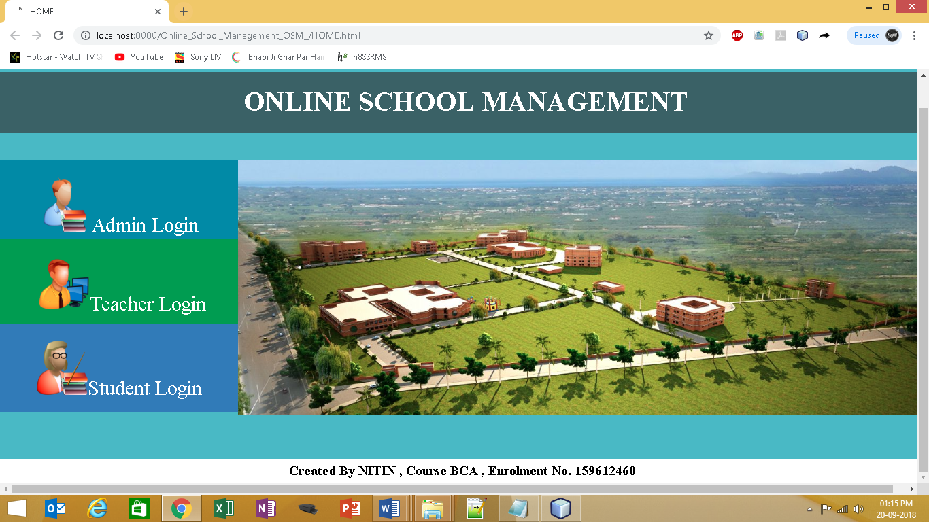Student Login
4. Output adminlogin.jsp

Admin Login

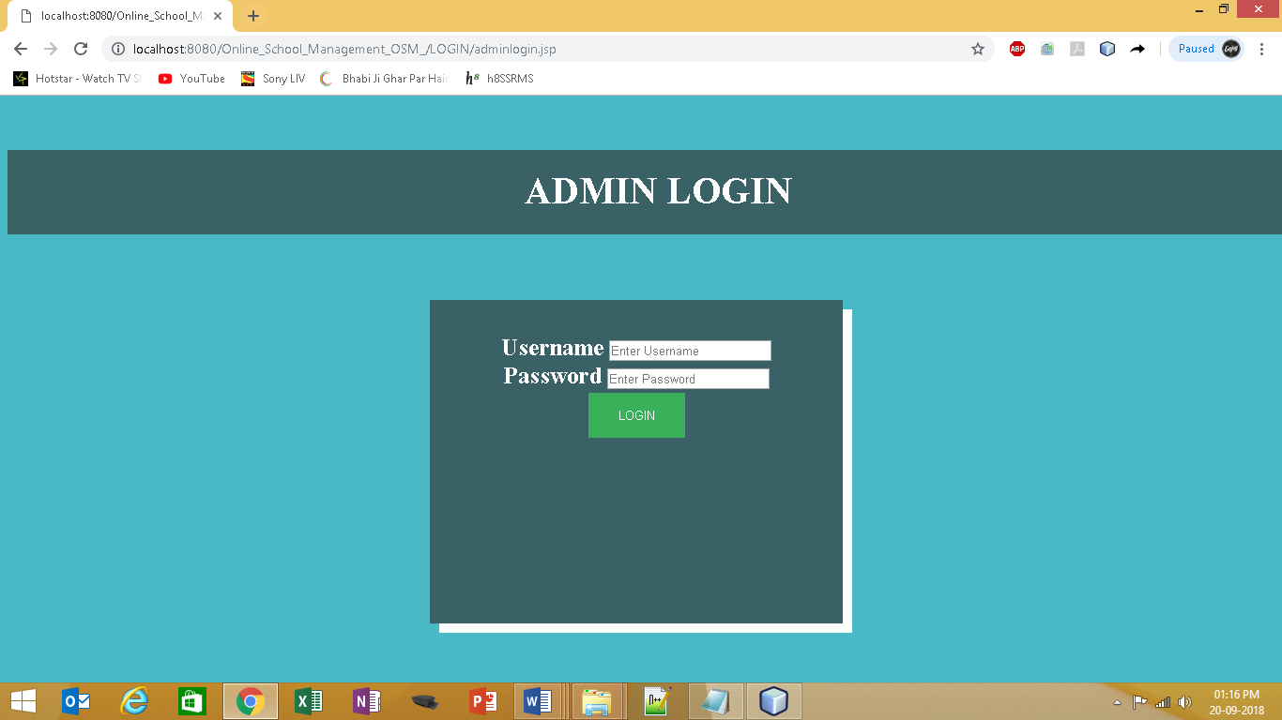

1. Output teacherlogin.jsp page

Teacher Login

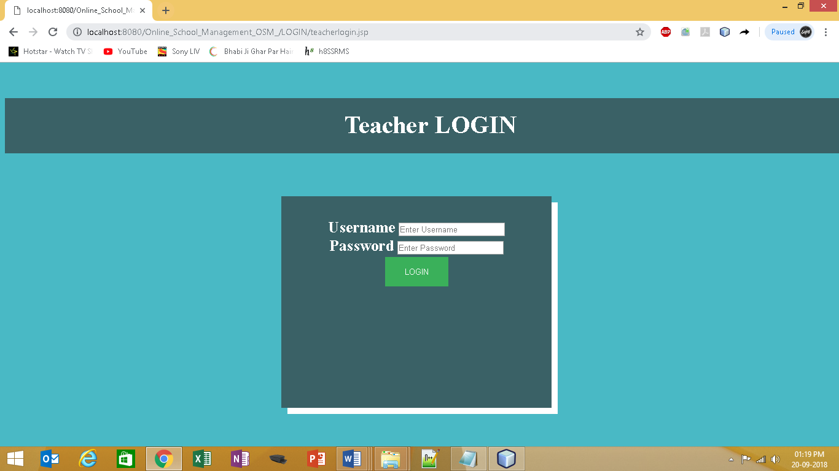

1. Output studentlogin.jsp page

Student Login

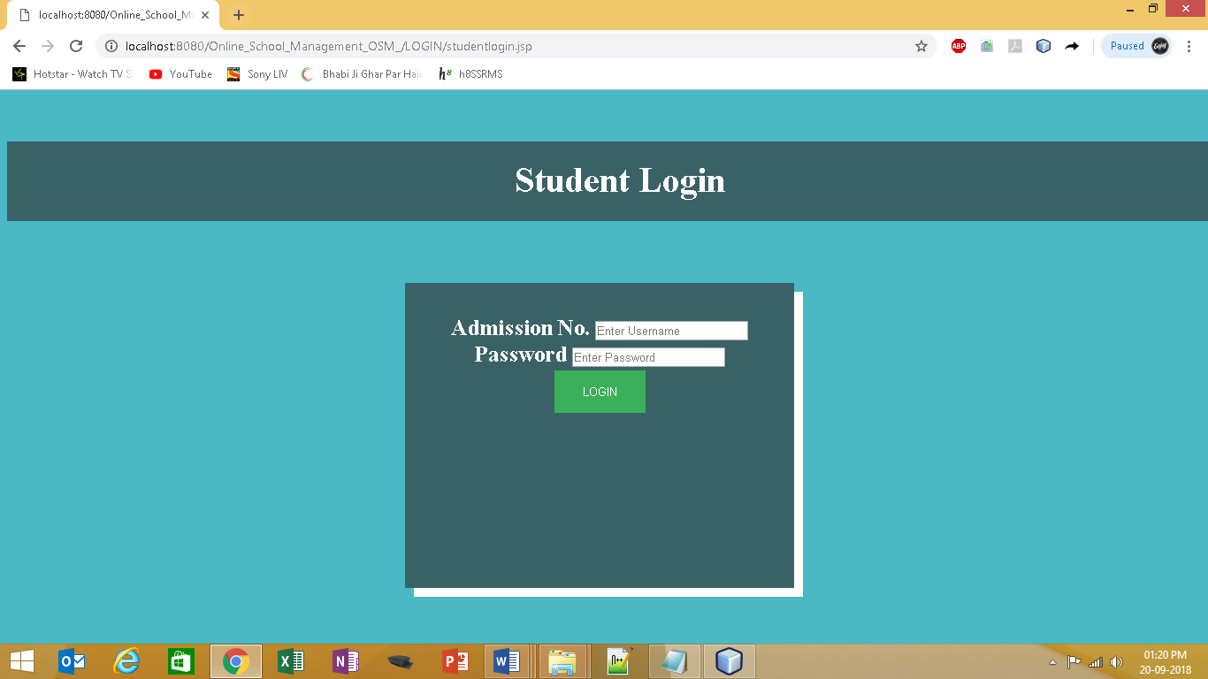

1. Input in adminlogin.jsp as follow
2. Username or Password is Correct
3. Username or Password is incorrect



1. Output When Username or Password is **Correct** through confirmuser.jsp to

welcome admin jsp page

Welcome Admin

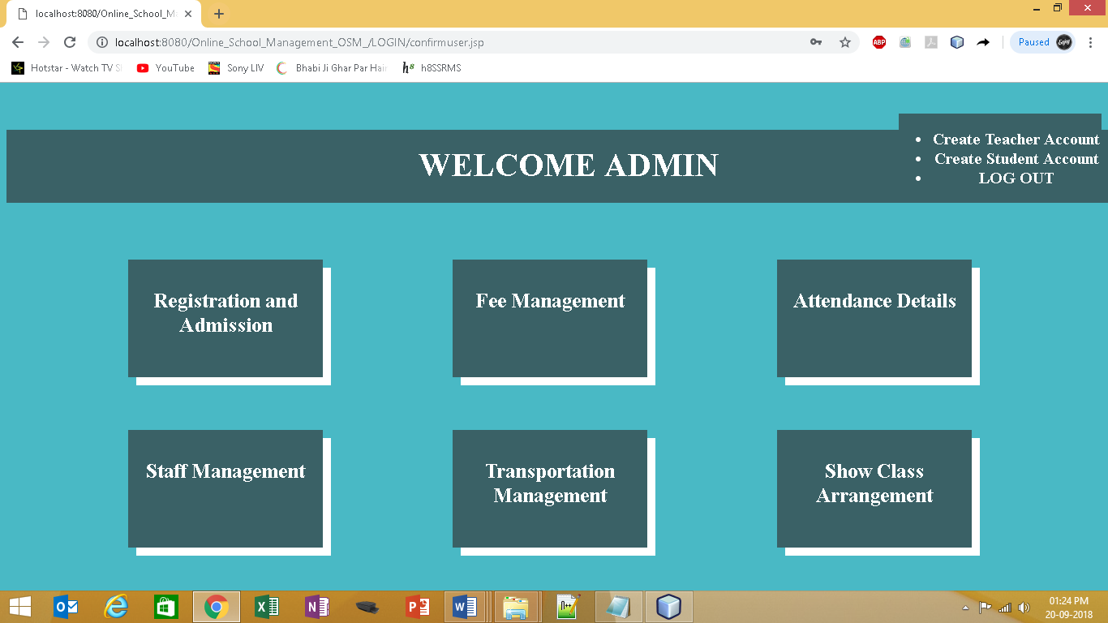

1. 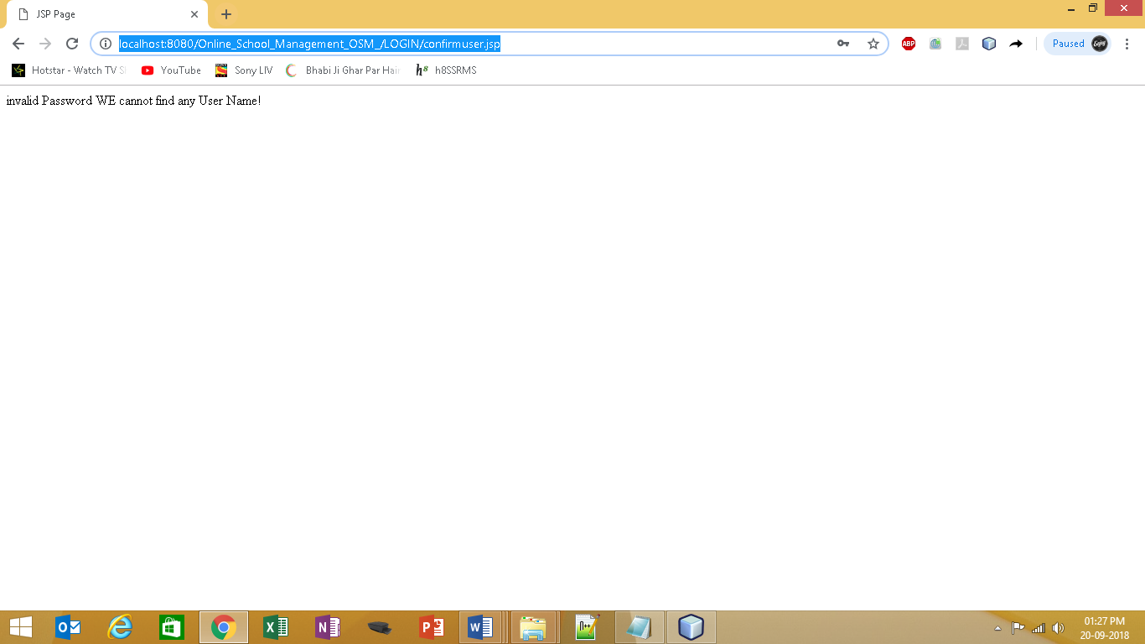Output When Username or Password is **incorrect** to confirmuser.jsp (Invalid Username/Password)
2. Input Welcome Admin
3. Click on Registration and Admission
4. Click on Fee Management
5. Click on Attendance Details
6. Click on Staff Management
7. Click on Transportation Management
8. Click on Show Class Arrangement



1. Output to Admission & Registration Jsp (Admin Account)

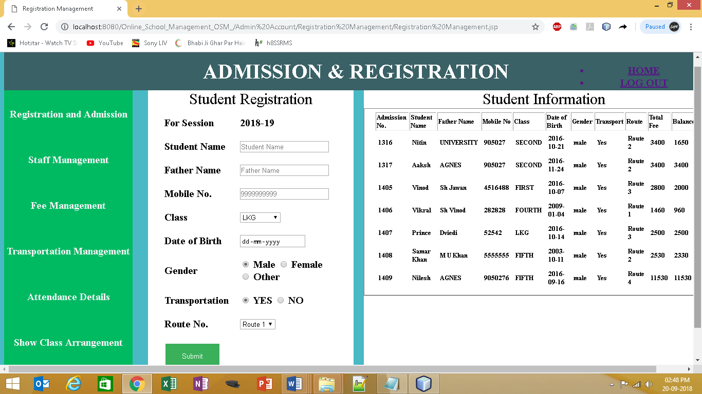

1. Output to Click on Fee Management (Admin Account)

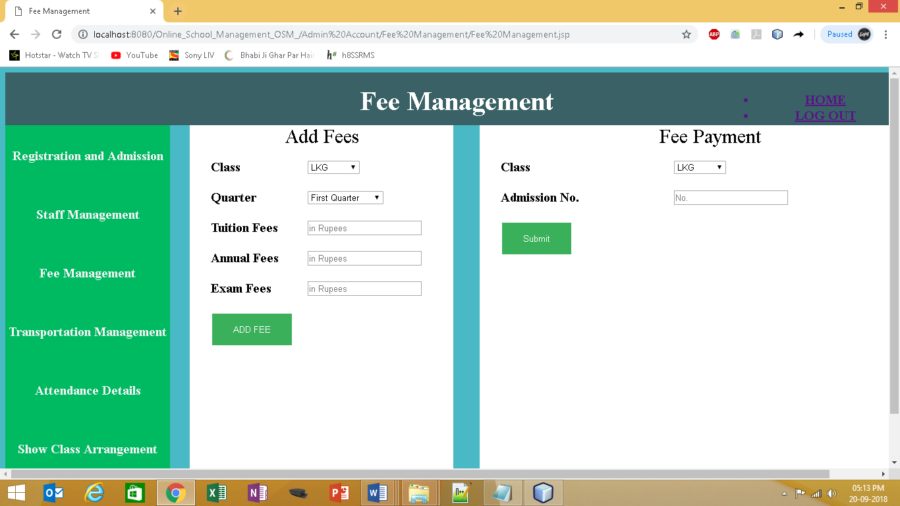

1. Output to Click on Attendance Details (Admin Account)

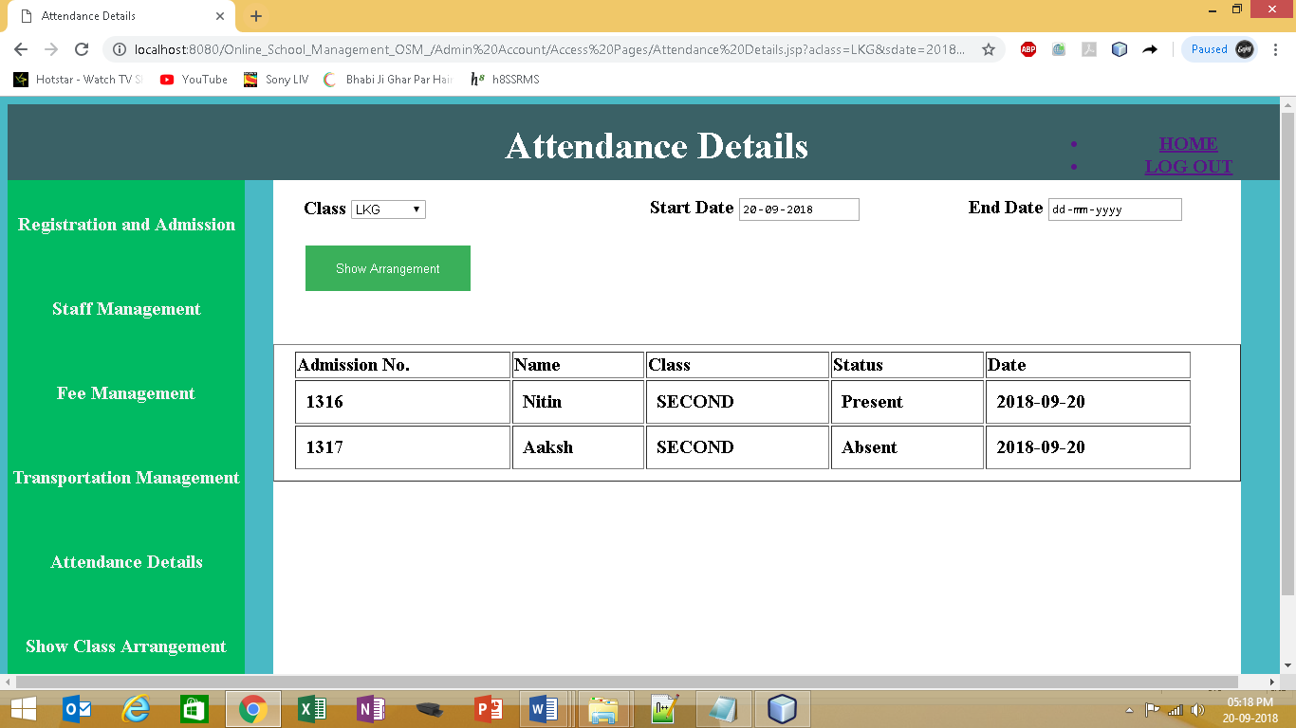

1. Output to Click on Staff Management (Admin Account)

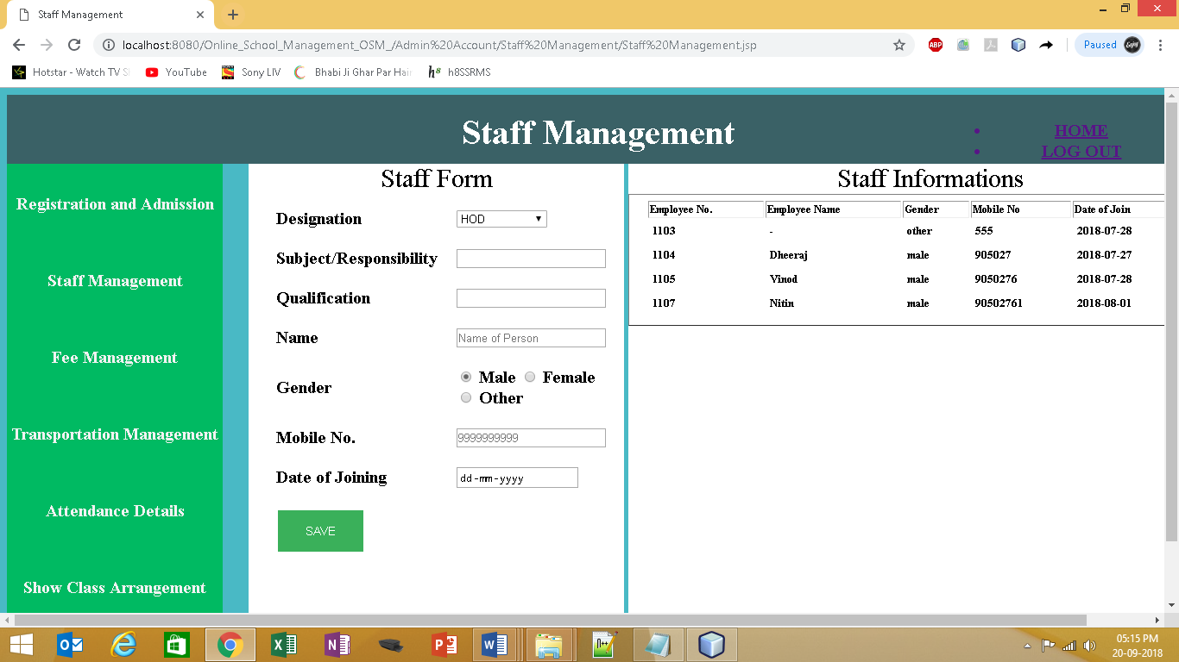

1. Output to Click on Transportation Management(Admin Account)

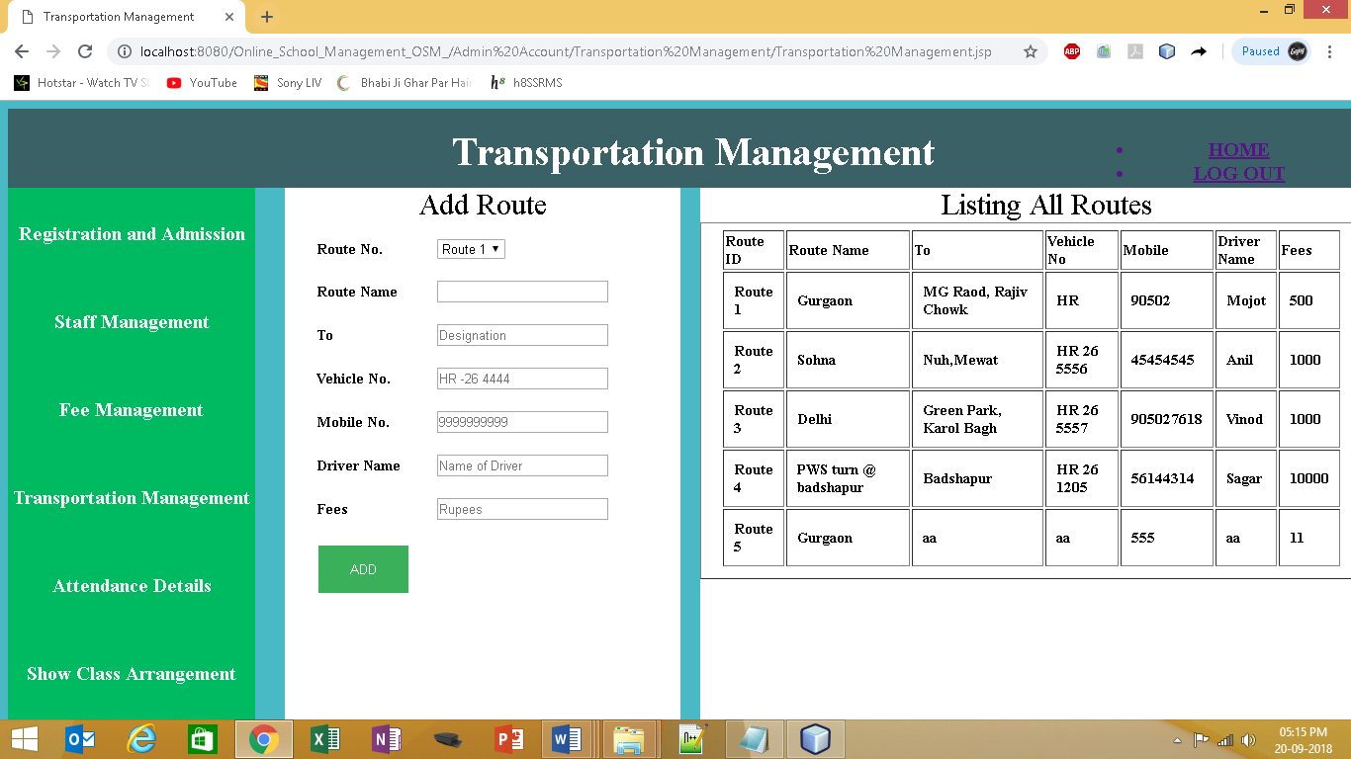

1. 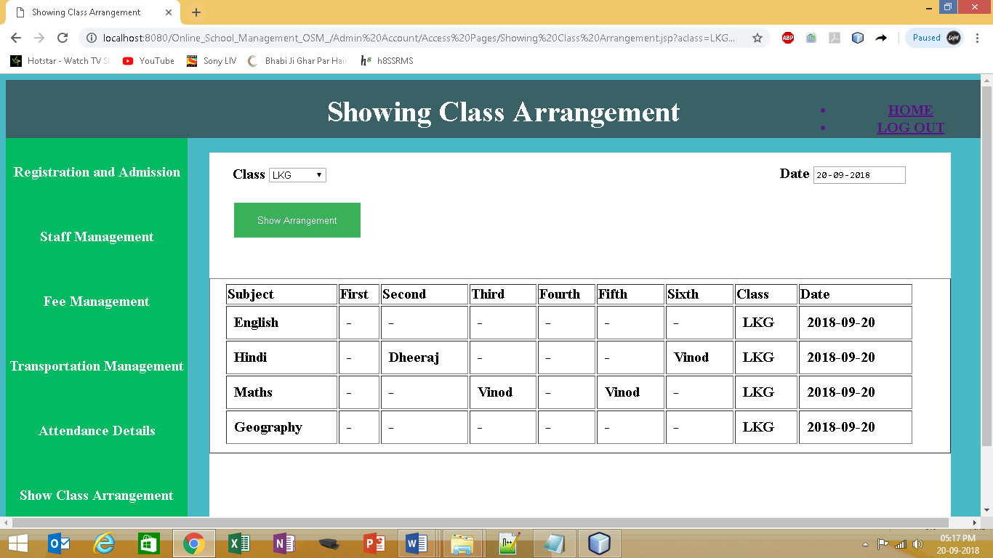Output to Click on Show Class Arrangement (Admin Account)
2. Input to Admission & Registration Jsp (Admin Account)

Fill the Student Registration Form as show in screen shot.

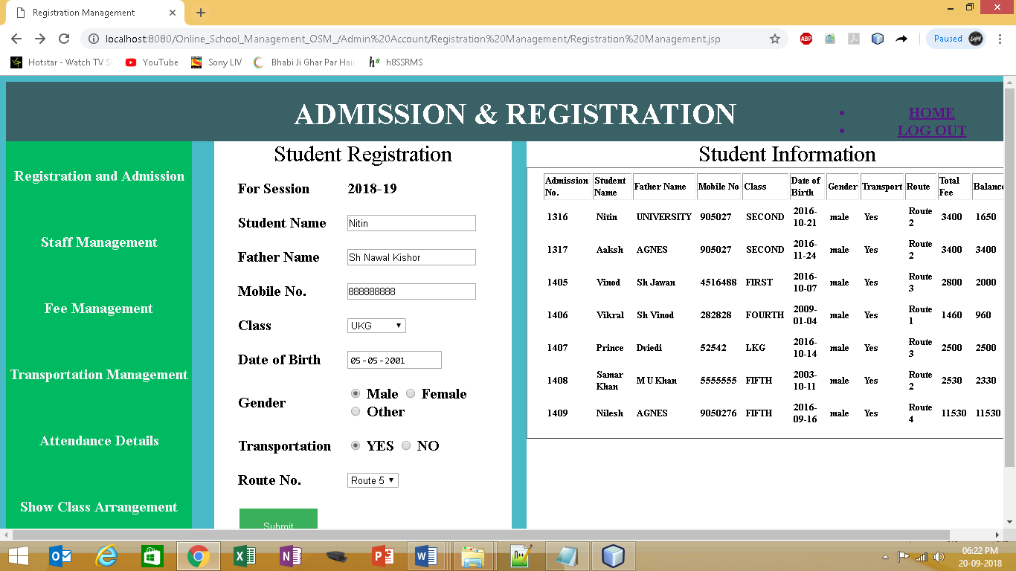

1. 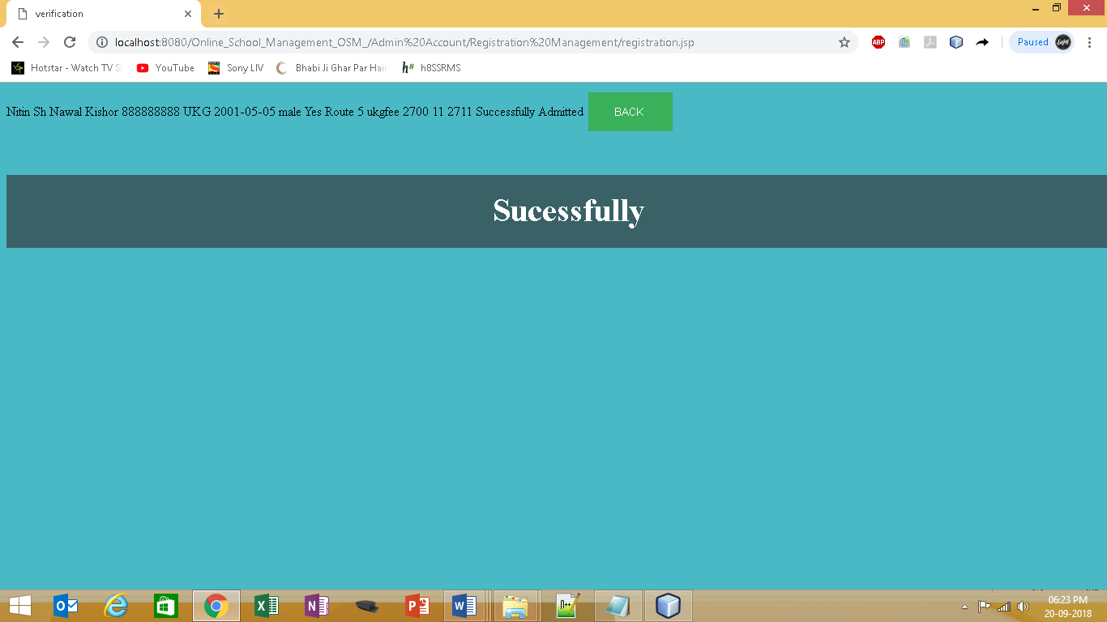Output when Successfully Admitted
2. Output when Not Successfully Admitted

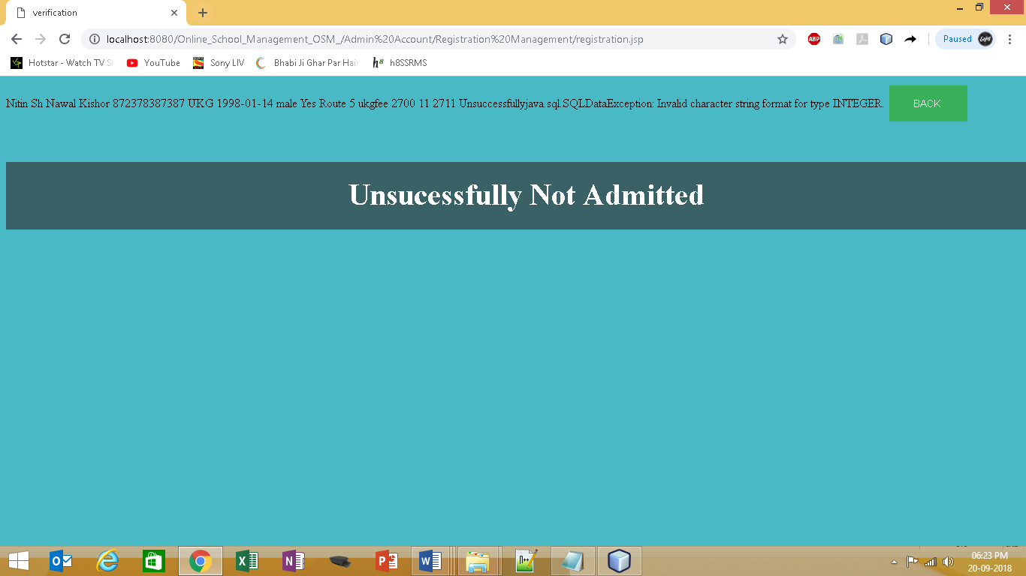

1. Input to Fee Management JSP page (Admin Account)
2. Fill the Add Fees Form as show in screen shot.

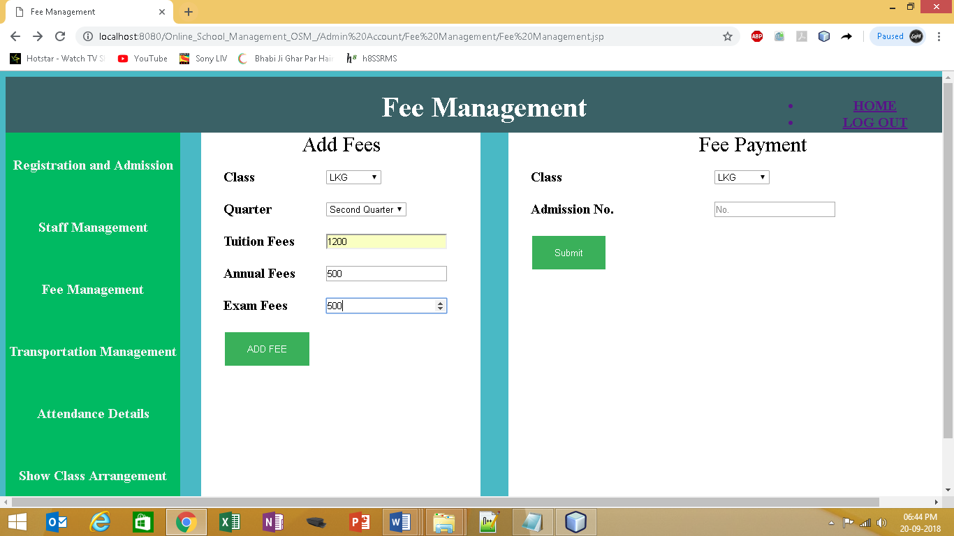

1. Output When Successful Added

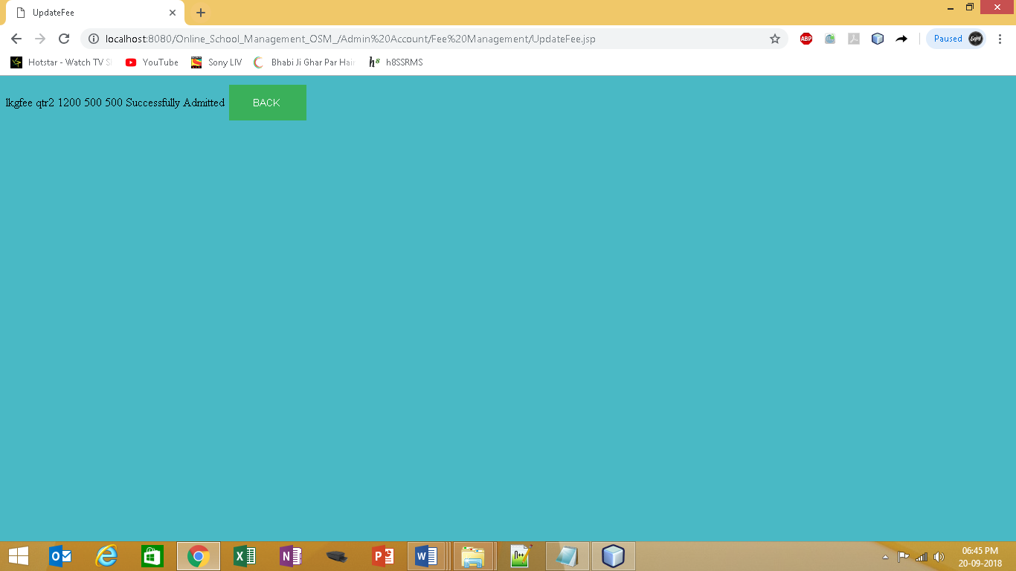

1. 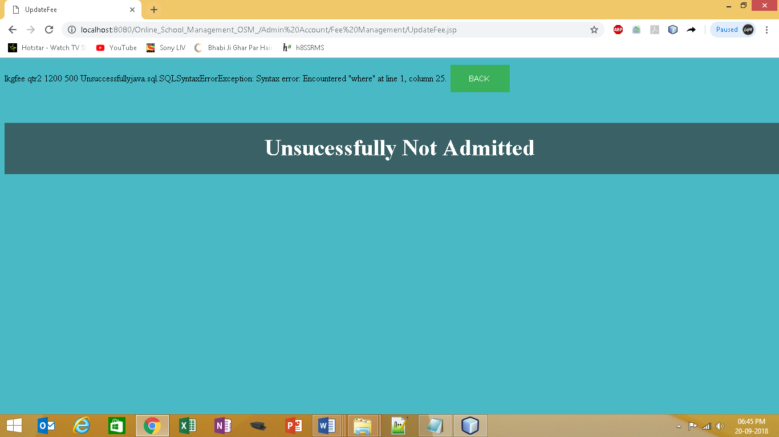Output When Unsuccessful Added
2. Input Fill the Fee Payment Form as show in screen shot. (Admin Account)

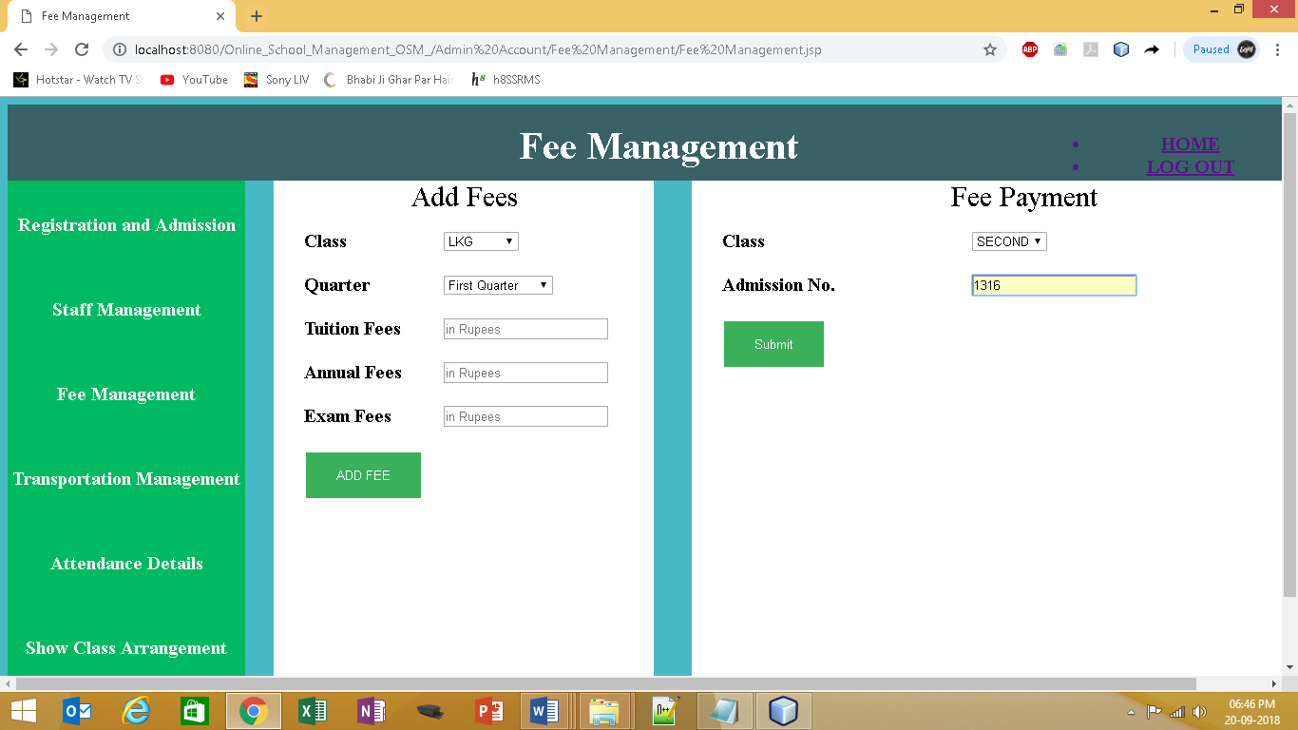

1. 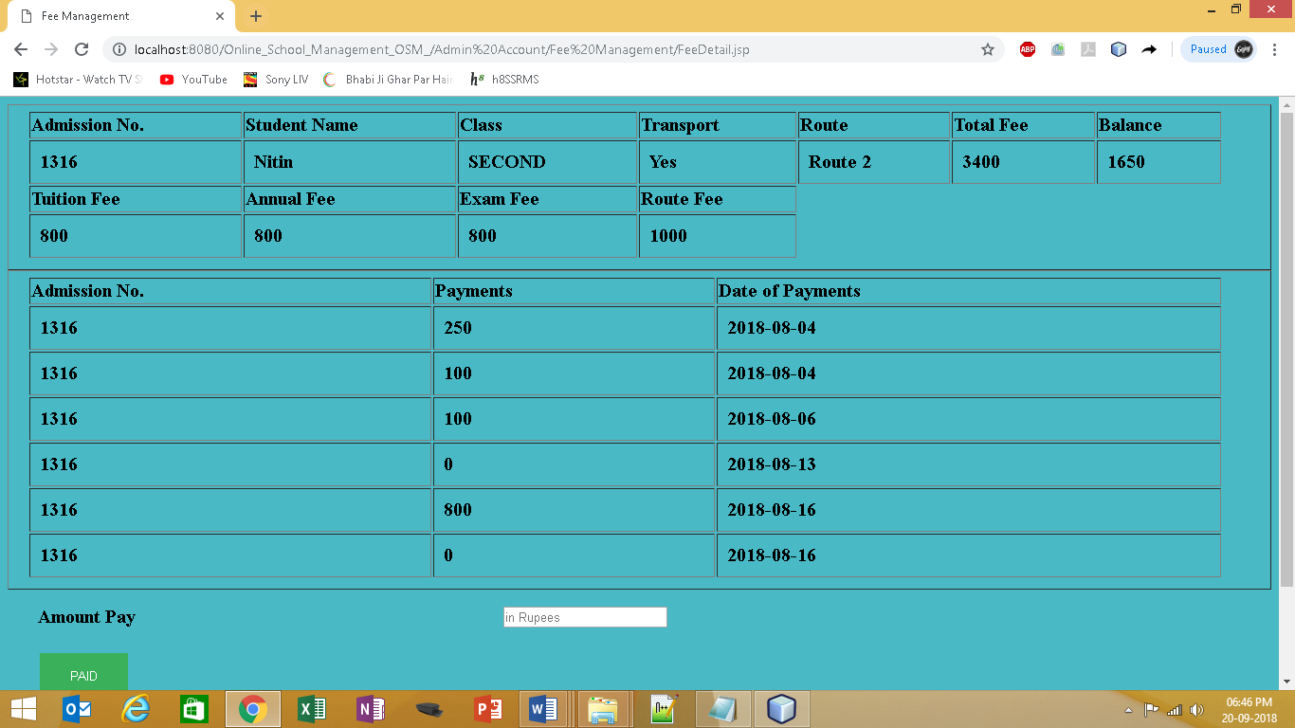Output When Class and Admission No. is Found
2. Output When Class and Admission No. is Not Found

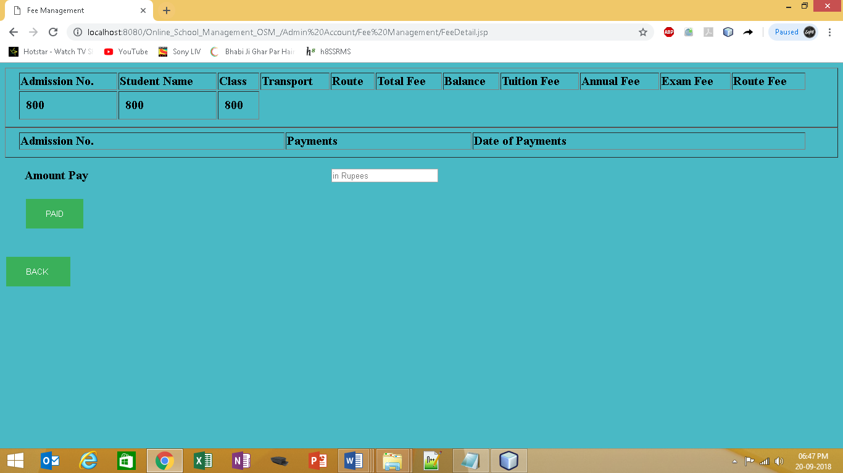

1. Input to Attendance Details JSP page

INPUT Fill Start Date 20/09/2018 and End Date20/09/2018 as show in Screenshot Class LKG .

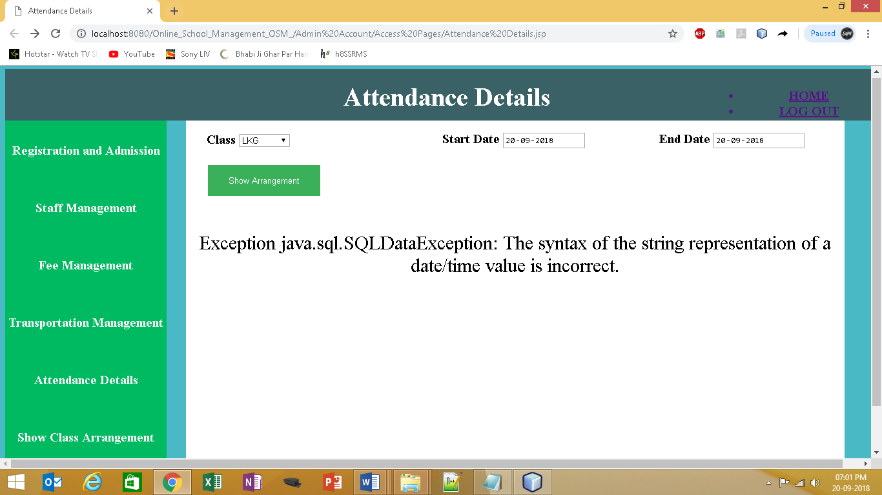

1. Output is Attendance detail of class LKG from 20/09/2018 to 20/09/2018



1. Input to Staff Management Jsp (Admin Account)

Fill the Staff Form Form as show in screen shot

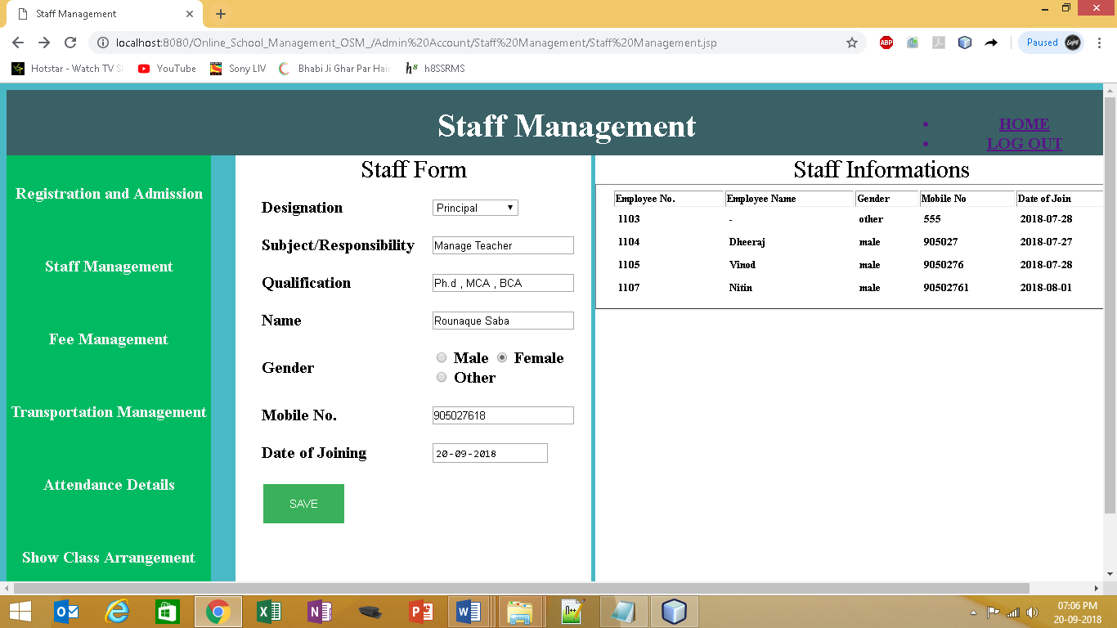

1. Output when Successfully Admitted

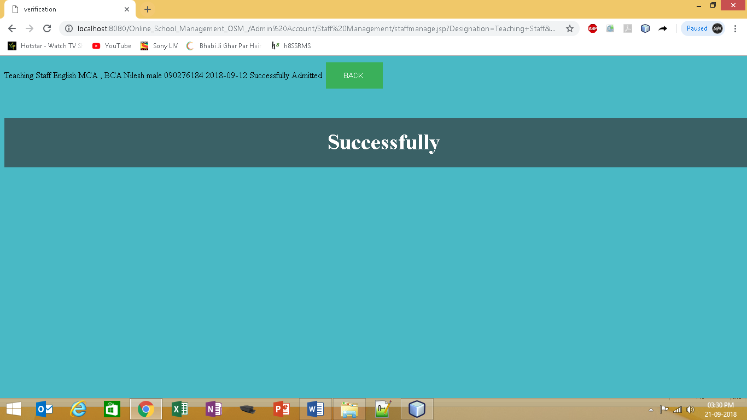

1. Output when Not Successfully Admitted

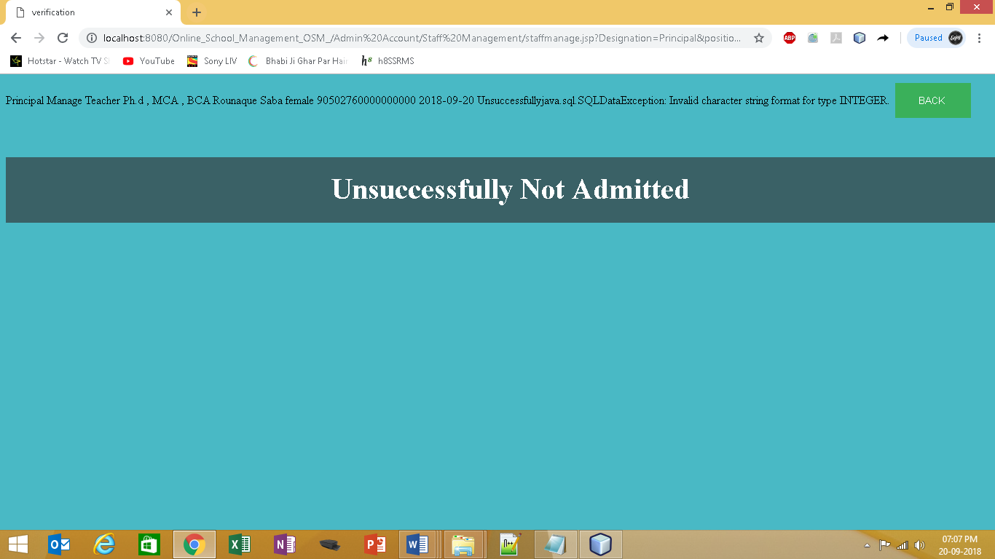

1. Input to Transportation Management Jsp (Admin Account)

Fill the Add Route Form as show in screen shot(Admin Account)

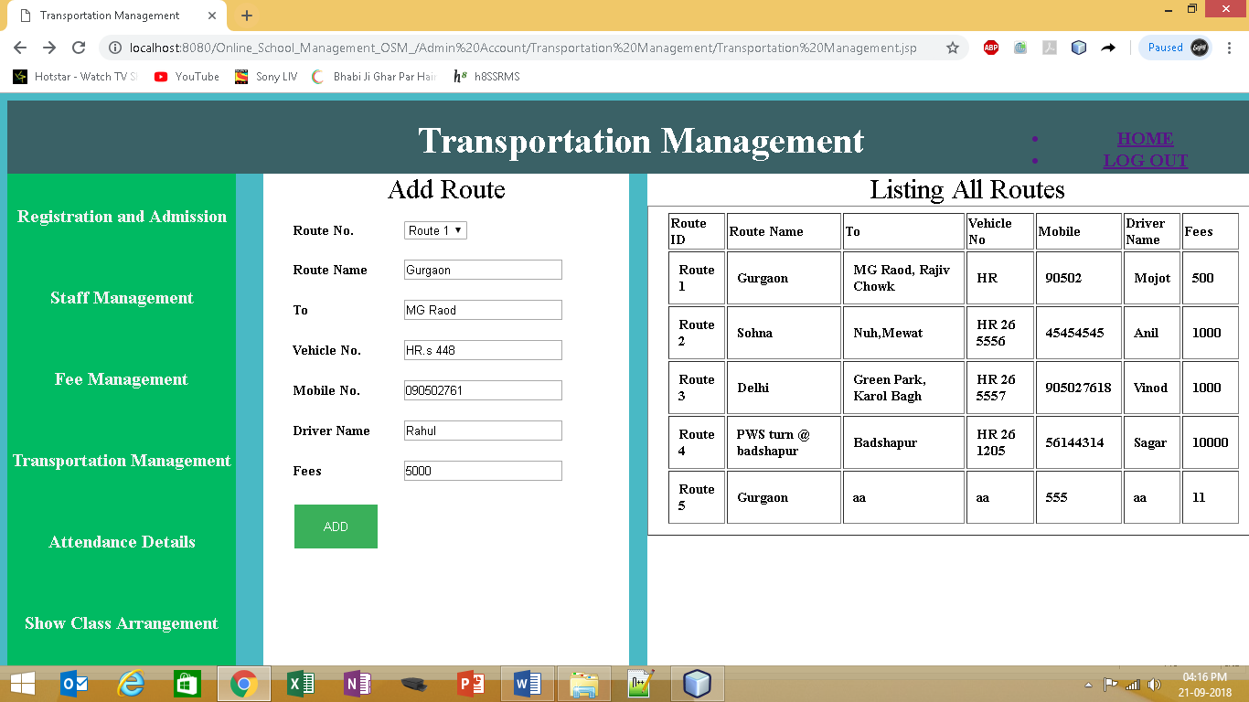

1. Output when Not Successfully Admitted

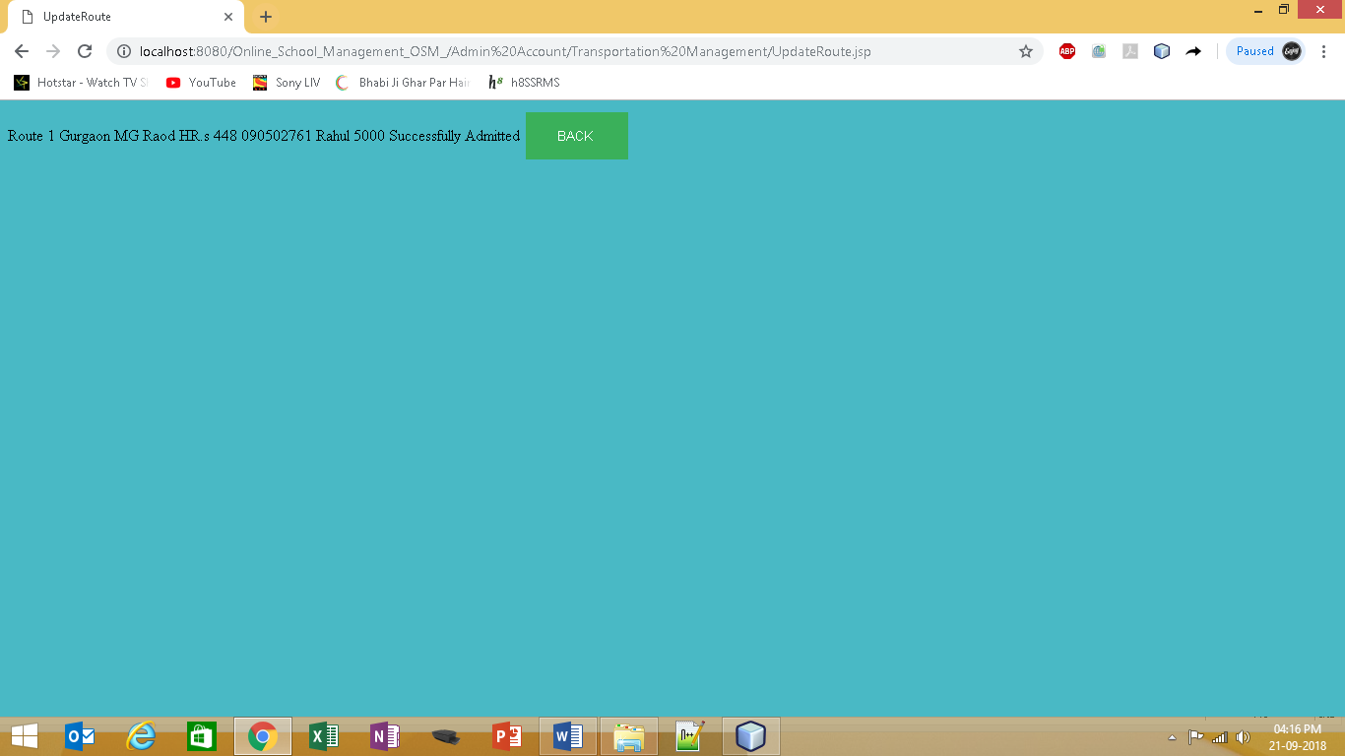

1. Output when Successfully Admitted

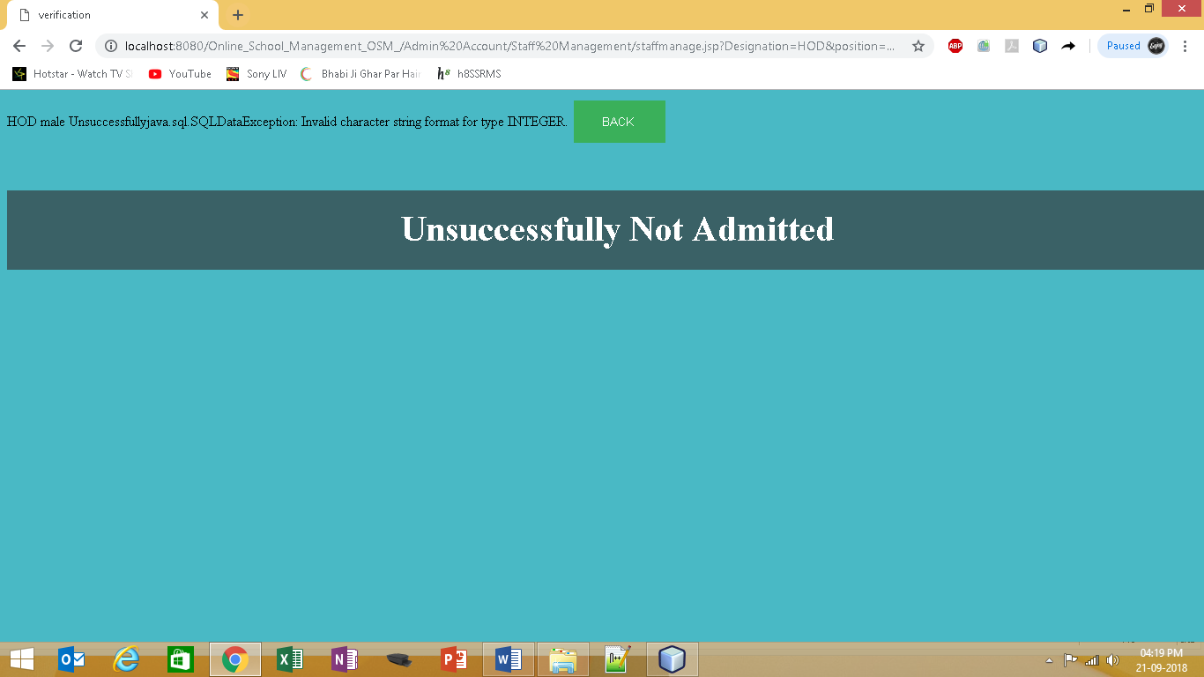

1. Input to Show Class Arrangement JSP page (Admin Account)

INPUT Fill Class LKG Date 20/09/2018 as show in Screenshot .

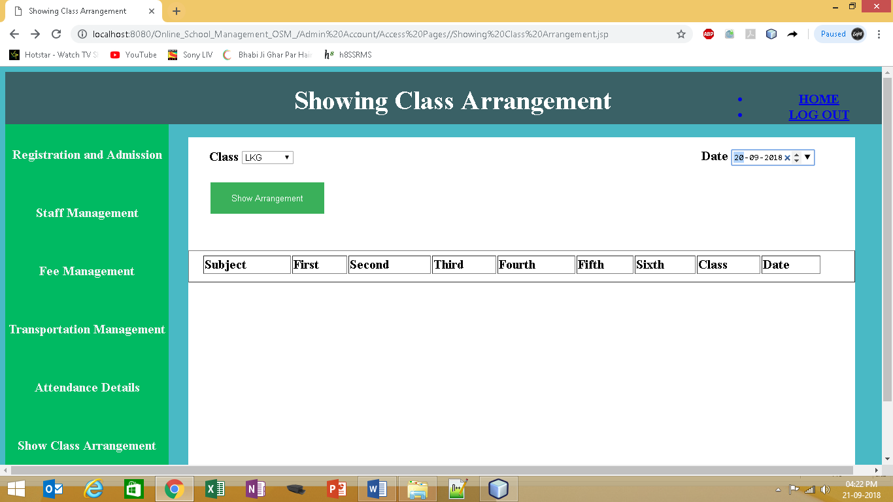

1. Output is Class Arrangement detail of class LKG and Date 20/09/2018



1. **Input in teacherlogin.jsp as follow**
2. Username or Password is Correct
3. Username or Password is incorrect

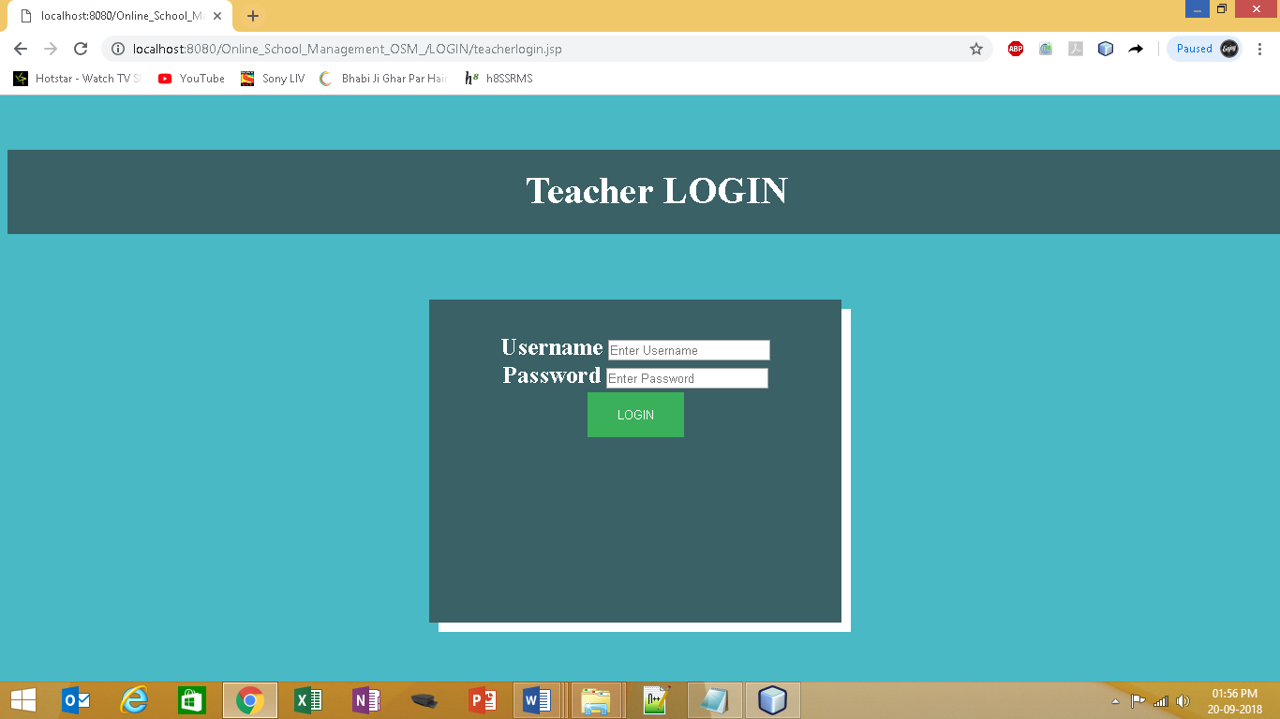

1. Output When Username or Password is **Correct** through confirmuser.jsp to

welcome Teacher jsp page

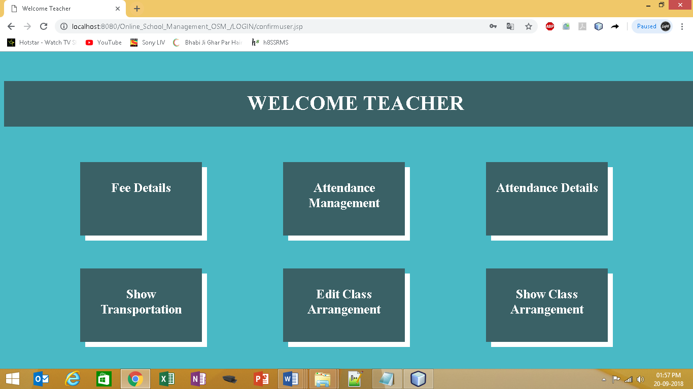

1. Output When Username or Password is **incorrect** to confirmuser.jsp (Invalid Username/Password)

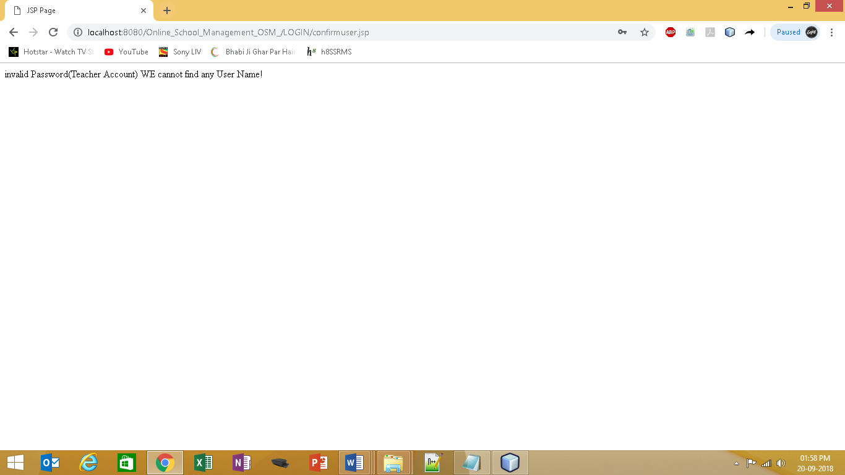

1. **Input Welcome Teacher (Teacher Account)**
2. Click on Fee Details
3. Click on Attendance Management
4. Click on Attendance Details
5. Click on Show Transportation
6. Click on Edit Class Arrangement
7. Click on Show Class Arrangement

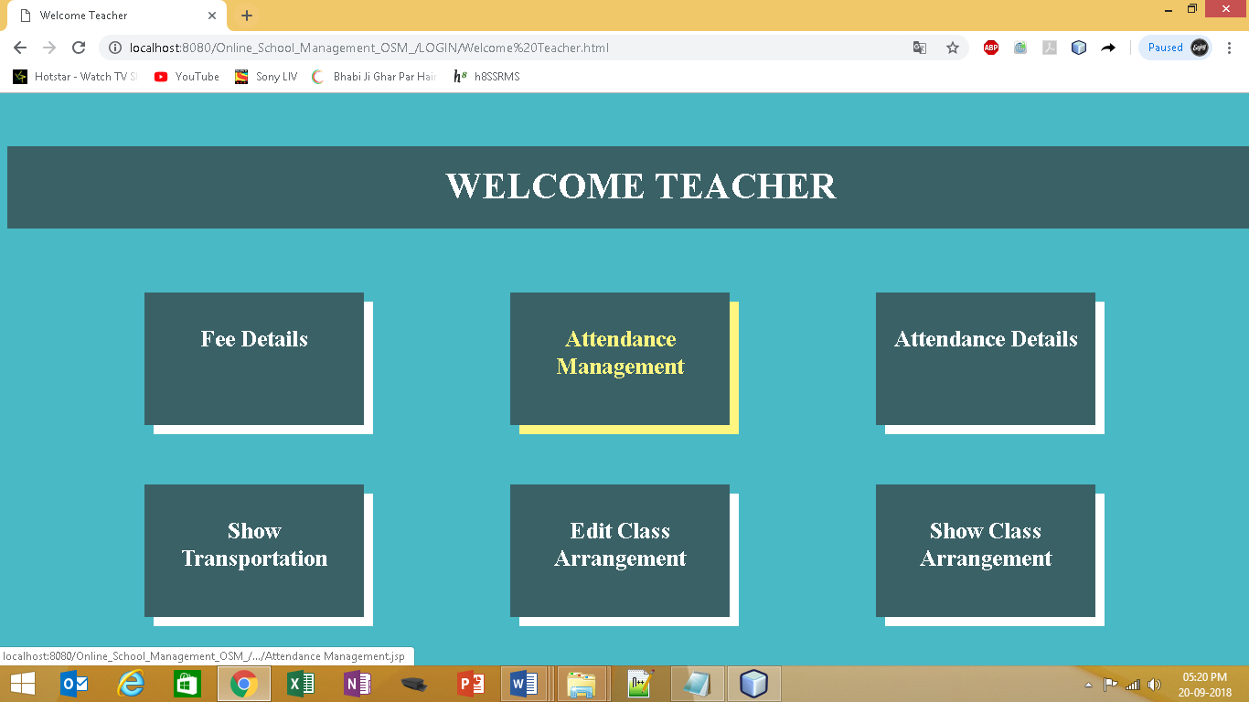

1. Output to Click on Fee Details (Teacher Account)
2. INPUT Fill Class Second and Admission No. 1316 as show in Screenshot.

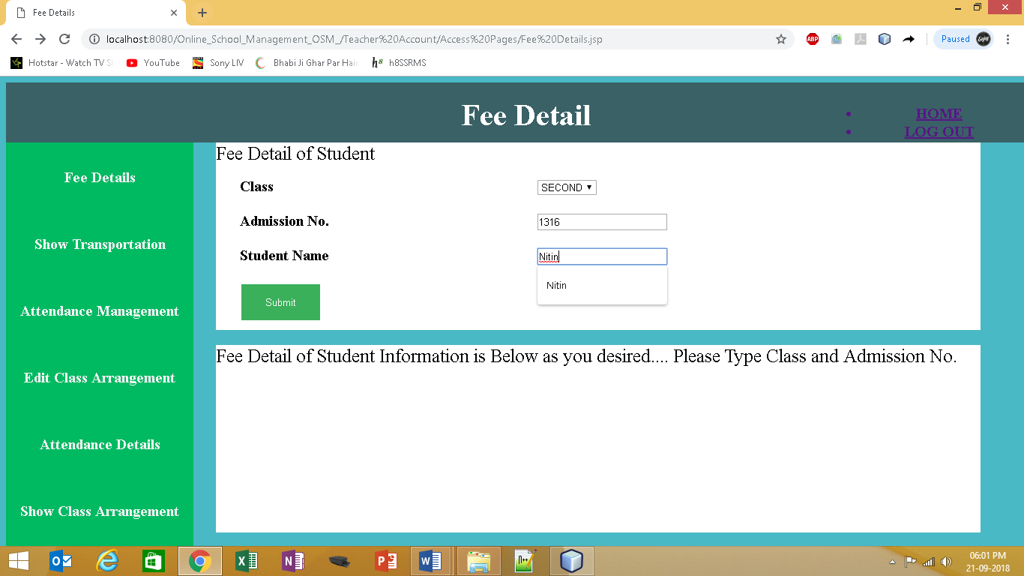

12 (a) Output to Fee Details of Class Second and Admission No. 13516

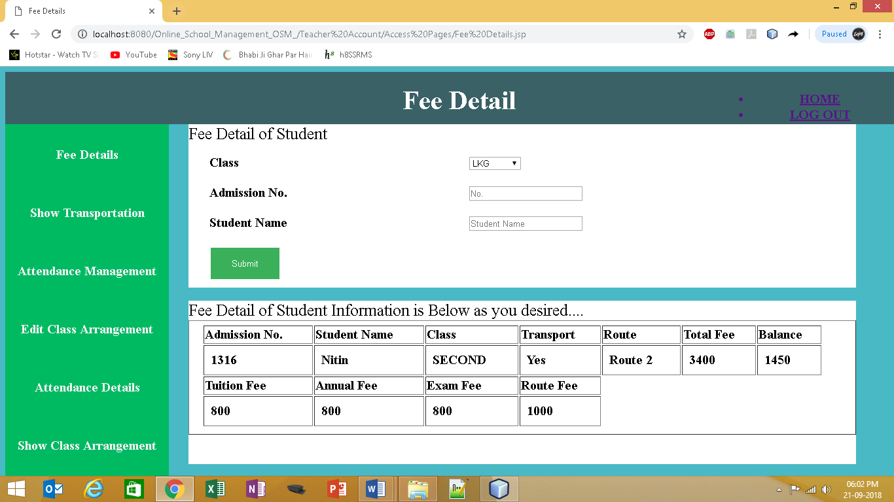

1. Output to Click on Attendance Management (Teacher Account)
2. INPUT Fill Class Fifth as show in Screenshot.

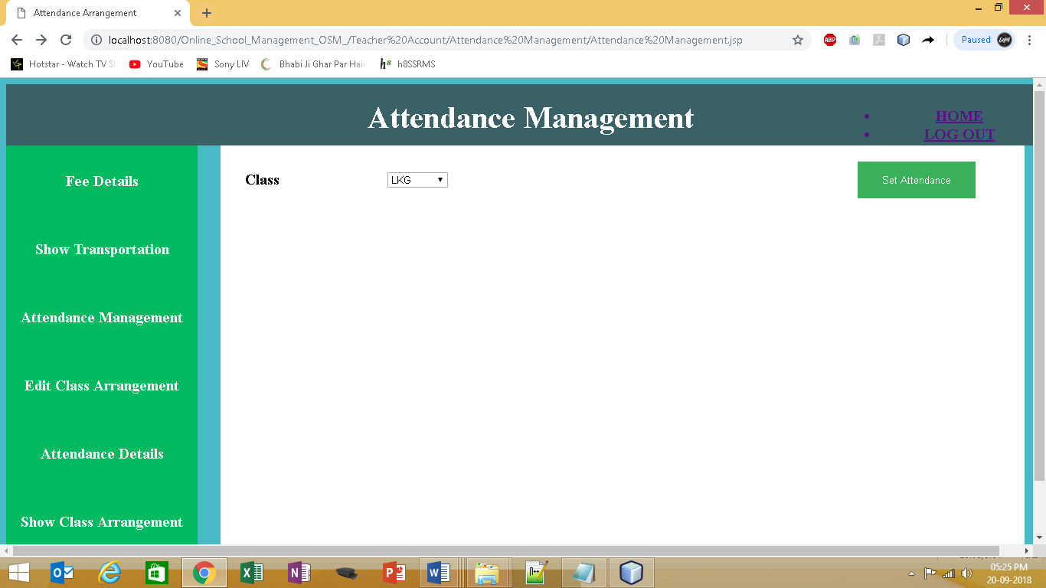

1. Output to Attendance Management Showing all student of class Fifth.
2. (a) Input choose student absent/present on date.

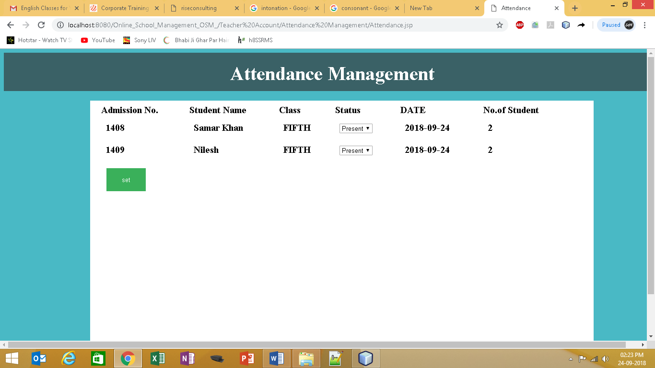

(b) Output to When Sucessfully Updated Student’s Attendance

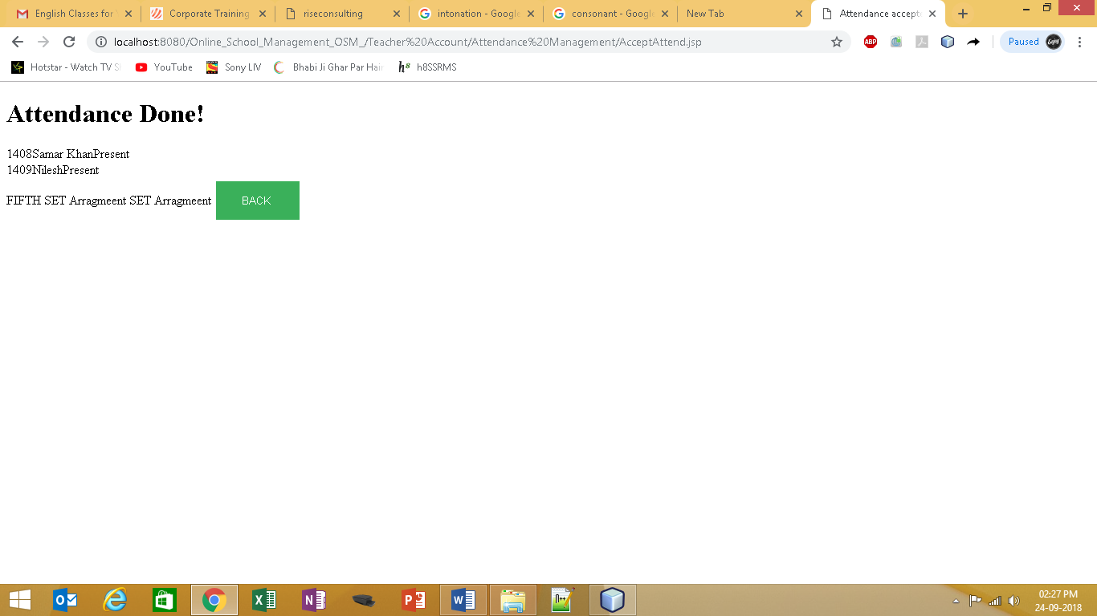

1. Output when when taking same class on same day Attedance!

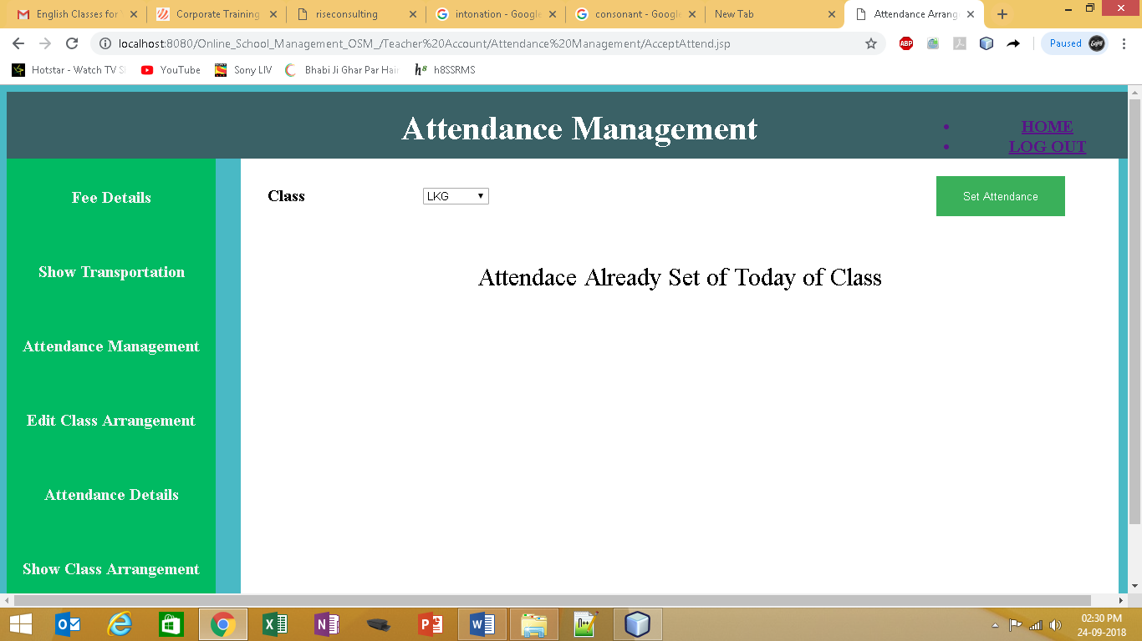

1. Output to Click on Attendance Details (Teacher Account)
2. INPUT Fill Start Date 20/09/2018 and End Date20/09/2018 as show in Screenshot Class LKG .



1. Output is Attendance detail of class LKG from 20/09/2018 to 20/09/2018



1. Output to Click on Show Transportation (Teacher Account)

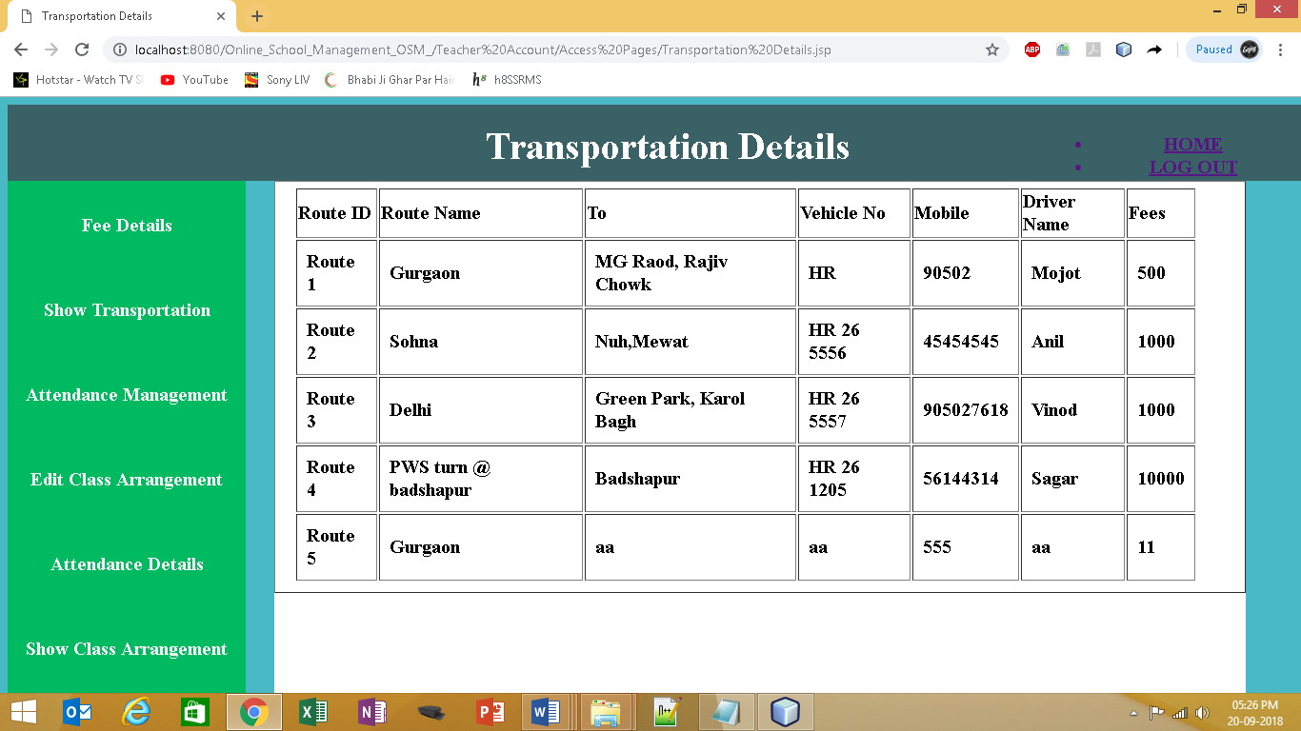

1. Output to Click on Edit Class Arrangement (Teacher Account)
2. Input to set arrangement of Class LKG and Date24-09-2018 as on Screen

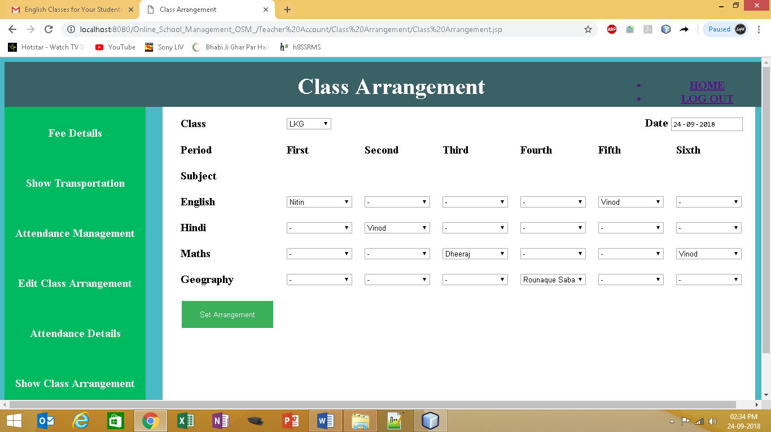

* 1. Output When Sucessfully Set Arrangement of Class

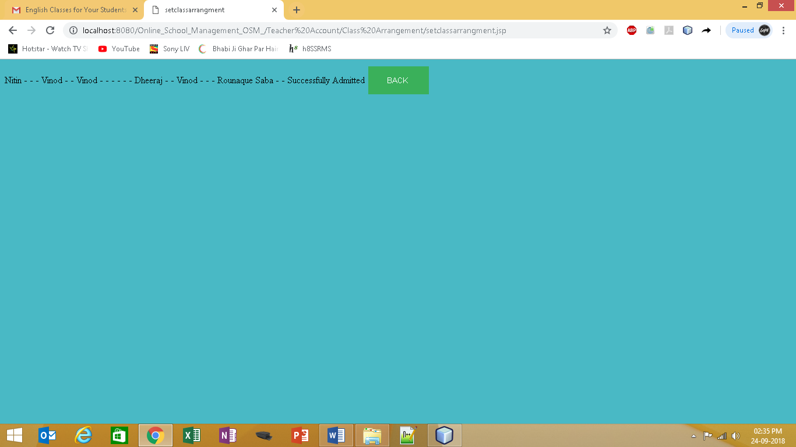

* 1. Output when when taking same class on same day Arrangement!

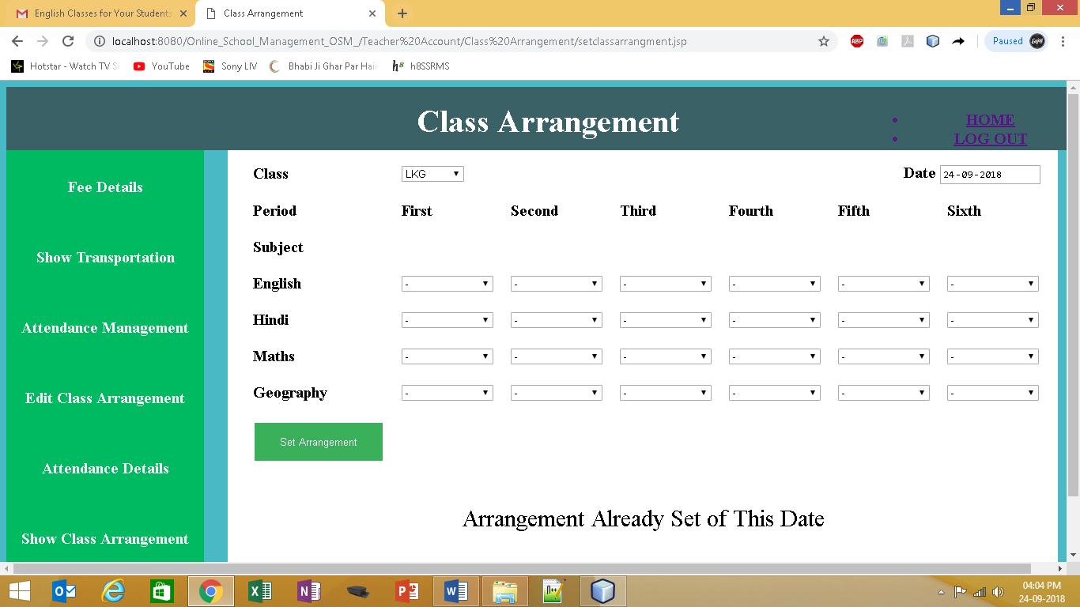

* 1. Input to Show Class Arrangement JSP page (Teacher Account)

INPUT Fill Class LKG Date 20/09/2018 as show in Screenshot .



1. Output is Class Arrangement detail of class LKG and Date 20/09/2018



* 1. Input in studentlogin.jsp as follow

1. Username or Password is Correct
2. Username or Password is incorrect

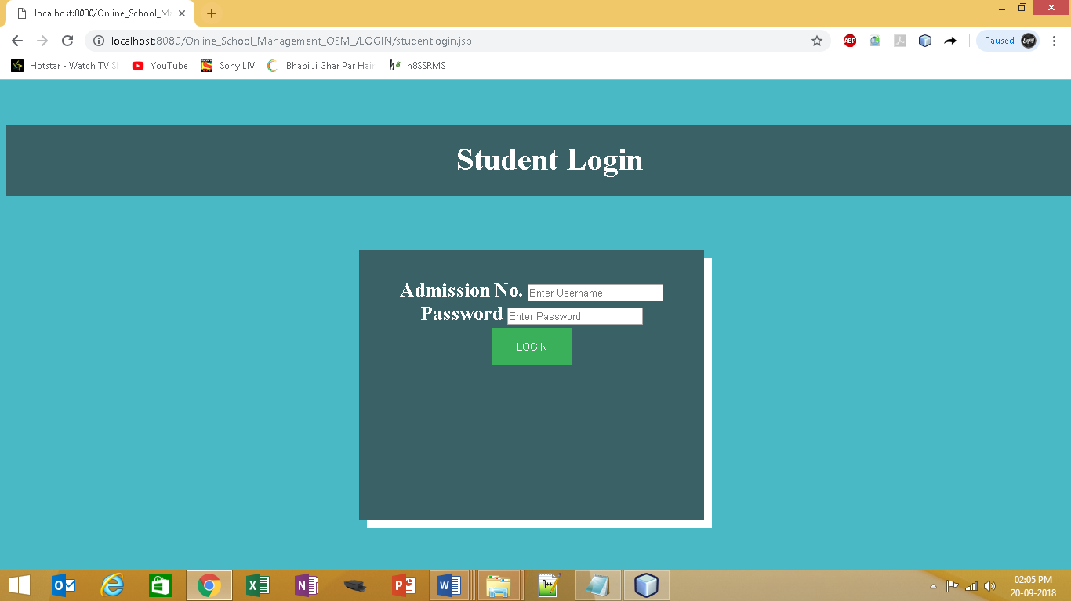

1. Output When Username or Password is **Correct** through confirmuser.jsp to

welcome Student jsp page

Welcome (Student Name will print)

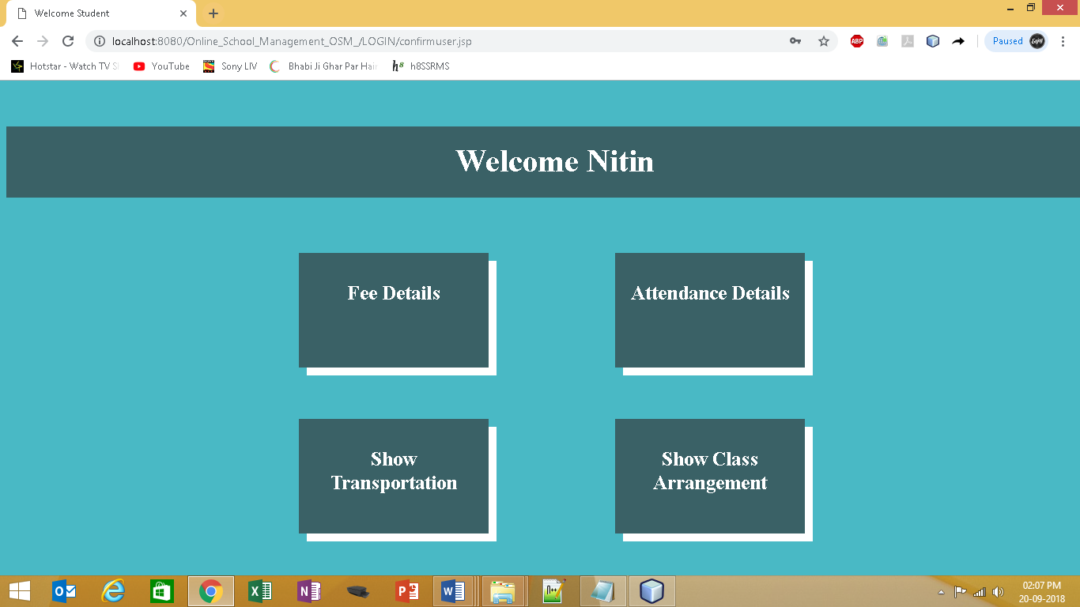

1. Output When Username or Password is **incorrect** to confirmuser.jsp (Invalid Username/Password)

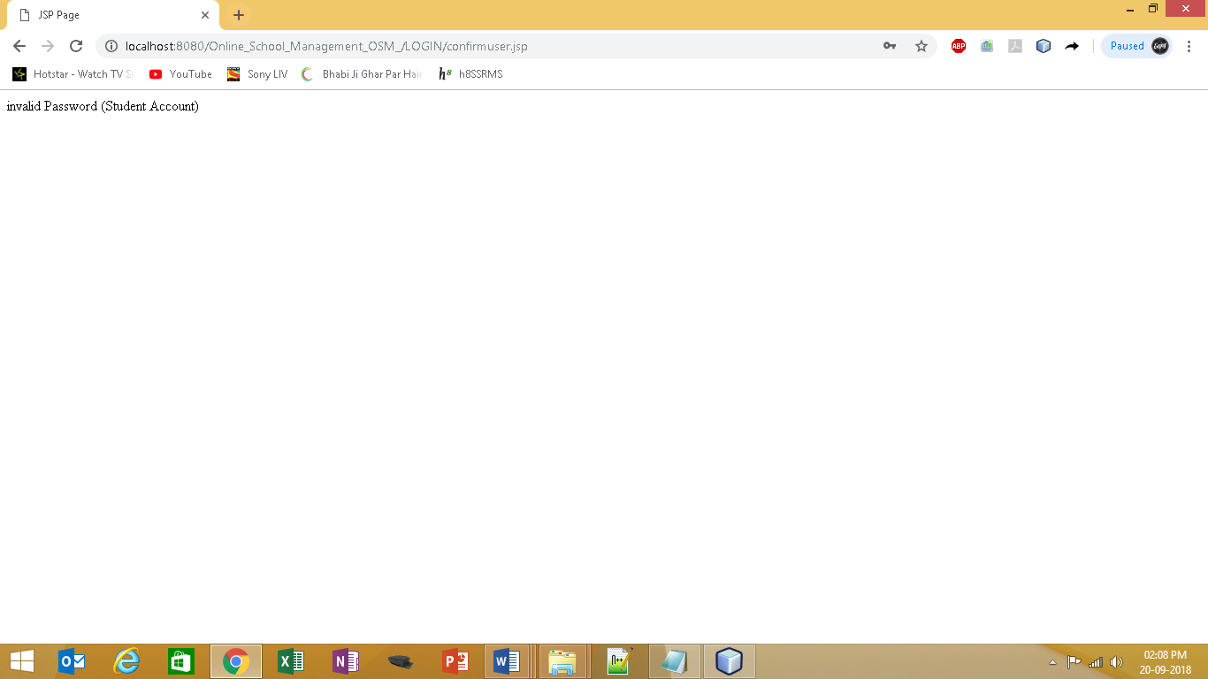

1. Input Welcome Student as Admission No. 1316 and Name Nitin
2. Click on Fee Details
3. Click on Attendance Details
4. Click on Show Transportation
5. Click on Show Class Arrangement



1. 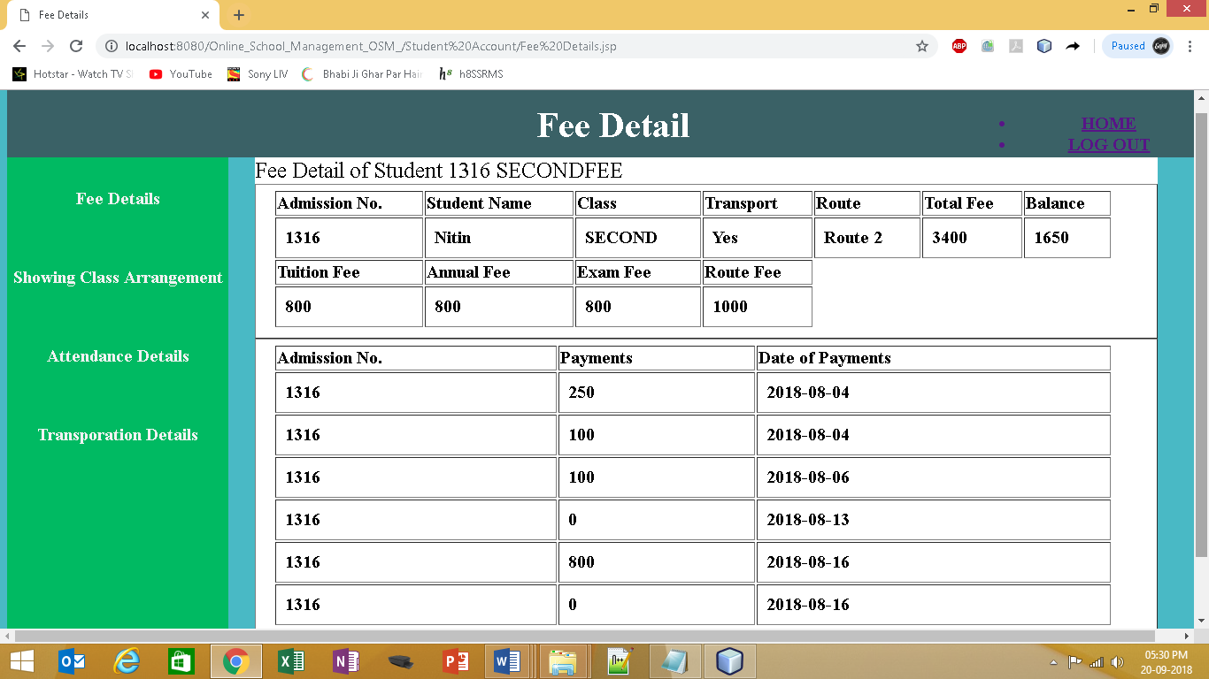Output to Click on Fee Details Details of student Nitin Admission No. 1316
2. Output to Click on Attendance Details of student Nitin Admission No. 1316

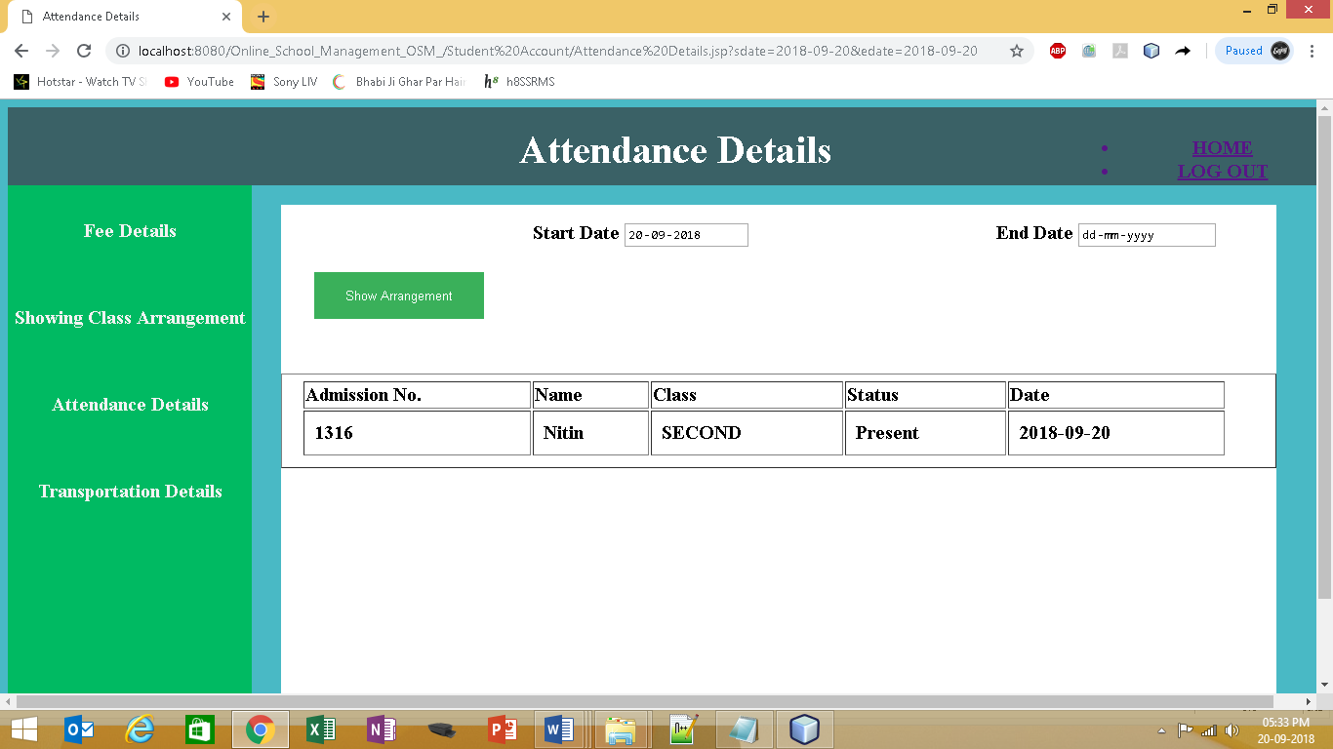

1. Output to Click on Show Transportation

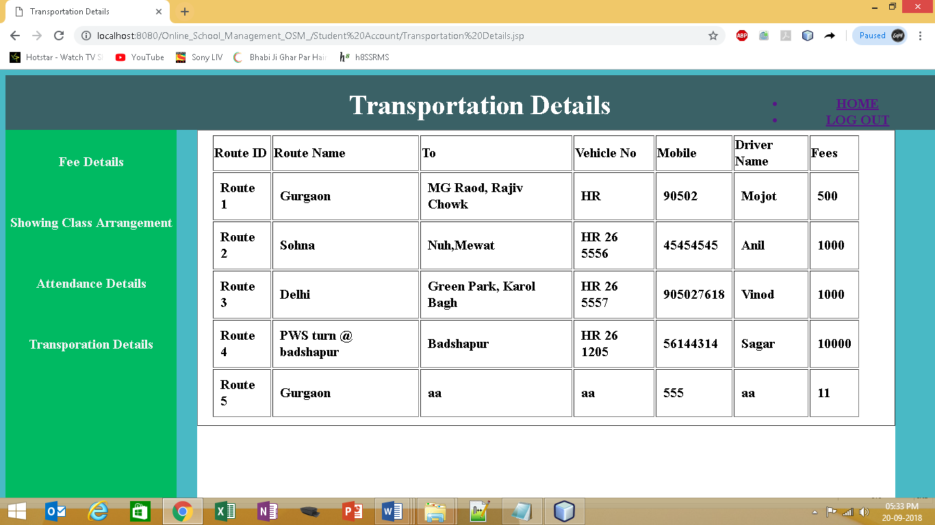

1. Output to Click on Show Class Arrangement Details of student Nitin Admission No. 1316

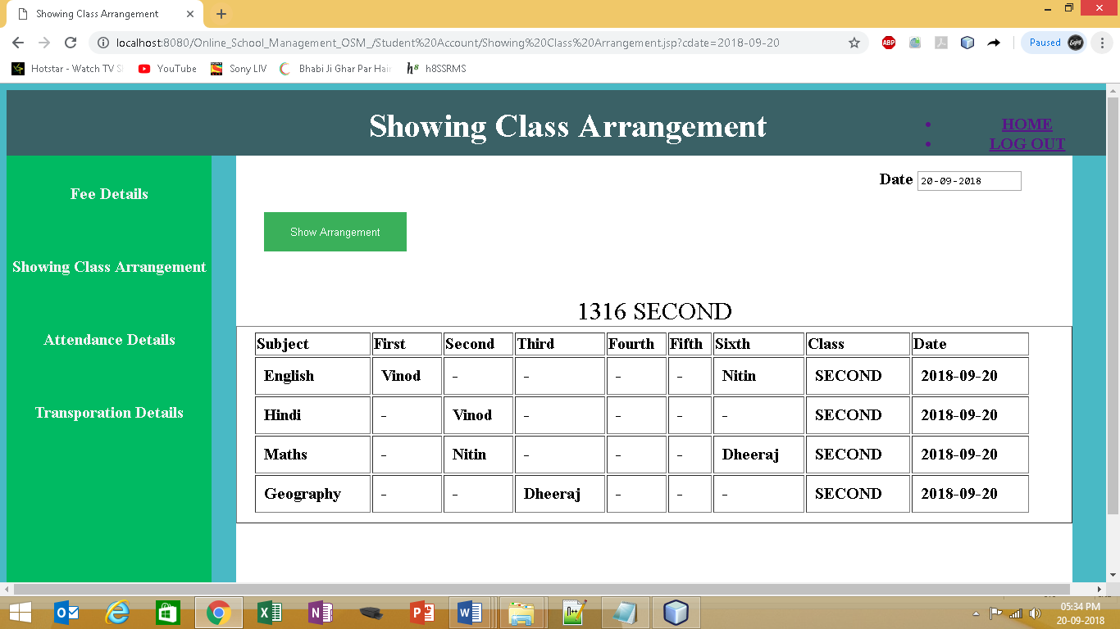

# Implementation of Security and validation checks

In this project we have used following validation checks.

1. This project have three security verification Admin, Teacher and Student Separately all will open with correct userid and password .
2. While entering the data into the form it will check for the name of the client is properly filled & it should not be null.
3. Whenever we enter the data for the new staff detail, student detail , or user will automatically check the details from the database tables and also generate the connection number automatically.
4. Almost for all fields we have used the validation for example if name of the fields requires the text type of data then it will check for the string and if the data is numeric then it will check if the number entered is proper numeric or not.
5. Evidence-based security (authentication)

# Limitations of the Project Future

1. For Uploading this project we require some space on the internet server.
2. This Software is not run on android devices.
3. This Project is not having any Exam Management module for recording and taking students’ evaluation
4. This Project is also not having any Library Management Module for Recording Books Details and Issues Records.

# Application of the Project

1. This project can be used as Administrative/Teacher /Student to support system for School with adding some more useful modules in the project.
2. In future it will have Library management and Exam Management for provide more smooth functioning of school.
3. This project is designed to meet the requirements of School Management . It provides the facilities for Fee Payment, Attendance Management and Class Arrangement , Staff Management etc.. It has been developed in JSP server keeping in mind the specifications of the system. For designing the system we have used simple data flow diagrams. Overall the project teaches us the essential skills like:

Using system analysis and design techniques like data flow diagram in designing the system.

Understanding the database handling and query processing using SQL Server.

# BIBLIOGRAPHY

1. Senn James A: Analysis and Design of Information Systems, McGraw Hill, International Ed, 1989.
2. O’Brien Jamea A: Management Information Systems, Galgotia Publications Pvt Ltd, New Delhi, 1998.
3. Laudon & Laudon: Management Information Systems, Organisation and Technology, PHI, New Delhi, 1998.
4. Wetherebe James: Systems Analysis and Design, Galgotia Publications Pvt Ltd, New Delhi, 1990